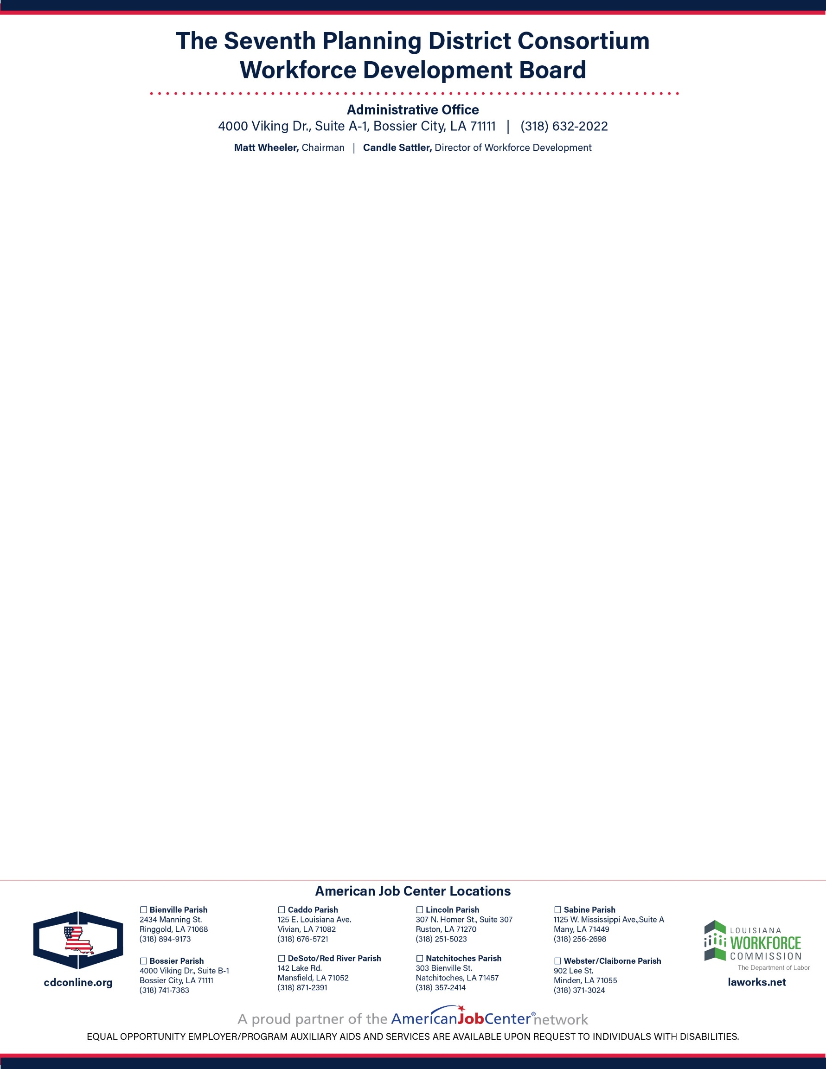

**June 2, 2023**

**Agenda**

**Call to Order and Welcome……………….…………...……………………………………….............…… Matt Wheeler**

*Chairperson*

**Pledge of Allegiance…………………………….…………...…..…….…………......……………………Brent Moreland**

*Business Manager, IBEW Local 194*

**Invocation………………………….….…………………...………………......………………………...…. Nicholas Olsen** *Program Manager of WIOA, CDC*

**Roll Call of Members and Introduction of Guests.……..………………….………………………………Julie Moore** *Operations/Communications Manager*

**Public Comment…………………………………...………………….………………………………………. Matt Wheeler**

**Acknowledgment of LWDB Member Reappointment.……….……………….....………..………...…. Matt Wheeler**

**Approval of Minutes, March 29, 2023, Workforce Development Board Meeting………………….. Matt Wheeler**

**Approval of LWDA 70 Policies…………………………………………………….…………………..….…Matt Wheeler**

**Approval of LWDA 70 American Job Center Certification…..……………….…………………..….…Matt Wheeler**

**Budget and Operating Statements…………………………………………………..….…………...…… Candle Sattler** *Director of Workforce Development, CDC*

**Program Manager’s Report…………………...…………...……………….………………..…...……... Nicholas Olsen**

*Program Manager of WIOA, CDC*

**Assistant Program Manager’s Report and WIOA Performance.…………………….…...Chaquana Harper-Wells**

*Assistant Program Manager of WIOA, CDC*

**Business Services Report ………......................………………………………………...…………….…. Mark Colwick** *Business Services Representative, CDC*

**Monitor’s Report……….……….………….………………………………………………..…………....…Craig Sheppert** Senior Program Monitor / *EO Coordinator, CDC*

**One-Stop Operator Report………………………………………………………………………...…....……. Robin Berry** *One Stop Operation Manager*

**Personal Financial Disclosure and Ethics…………………………..…………………...………….…. Candle Sattler**

**Other Business……………………………...………………….…………………...……………………...... Matt Wheeler**

**Adjournment……………………………………………..………………....………….…...………………… Matt Wheeler**