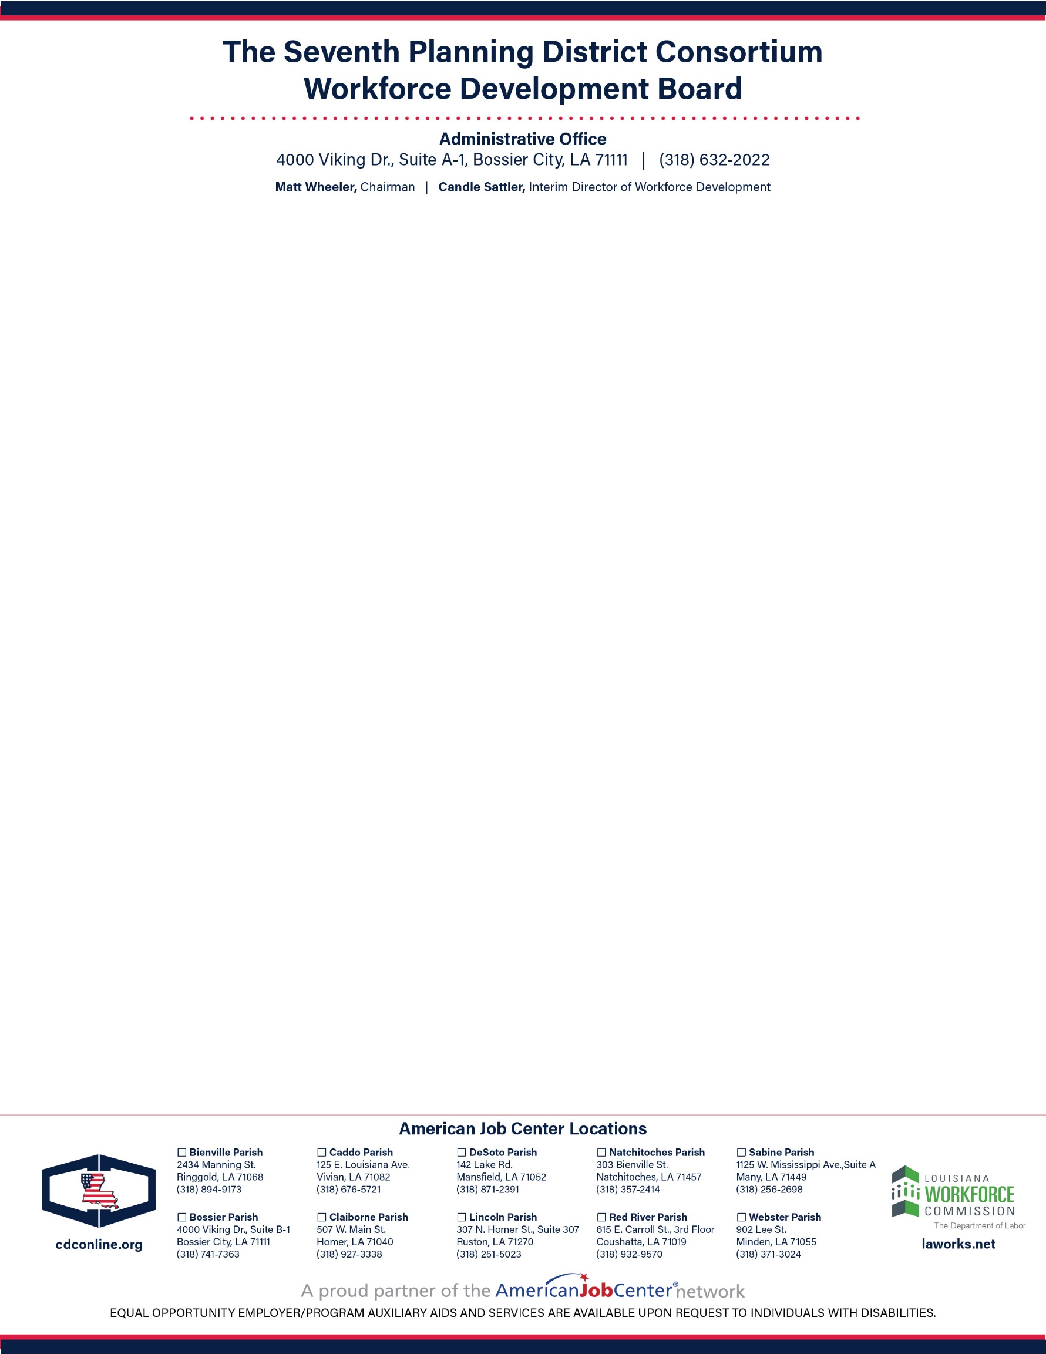

**Agenda**

**Call to Order and Welcome Matt Wheeler**

*Chairperson*

**Certification Pursuant to Gubernatorial Proclamation Matt Wheeler**

**Pledge of Allegiance to the Flag Jack “Bump” Skaggs**

*President and CEO, CDC*

**Invocation Nicholas Olsen**

*Program Manager of WIOA, CDC*

**Roll Call of Members and Introduction of Guests Julie Moore**

*Operations and Communications Manager, CDC*

**Welcome New Board Members, One-Stop Operator, and LWDA 70 Staff Matt Wheeler**

**Acknowledgment of LWDB Members Resignations Matt Wheeler**

**Nomination and Approval of New Vice-Chairperson Matt Wheeler**

**Approval of Minutes from the September 25, 2020 Workforce Development Board Meeting Matt Wheeler**

**Approval of Resolution for the Seventh Planning District Consortium Workforce Development Board Matt Wheeler**

**Approval of Fiscal Agent Service Agreement Matt Wheeler**

**Approval of Local and Regional Plan Matt Wheeler**

**Approval of LWDB 70 WIOA Policies Matt Wheeler**

**Budget and Operating Statements Candle Sattler**

*Interim Director of Workforce Development, CDC*

**Update on WIOA Performance Candle Sattler**

**Program Manager’s Report Nicholas Olsen**

**Business Service Representative’s Report Courtney Brooks**

*Business Service Representative of WIOA, CDC*

**Youth Report Chardia Veal & LLoyd Jackson ll**

*Youth Business Coordinators, CDC*

**Presentation from Eckerd Connects Jonathan Zeigler**

*Vice President of Operations*

**Other Business Matt Wheeler**

**Adjournment Matt Wheeler**