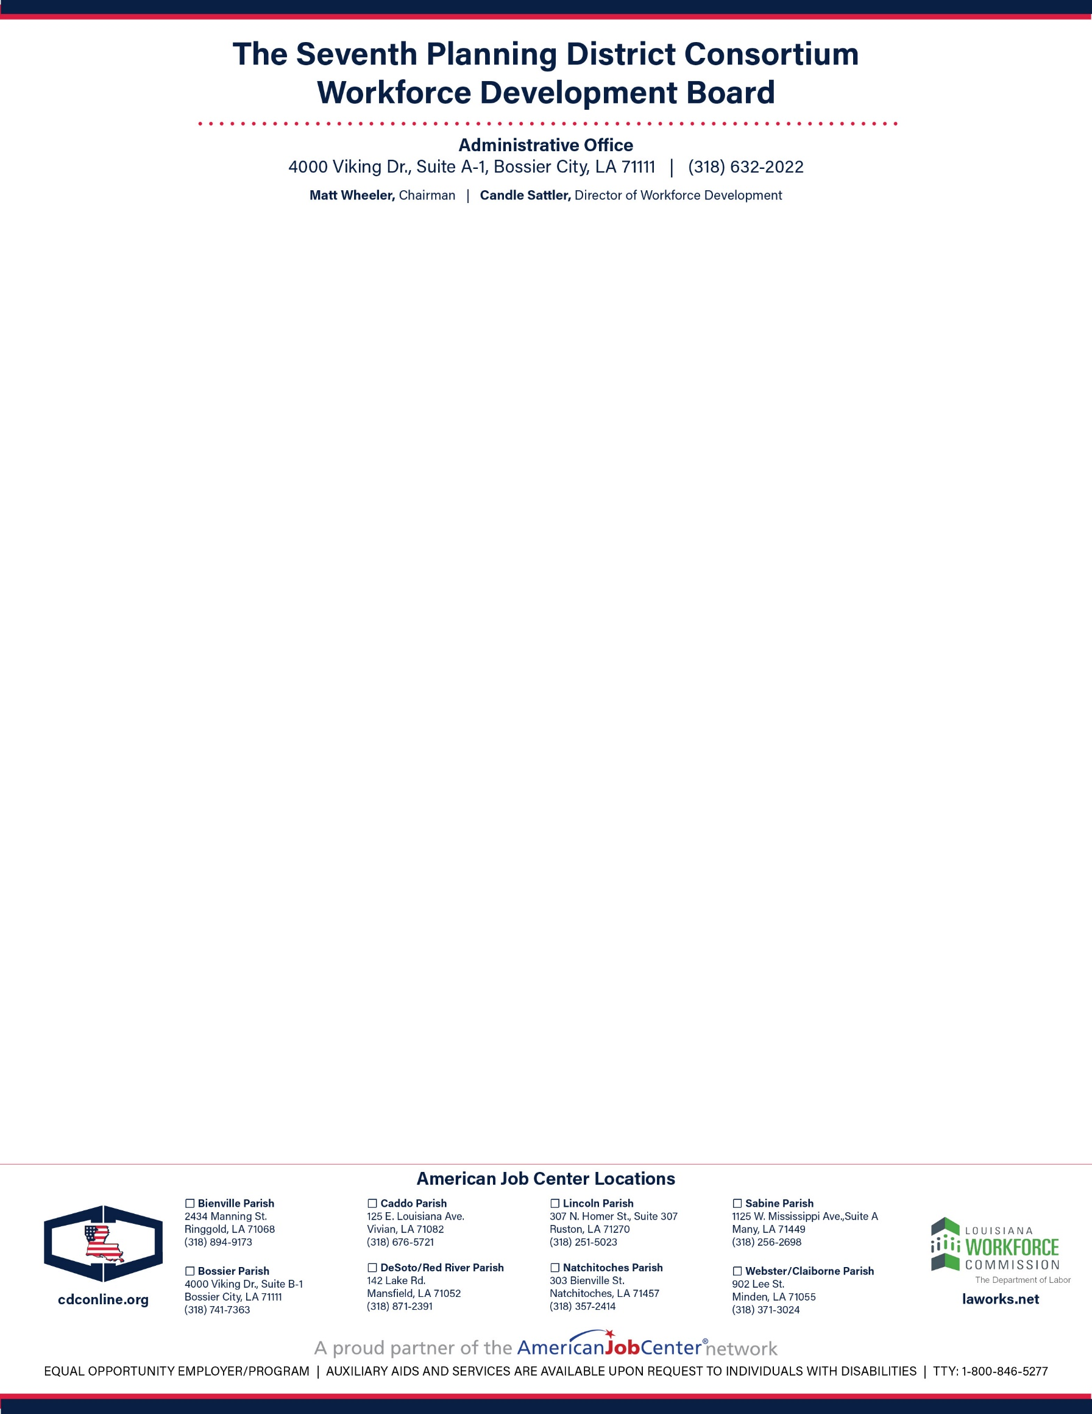

**PUBLIC NOTICE**

**THE COORDINATING AND DEVELOPMENT CORPORATION**

**Division of Workforce Development**

*Notice is hereby given to the members of The* *Seventh Planning District Consortium Workforce Development Board and the general public that the Seventh Planning District Consortium Workforce Development Board will hold a REGULAR MEETING open to the public on*

***Friday, December 2, 2022, 11:30 am***

***Warrior Network Center, 4000 Viking Drive, Suite A-1, Bossier City, LA 71111***

*Public Notice posted on Thursday, December 1, 2022*

*Copies of the agenda and directions can be obtained from Julie Moore*

*Phone: (318) 632-2022*

*Email:* [*jmoore@cdconline.org*](mailto:jmoore@cdconline.org)

*The Seventh Planning District Consortium Workforce Board and The Coordinating and Development Corporation is an Equal Opportunity Employer and will make every effort to provide reasonable accommodations for people with disabilities who wish to attend a public meeting. Please provide notification at least 72 hours before the meeting by calling (3185) 632-2022. WIOA Title I-financially assisted programs and activities are an Equal Opportunity Employer/Program. Auxiliary aids and services are available upon request to individuals with disabilities.*