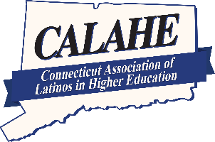
CONNECTICUT ASSOCIATION OF LATINOS

IN HIGHER EDUCATION, INC.
www.calahe.org

Verification of Financial Need
Undocumented Students Only

In order to determine eligibility for the CALAHE Scholarship, all applicants must demonstrate proof of financial need as determined by completing a FAFSA, or any alternative financial aid application provided to students who are not eligible to complete a FAFSA but would provide a means to determine financial need and establish eligibility for non-federal financial aid.

Undocumented students please use this link www.ct.edu/admission/finaid#undocumented to apply for financial aid. This application is exclusively for a specific group of undocumented students who cannot apply for federal student aid.

The Verification of Financial Need Form must be email to Wilson Luna at 70harvest@gmail.com by Friday, June 24, 2022. Your scholarship application will be considered incomplete without the Verification of Financial Need

Applicant’s Name: ______________________________________________________________

Address: _________________________________________________________________

City/State/Zip: ________________________________________________________________

Telephone Number: ________________ Cell Number: _____________________________
Email Address _________________________________________________________________
Signature: Date:

FINANCIAL AID INFORMATION

Please have your Financial Aid Office certify the following information.

Type of 2020-21 Financial Aid Application: FAFSA _____ Other _____
Student’s Cost of Attendance (COA): $
Student’s Expected Family Contribution (EFC): $
Student’s Gross Need: $

ATTESTATION OF COLLEGE FINANCIAL AID ADMINISTRATOR

I hereby state that the financial aid information requested above is true and accurate at the time of this attestation.

Name (Print):

Title (Print):

Name of College/University ____________________________________________________________________

Signature: Date:

