**Insulated Concrete Form (ICF) Construction**

Benefits:

¨ Sustainable - Long lasting, durable, impact resistant, energy efficient

¨ Resilient - Disaster resistant: fire, hurricane, tornado, strong winds, etc.

¨ Comfortable - Very quiet, draft free, constant temperature

¨ Fewer building steps/tradesmen are needed. 6 construction steps in one easy process: concrete, steel reinforcement, insulation, air barrier, vapor barrier, furring strips.

¨ Beautiful - ICF homes don’t look like storm shelters or boxes

¨ Affordable - Depending on competitive materials like wood pricing, concrete homes are affordable

Resources:

¨ ICFMA - Insulated Concrete Form Manufacturers Association  
<https://icf-ma.org/>   
ICFMA Project Profiles: homes, commercial, mid-rise, apartments, medical etc.  
<https://icf-ma.org/designing-with-icf/project-profiles/>

¨ NRMCA - National Ready Mixed Concrete Association  
Podcast including ICF’s <https://buildwithstrength.com/concrete-credentials/>

¨ BWS - Build with Strength Program  
<https://buildwithstrength.com/wp-content/uploads/2016/07/02-NRMCA-BWS-ICF-v2-Infographic-NS.pdf>

¨ Habitat for Humanity & ICF’s   
<https://buildwithstrength.com/habitat-for-humanity/>

¨ PCA – Portland Cement Association

<https://www.cement.org/cement-concrete/paving/buildings-structures/concrete-homes/building-systems-for-every-need/insulating-concrete-forms-(ICFs)>

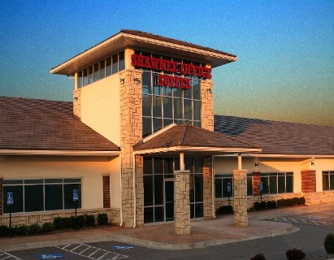

ICF Homes & Buildings, in Kansas City, in varies stages of construction.

Concrete Promotional Group, Inc. 15700 College Blvd. #103, Lenexa, KS 66219, 913-341-5800