

NATIONAL ORDER OF TRENCH RATS

Ritual and Ceremonies of a Business Meeting

**GOLDEN RODENT:** (Raps the Gavel Once)

The officers will take their respective stations and the ______ will come to order.

**GOLDEN RODENT**:

Silver Rodent, you will ascertain if the Iron Claw is in his true position and at his proper station.

**SILVER RODENT**: (Salaams)

Most Worthy GOLDEN RODENT, the Iron Claw is in his true position at his proper station.

**GOLDEN RODENT**:

Bubonic Plague and Black Plague attend. You will determine if all present are True Trench Rats by causing each one to give you the Grip of this Order, the Password or Answer, and you will carefully scrutinize the Membership Card of all those present within this ______.

(The Bubonic Plague and Black Plague., when obeying the command of the GOLDEN RODENT, will proceed from their respective stations to the end of the room at which sits the GOLDEN RODENT, they will then proceed down the room examining those present on their respective side of the room. When their task is completed they will meet at a point four paces in front of the S.R. and face about so that they may face the GOLDEN RODENT and each will report.)

**BUBONIC PLAGUE**: (Salaams)

Most Worthy GOLDEN RODENT, all present on my side of the room are Brothers in good standing. (Or not in good standing,)(or unknown.)

**BLACK PLAGUE**: (Salaams)

1

Most Worthy GOLDEN RODENT, all present on my side of the room are Brothers in good standing. (Or not in good standing,)(or unknown.)

**GOLDEN RODENT**: (Raps the Gavel three Times) Hole-y Rat. You will now recite our opening prayer. (All members will place their official fez over their hearts.)

**HOLE-Y RAT**: Let us bow our heads.

Our Supreme Commander, the God of Power and the God of Might, Please watch us through all the day and through the dark of night, While we lay in the trenches, we do want to pray, We ask your help to know just what to say. That we may be better able to perform the duties now before us, we ask for the Divine Grace. Inspire us to safeguard the interest of those who are absent as well as those who are with us in this place. May we serve well those who have placed their faith in us. Always remembering, “Semper Idem et Semper Fidelis”. Amen.

(The GOLDEN RODENT may at this stage of the proceedings pay tribute to the Flag of our beloved country. The method and manner of doing this

by placing the official fez over their heart. The hand salute will not be used.)

**GOLDEN RODENT**: (Raps the Gavel three times if not standing already) Please join with me in giving the Pledge of Allegiance to the Flag of our beloved country.

**GOLDEN RODENT**: (Raps the Gavel Once, Seating the Audience)

By virtue of the authority vested in me under the Constitution, rules and Regulations of the Imperial Council of the National Order of Trench Rats, I now declare ______ to be duly and properly convened.

**GOLDEN RODENT**:

Red-Eyed Gnawer, for what purpose are we now assembled?

**RED-EYED GNAWER**: (Salaams)

Most Worthy GOLDEN RODENT, we are assembled for the Regular Business Meeting.

**GOLDEN RODENT**:

Red-Eyed Gnawer, you will call the roll of officers.

**GOLDEN RODENT**:

Red Eyed Gnawer, you will now read in its entirety any correspondence received from Imperial.

2

**GOLDEN RODENT**:

Red-Eyed Gnawer, you will now read the minutes of the previous meeting.

**GOLDEN RODENT**:

Are there any omissions or corrections? If not, they will stand as read.

**GOLDEN RODENT**:

Red-Eyed Gnawer, you will now read the Treasurer’s Report.

**GOLDEN RODENT**:

Are there any omissions or corrections? If not, they will stand as read.

**GOLDEN RODENT**:

Red-Eyed Gnawer , is there any report on Supplies and Regalia?

**GOLDEN RODENT**:

Red-Eyed Gnawer, is there any correspondence? (Other than from Imperial)

**GOLDEN RODENT**:

Are there any Brothers ill or in distress?

**SYMBOLIC HOUR OF NINE**: (Raps the Gavel three Times)

No prayer, no salute, only silence and the proscribed ceremonies.

The Symbolic Hour of Nine-R.E.G. reads names of Brothers who died since last Rendezvous. Brothers standing in silence, lights out, then 9 strokes of chimes by R.E.G., B.R., S.R., lights on. (R.E.G. has lowest note, B.R. has middle, S.R., has highest.)

**GOLDEN RODENT**: May they rest in peace.

**GOLDEN RODENT**: (Raps the Gavel Once, Seating the Audience)

**GOLDEN RODENT**:

We will now be open to proposals for membership.

**GOLDEN RODENT**:

We will now vote on any previously proposed members who have been investigated.

**GOLDEN RODENT**:

3

We will now hear any reports from Officers and/or Committees.

**GOLDEN RODENT**:

Is there any Old Business to come before this ______?

**GOLDEN RODENT**:

Is there any Current Business to come before this ______?

(NOTE: In the ritual there is no “Good of the Order” but at this time the GOLDEN RODENT may have closing announcements or comments from Brothers present)

**CLOSING**

**GOLDEN RODENT**: (Raps the Gavel three Times)

I will now proceed to close this Rendezvous. Hole-y Rat you will recite the closing prayer.

**HOLE-Y RAT**: Let us bow our heads.

We thank you, our Heavenly Father, for the pleasure and benefits we have derived from this meeting. We implore Thee to be with us and to bless us, now and forevermore. Amen.

**GOLDEN RODENT**:

Silver Rodent, is all well in the far West?

**SILVER RODENT**:

All is well in the Far West, Most Worthy GOLDEN RODENT.

**GOLDEN RODENT:**

Brothers, the Hour Grows Late, the Smudge Pots Burn Low and the Fog Hangs Heavy o’er the Hills and Valleys. ‘Tis Time for Trench Rats to Part – Blue Rodent, how should Trench Rats Part?

**BLUE RODENT**:

With harmony prevailing and naught but good will toward his brother.

**GOLDEN RODENT**:

And so shall it be. HOLE-Y RAT what shall forever remain in the memory of all those present?

**HOLE-Y RAT**:

“Semper Idem et Semper Fidelis”.

4

**GOLDEN RODENT**:

I now declare this meeting adjourned.

5

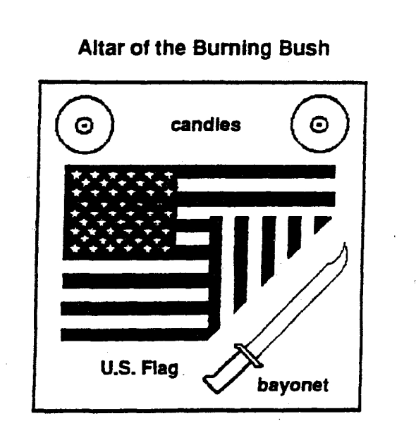

6

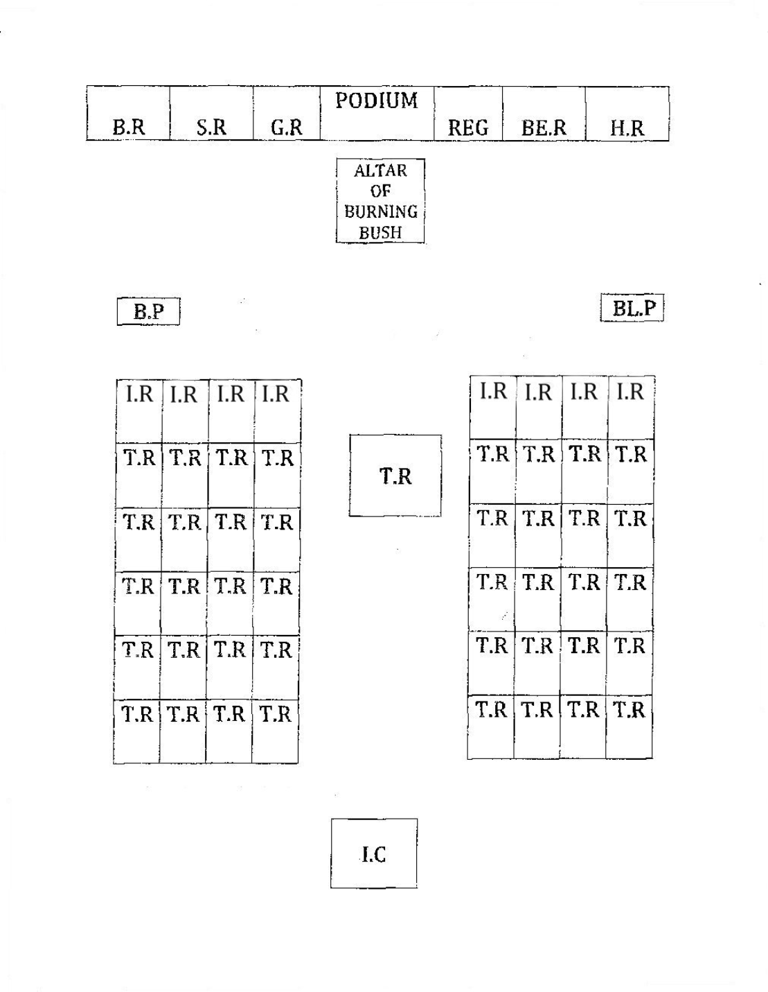Seating arrangements for the Imperial Rendezvous.

7