The Illinois Scottish Rite has given over $5 Million in scholarships over the last 15 years, awarded to individuals of all ages, allowing them to pursue or continue their education, knowing education is the stimulus for individual growth and improvement of our society.

With your financial support, we can increase the scholarship amounts and the number of scholarships awarded.

The Illinois Scottish Rite Scholarship Fund is a 501(c)3 charity, and upon completion of your donation, a printable receipt for your tax records is generated.

Scholarship Credit Card Donation Link

<https://swipesimple.com/links/lnk_7bbe7a7e>

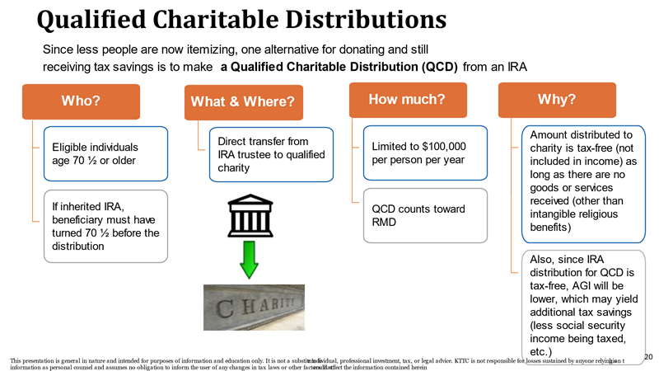

See your tax advisor about other benefits