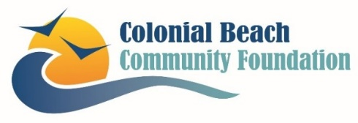

Colonial Beach Community Foundation
Michele Inderrieden
communications@cbcommunityfoundation.org
CBCommunityFoundation.org
301.646.8827

Colonial Beach Community Foundation Awards Beautification Grants

Colonial Beach, VA | June 28, 2022. The Colonial Beach Community Foundation (CBCF) recently invested more than $20,000 through its 2022 Beautification Grants cycle to nonprofit organizations in Colonial Beach for beautification projects.

CBCF designated proceeds from the 2021 3rd Annual Northern Neck Beach Music Festival and Building Community Raffle—two signature fundraising events for the Foundation—to fund the grants. “We were very pleased to use funds from the Beach Music Festival and raffle to help the Colonial Beach community,” said Cathy Bokman, Foundation Board member and Northern Neck Beach Music Festival co-chair. “People like to visit and invest in a ‘pretty’ town.”

Beautification grants include:

- $2,275 to the Colonial Beach Artists Guild to create several face-in-the-hole photo opportunity props depicting historic and iconic images.
- $2,340 to the Colonial Beach Historic Society and Museum to create an outdoor garden and seating area for presentations, meetings, and relaxation.
- $5,000 to Colonial Beach Performing Arts for updates to the building façade in the Historic District and install a marquee sign and lighting.
- $1,500 to the James Monroe Birthplace for signage and outdoor improvements.
- $9,000 to the Town of Colonial Beach for new, updated, consistent wayfinding signage.

“The Foundation’s Grants Committee was impressed by the applications we received,” said Michele Inderrieden, Foundation president. “I’m proud of the work the Foundation is doing to help follow our mission of improving the quality of life in and around Colonial Beach. It will be exciting to see these projects come to life.”

The time, talents, and treasures of many are needed to make a positive difference in Colonial Beach. CBCF offers a variety of ways someone can help, including making financial donations, volunteering for events or help on committees, setting up donor-directed funds, considering CBCF in estate planning, or simply attending meet ups and events.

The Colonial Beach Community Foundation’s mission is to improve the quality of life in around Colonial Beach through community strength, youth development, health and wellbeing, cultural enhancement, environmental protection and beautification. If you have the desire to help, please reach out to us at info@cbcommunityfoundation.org or visit our website www.cbcommunityfoundation.org. Follow the CBCF on Facebook at www.facebook.com/cbvafoundation.

