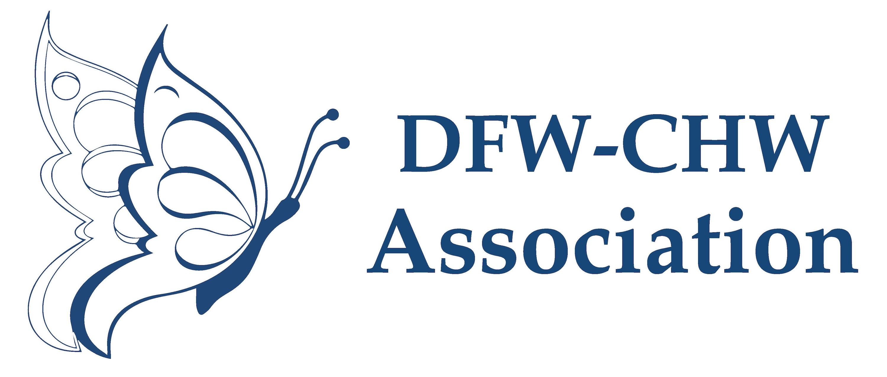

**Collaborative Initiatives/Projects**

**PAST PROJECTS**

Bi-National Health Week Symposium

* Hosted in partnership with Mexican Consulate

UT HSC Houston

* For Our Children HPV Educational Program
  + 2,443 families received HPV education and resources

KDH Research & Communication

* Dientes Fuertes, Vida Sana
* Latinos con Lupus, Promotoras con Informacion

National Association of Latino Elected & Appointed Officials (NALEO)

* Know Your Rights Workshop

Texas AHEC East Coastal Region

* P.O.T. and more (an opioid training)

Tarrant County Public Health

* Let’s Talk Health: Visual Images for Healthy Living

UTSW & Crossroads Food Pantry – BUILD Project

* CHW Training & Outreach

**CURRENT PROJECTS**

**It’s Time Texas – Living Healthier Program**

This program is funded through BCBS to provide health coaching to Texans suffering from pre-diabetes, diabetes, hypertension, chronic kidney disease (CKD), chronic obstructive pulmonary disease (COPD), and those who are smokers. CKD and COPD is a problem in the Dallas area. Living Healthier was created to address these problems by providing high quality services via Health Coaching. The free Health Coaching aims to influence health behavior change; and to empower, motivate, and provide support throughout their health journey. CHWs play a key role in reaching high-risk population and connective them with the Living Healthier program. For every registration form submitted, CHWs are reimbursed $4.00 and receive compensation for time spent at health fairs or other related events.

**Contact Tracing**

Contact tracing is a key strategy in stopping the spread of COVID-19. Contact tracing helps protect you, your family, and your community by letting people know they may have been exposed and should monitor their health for signs and symptoms of COVID-19.

The DFW-CHW Association is advocating for incorporating CHWs into the COVID-19 public health response through contact tracing and education efforts. Once CHWs complete the course offered by Johns Hopkins through Coursera, they will send their certificate to the association and let the association know if they are interested in getting connected to hiring agencies and/or participating in a follow up refresher course.

The DFW-CHW Association has been in contact with Dr. Gurley, Johns Hopkins instructor for the course, who has expressed her support for CHW training.

**La Alianza**

* Newly formed group to ensure consistent and factual communication to the Latino community regarding relevant health topics.
* Stemmed for the need for reliable COVID-19 information
* Participation in strategic planning and health pillar

**Promoting knowledge to action In COVID-19 prevention and engagement among underserved communities: The Tarrant CEAL Project**

The goal of the Tarrant CEAL project is to promote Knowledge-to-Action (KTA) of research findings related to COVID-19 by disseminating information, building organizational capacity, and implementing actionable knowledge products. The strategies identified to achieve this goal include: (1) determining factors associated with community-level misinformation and myths of COVID-19 and trust in sources of information in primarily non-white and Hispanic communities disproportionately impacted by COVID-19. 2) Assessing fears, beliefs, attitudes, knowledge about COVID-19, vaccine hesitancy, vaccine acceptance and willingness to participate in COVID-19 prevention, therapeutics, and vaccine trials. (3) Using a CBPR approach, effectively communicate and disseminate science-based educational campaigns and evaluate their impact on beliefs, attitudes, knowledge, and practices of COVID-19 prevention and reducing mistrust and increasing willingness to participate in clinical trials associated with COVID-19 prevention, therapeutics, and vaccines.

Texas CEAL Team is made up of Tarrant, Dallas, Hidalgo, Bexar, and Harris counties. In Tarrant County, the project partners include the University of North Texas Health Science Center (PI), Tarrant County Public Health, United Way of Tarrant County, YMCA of Metropolitan Fort Worth, and DFW-CHW Association.

Target zip codes: 76106, 76111,76164, 76110, 76115, 76134, 76104, 76105, 76119, 76010, 76014, and 76019

The DFW CHW Association project coordinator will:

1. Ensure project CHWs have access to the proper training materials and project documentation materials;
2. Provide the necessary PPE for safety while conducting community assessments and/or education.
3. Inform CHWs about possible venues for survey dissemination and education.
4. Provide necessary documentation for tax purposes.
5. Provide administrative and technical support throughout the project.
6. Compensate CHWs for completion of project tasks

**UPCOMING PROJECTS**

**UTSW - PA Project**

A partnership between the DFW Community Health Worker (CHW) Association with the UT Southwestern PA Program will benefit the primary care workforce in Texas, have a positive impact on the relationship between physician assistants and CHWs, and ultimately improve the health of the medically underserved in North Texas communities. Belonging to the community they serve, CHWs have intimate understanding of the complexities related to health care access, supportive services, and ability to follow-through with treatment plans. Through annual presentations to PA students beginning their clinical education, our members can inform students about the role of CHWs and the daily issues they encounter when working with underserved individuals. We will share the rewards that come with helping those who are underserved. In turn, our members will learn more about the breadth of the PA profession and their training.

**American Heart Association**

* Don’t Die of Doubt presentation – would like to offer training to CHWs
* Hands only CPR – training to encourage bystander CPR
  + Train the training opportunity
  + CPR Week – Mid June
* Donating a large kit to the association – 10 mannequins

**Center for Vision Health**

The [Center for Vision Health](http://www.centerforvisionhealth.org/), is a nonprofit optometry clinic in North Dallas generally serves individuals who traditionally face the greatest barriers when it comes to receiving vision care. All of the patients receive a comprehensive, dilated eye exam and glaucoma screening. If a patient needs eyeglasses, an on-site technician and dispensary is available. Services for someone paying out-of-pocket cost about half of what a traditional optometrist would charge, but a variety of insurance plans are accepted. The center also has a variety of grant-funded opportunities that allow them to provide the range of services for*free* to individuals who qualify. One of these active programs includes a dilated eye exam, glaucoma screening, and prescription eyeglasses for FREE for adults in North Texas who have become unemployed as a direct result of COVID. The center also frequently has funding for low-income Dallas residents, older adults, and children (who are traditionally identified through our partnership with school nurses in the metroplex).

* Would like to share resources with CHWs to disseminate to their communities.
* Would like to explore the possibility of certifying trainings on behavioral patterns and virtual screening test. Tentative training date – May 2021

**Tobacco Cessation & Referral Training**

Dallas County Health and Human Services (DCHHS) recently signed a contract with Department of State Health Services (DSHS) to implement various projects under the auspices of the Texas Asthma Control Program. One of the objectives of these projects is to facilitate the delivery of free ‘tobacco cessation and referral’ training to local area community health workers. The program believes that community health workers (CHWs) play a crucial role in promoting the health and wellness of our communities. And as such, tobacco cessation and referral training will provide them with the knowledge and supportive tools to assist those that wish to live a smoke free lifestyle and improve their health.

Customized training for CHWs to include: Tobacco 101, How to Quit, Cessation Navigation, Navigator Training, Lunch Cancer, Resources to Quit. Training will be half a day in late Feb and will be provided by the American Lung Association.

The DFW-CHW Association will assist in disseminating training information to members and contacts to recruit participants for the training. This association will promote during first member meeting.

Also expressed an interest in submitting training for CHW CE certification, and exploring future collaborations with the association.