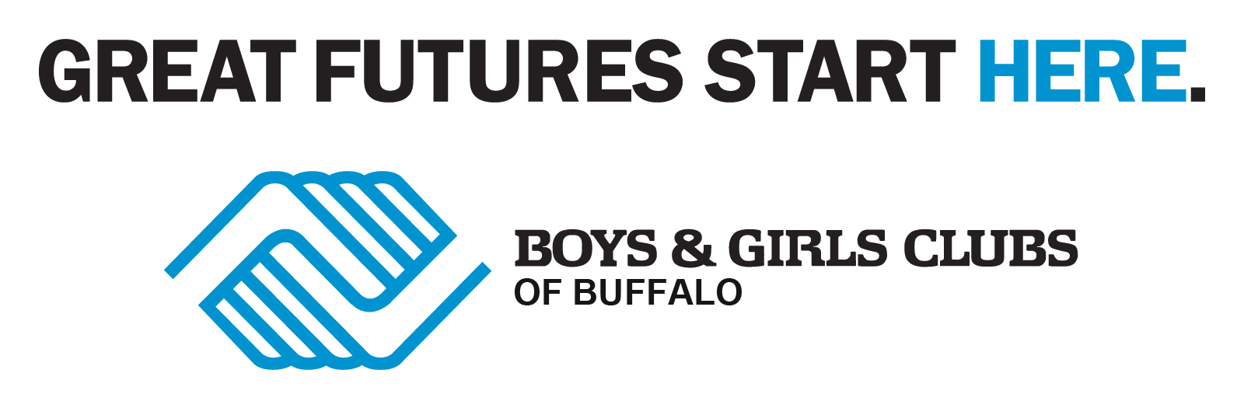

Youth Development Professional
Title: | PART-TIME
Department: | Program
Reports to: | Directors and Assistant Directors
Location: | Various Locations
Salary: | $15 p/hr.
Travel: | Possible travel between sites and on field trips using agency vehicle to perform necessary functions of position.
Shift Hours: | Summer - Flexible hours between 8:00am – 6:00pm  School Year – Flexible hours between 2:00pm – 9:00pm  Some Weekends
Benefits: | No benefits
Reply to: | Human Resources  282 Babcock St  Buffalo, NY 14210  careers@bgcbuffalo.org
Closing Date: | Open
Applicants: | - Valid NYS Driver’s License for 1 years is required  - 18 Years of Age  - High School Diploma or GED Equivalency

Health & Life Skills Youth Development Professional : This part-time position require that candidates have strong organizational and communication skills - both written and verbal, experience working with youth ages 6-18 and the ability to plan and implement programs in the specific core area of Health & Life skills. Must be an active, energetic, hands-on person able to handle large and small groups and must possess a valid NYS driver’s license. HS diploma required. CPR and First Aid training is a plus.

Character & Leadership Development Youth Development Professional: This part-time position require that candidates have strong organizational and communication skills - both written and verbal, experience working with youth ages 6-18 and the ability to plan and implement programs in the specific core area of Character & Leadership Development. Must be an active, energetic, hands-on person able to handle large and small groups and must possess a valid NYS driver’s license. diploma required. HS diploma required. CPR and First Aid training is a plus.

Boys & Girls Clubs of Buffalo is an Equal Opportunity Employer

