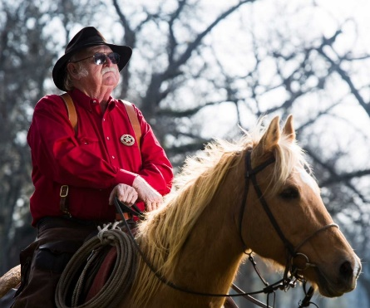

**Jim Hubbard Faithful Trail Rider Award**

Jimmy “Jim” Hubbard was a beloved and long-term member of the Valley Lodge Trail Ride for over 40 years, serving as Trail Boss from 2013 to 2016. Jim’s unwavering commitment and dedication were hallmarks of his involvement, as he never missed a trail ride regardless of the conditions. Through foul or fair weather, Jim was a steadfast presence, always mounted on horseback and ready for the trek.

Jim’s reliability and devotion were evident in every aspect of the trail ride. Whether it was helping to plan routes or working with landowners, Jim was always there to lend a hand. His consistent participation and readiness to assist made him a pillar of the Valley Lodge Trail Ride. Jim’s dedication ensured that the trail ride ran smoothly and that everyone felt supported and encouraged.

The Jim Hubbard Faithful Trail Rider Award honors his legacy by recognizing those who display the same unwavering commitment and reliability that Jim embodied. This award celebrates individuals who, through their steadfast presence and dependable nature, enhance the experience and continuity of the Valley Lodge Trail Ride. By showing their dedication and willingness to go the extra mile, they continue Jim’s tradition of being the reliable backbone of the trail ride community.

|  |  |  |
| --- | --- | --- |
| **Award** | **Year** | **Recipient** |
| Jim Hubbard Faithful Trail Rider Award | 2023 | Conner Hedegaard |
| Jim Hubbard Faithful Trail Rider Award | 2024 | Beth Arlington |