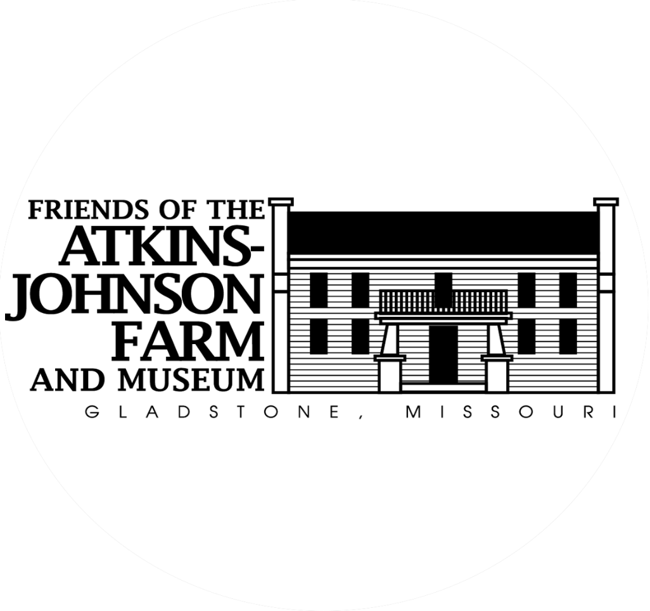

Big Shoal Country Fair September 28th, 2024

# Exhibitor/Vendor Registration

Please complete this application to join this year’s great lineup of live Bluegrass, food, carnival games, kids activities, a petting zoo, and old-fashioned family fun. Booth spaces will cost $30 this year. See vendor rules & regulations below for more details. All proceeds from this event will help support the mission of the Friends of the Atkins-Johnson Farm and Museum.

**The application deadline is September 6th, 2024.**

For questions or additional information please contact (816)-454-1519 or email [friendsofajf@gmail.com](mailto:friendsofajf@gmail.com)

**~Big Shoal Country Fair Vendor Registration~**

Company’s Name: ___________________________________________________________________

Contact’s Name: _____________________________________________________________________

Mailing Address: ___________________________________________________________________________________

Phone: _____________________________________________________________________________

Email: _____________________________________________________________________________

Product Description (please attach photo): _________________________________________________

Will you be doing any demonstrations? Yes _____ No_____

If so, what kind? ________________________________________________________________

Will you be using a canopy? Yes _____ No_____ (Canopies/tents, table, and chairs will not be provided by the fair)

Number of booths (booth size: 10ft x 10ft): ______ $30/booth

Social Media Tags (optional):_____________________________________________________________

# Payment Options (check one):

# Payment by credit card:

# Go to <https://friendsoftheatkins-johnsonfarm.org/online-payments-membership-fair-vendors> Please then email the completed registration form to [friendsofajf@gmail.com](mailto:friendsofajf@gmail.com).

# Payment by check:

# Mail your application and check to Friends of the Atkins-Johnson Farm & Museum P.O. Box 28846, Kansas City, MO 64188

Big Shoal Country Fair 2024

**Vendor Rules and Regulations**

**The Big Shoal Country Fair will operate from 10:00 AM – 4:00 PM, September 28th, 2024 At the Atkins-Johnson Farm and Museum 4109 NE Pleasant Valley Rd, Gladstone, MO 64119**

1. **General Provisions**
   * If the event coordinators decline your application and payment has already been made, a full refund will be given.
   * No pets will be allowed on the fairgrounds for the duration of the event.
   * No open flames are permitted on the property.
   * No moving vehicles will be permitted on the grounds during the operational hours of the event, from 10:00 AM - 4:00 PM.
   * If the event is canceled due to inclement weather before the start of the event, full refunds will be given via check mailed to the listed address on the vendor application.
2. **Vendor Rules**
   * After applications are received and approved, vendors will be assigned an unloading time between 7:00 AM – 9:00 AM. Please adhere to the time assigned to you as maneuvering space is limited.
   * Vehicles will be permitted to pull in to unload only. Vehicles must be moved to the designated parking area on the property before setting up booth space.
   * Booth must be torn down and ready to load before vehicles are allowed back on the property.
   * No vehicles may remain on the property during hours of operation.
   * Instructions and directions for entrance will be provided when unloading times are assigned.
   * Farmer’s Market participants **only** will be allowed to park on the property because they work from their vehicles.
   * Booths are to be manned during all hours of operation. Early tear-down will not be permitted.
   * Merchandise – At no time shall a vendor display for sale any material or item which, in the sole judgment of the event coordinators, shall be deemed obscene, dangerous, unlawful, or inappropriate. Specifically, drug paraphernalia, anything depicting or promoting drug use, profane or inciteful verbiage, or depictions are prohibited.
3. **Booth Space/Construction**
   * Booth space will be 10x10 ft.
   * The event generally does not provide canopy/tents, tables, or chairs. Shade cannot be guaranteed if you do not provide your own covering. However, event coordinators will do their best to place vendors appropriately.
   * If a trailer is used in a booth space it must fit within the booth space.
   * Event coordinators reserve the right to remove a booth from the Fair if it is constructed in an unsafe manner.
   * Subleasing - Subleasing of any or all assigned booth space by the vendor is strictly prohibited

**Insurance – Any vendor selling consumable food items must provide a certificate of insurance naming the city of Gladstone, The Atkins-Johnson Farm Limited Partnership, and the Friends of the Atkins-Johnson Farm and Museum as additional named insured. This must be provided before the date of the Fair. Compliance with Clay County, MO Health Department criteria is also required.**  **Insurance proof must also be provided to Gladstone City Hall**

(rev 04/1/2024)