  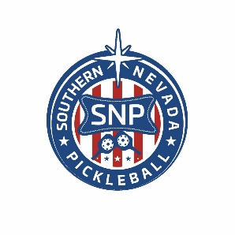
  Southern Nevada Pickleball Logo
  The Southern Nevada Pickleball emblem or seal is already well known in the community.



  
  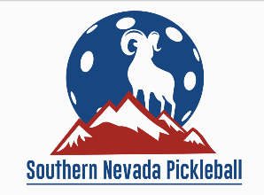
  Desert Bighorn
  The big horn sheep became our mascot subsequent to a membership contest in the first two quarters of 2022.
  We asked a graphic designer to expand on the concept and the results are presented here.
  Expect to see "Desert Bighorns" at venues across Southern Nevada sporting these images.

  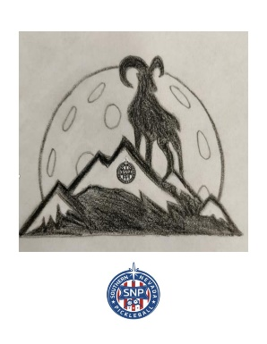
  Mascot Concept
  The mascot concept for the desert bighorn came from the Andrew Tam family.
  They received a $250 prize for submitting the winning idea with an original drawing pictured here.

