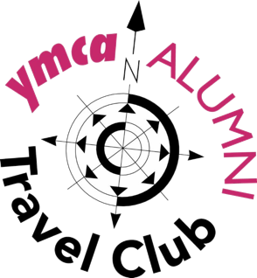

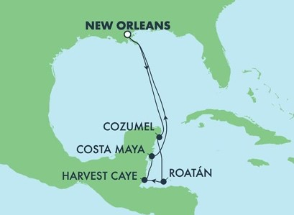

Day-By-Day Itinerary: A Caribbean Reunion

Sunday, Jan 16: Depart Port of New Orleans at 4 p.m.

Monday, Jan. 17: Spend a relaxing day at sea aboard the NCL Breakaway cruise liner.

Tuesday, Jan. 18: Arrive at Costa Maya, México at 10 a.m. Costa Maya Port offers a wide range of shore excursions. It combines adventure and
relaxation on every slice of paradise available on site. The port is in a privileged area fed by the clear turquoise waters of the Caribbean Sea. You will find colorful lagoons and a rich variety of native flora and fauna in this zone. Depart 6 p.m.

Wednesday, Jan. 19: Arrive at Harvest Caye (pronounced "Key"), Belize at 8
a.m. Owned by NCL, the private island of Harvest Caye is absolutely beautiful. Restaurants, bars, shopping, swimming, walkways through beautiful flowers, an amazing clean beach with hundreds of lounge chairs and lifeguards. Depart 5 p.m.

Thursday, Jan. 20: Arrive at Roatán, Honduras at 8 a.m. Roatán is the largest and most developed of the Bay Islands. Long and thin the island is a diving and snorkeling paradise – virtually its entire coastline is fringed by an astonishingly diverse coral reef teeming with tropical fish. Depart 5 p.m.

Friday, Jan. 21: Arrive at Cozumel, México at 9 a.m. One of the top diving destinations in the world for its bright storybook coral reefs, the island
of Cozumel is also home to a variety of natural beaches. Choose a beach with soft white sand for relaxing, or snorkel off a rockier vista. The Mayan Ruins of the Yucatan Peninsula are truly a treasure to behold. These lost cities hail back to as many as 2,000 years ago. Depart 6 p.m.

Saturday, Jan. 22: Enjoy another relaxing day at sea before, alas, we head back to the real world tomorrow.

Sunday, Jan. 23: Arrive at the Port of New Orleans at 7 a.m. Disembark.

Details:

What will it cost?
There are two amenity packages available for Ocean View and Balcony cabins. Choose one. Package pricing is for TWO people, taxes/fees are included. Regular gratuities and optional travel protection insurance is additional. Insurance may be adjusted to include airfare, hotel and other non-refundable items and is priced per person. Discuss your options and get questions answered with your GoTravel agent when booking.

Amenity Package 1:
Premium Beverage Package (Mandatory service charge added of $138.60 per person); Dining Service Package – 2 nights (Mandatory service charge added of $15.80 per person); Choice Shore Excursion Credit - $50 per port; WiFi – 250 Minutes; $100 onboard credit per cabin 5th Bonus amenity

Amenity Package 2:
$100 per cabin onboard credit; Choice Shore Excursion Credit - $50 per port; WiFi – 250 Minutes; 10 Photo package; $100 onboard credit non-refundable per cabin (Oceanview and above) 5th Bonus Amenity.

Balcony:
Package 1: $2,764.80 per two people. Insurance: $112 per person
Package 2: $2,456 per two people. Insurance: $112 per person

Ocean View:
Package 1: $2,540.80 per two people. Insurance: $112 per person
Package 2: $2,232 per two people. Insurance $112 per person

Ask your GoTravel agent about Interior, Mini Suites, Suites or for triple, quad, quint pricing.

YMCA Alumni hosts:

Larry and Debbie Garvin of the Willis Chapter. Larry is YMCA Alumni Vice President/East and Chair of Reunion '22.

