My symptoms started with weight gain, tiredness, hair loss and constipation. Next I started noticing smelly urine, dry hair and skin, muscle aches and weakness, slow movements and thought, extreme feelings of cold and I missed my period. My GP ordered blood work, and the results flagged my Thyroid Stimulating Hormone (TSH) levels 25. Healthy level is 2.5. As a result I was diagnosed with Hypothyroidism (underachieve thyroid) and elevated cholesterol levels in November 2020. Doctor explained it is an autoimmune disease and I will need to take hormones for the rest of my life to balance the Thyroid Hormone. I began treatment with Kim at the end of November 2020. 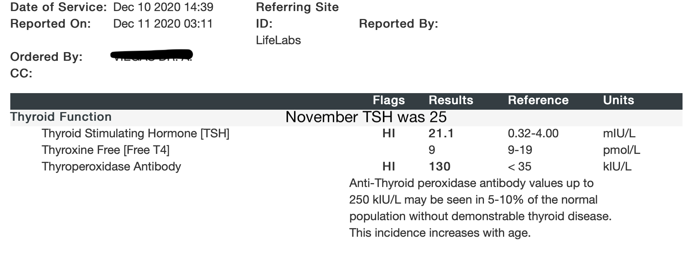

My blood test follow up 2 weeks into treatment shows TSH drop to 21.1. I noticed slight improvement in energy levels and sensitivity to cold.

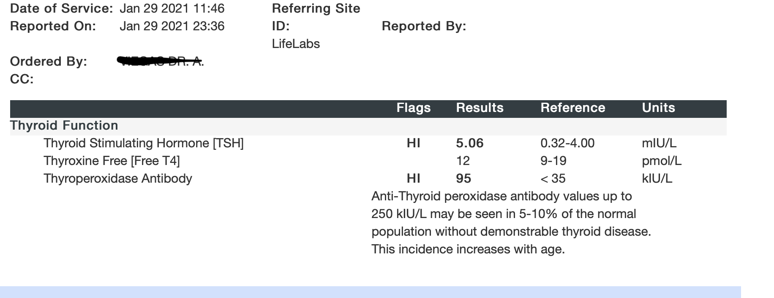

Next blood test follow up my TSH levels dropped to 5.06 and the antibody to 95. I’ve lost 7 lbs, and symptoms improved significantly.

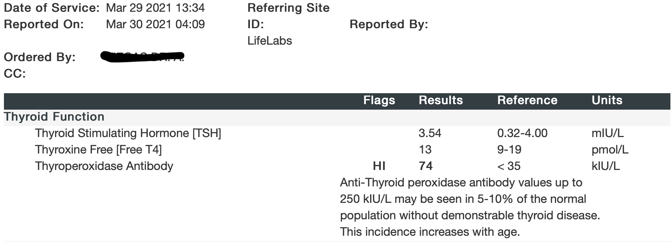

My latest blood test (3.5 months into treatment) shows TSH levels at 3.54 which is within the normal range and the antibodies dropped to 74. My menstrual cycle restarted after 5 months of missed periods. The brain fog is gone, bowel movement more regular and energy levels much higher.