Program Notes

Music was an essential aspect of the theatrical experience in Elizabethan England. Shakespeare’s plays contain songs that would have been well known to his audiences, including folk melodies and songs by eminent composers.  Plays would be preceded by a concert, often lasting as much as an hour. After the play had concluded, the actors would gather on stage, often rising from the place at which they had just “died,” to dance a *jig*, not necessarily the lively dance that we associate with that name. Among the most common instruments in Elizabethan England were the viols, recorders, harpsichord, organ, and lute.

Gervaise

“Greensleeves to a Ground” was published in *The Division Flutist* (1706). Although appearing well after Shakespeare’s death, this selection demonstrates the enduring popularity of many Elizabethan-era melodies, as well as the practice of improvising virtuosic variations over a repeated progression of harmonies.

Sweelinck

William Byrd was one of the great masters of European Renaissance music. He was also an important and influential teacher, among whose students was Thomas Morley.  His most significant positions were as organist and choirmaster at Lincoln Cathedral beginning in 1563, and as a Gentleman of the Chapel Royal in 1572.

Orlando Gibbons

Thomas Morley was an important composer, theorist, organist, and publisher

Anthony Holborne

Mockingbird Early Music Ensemble

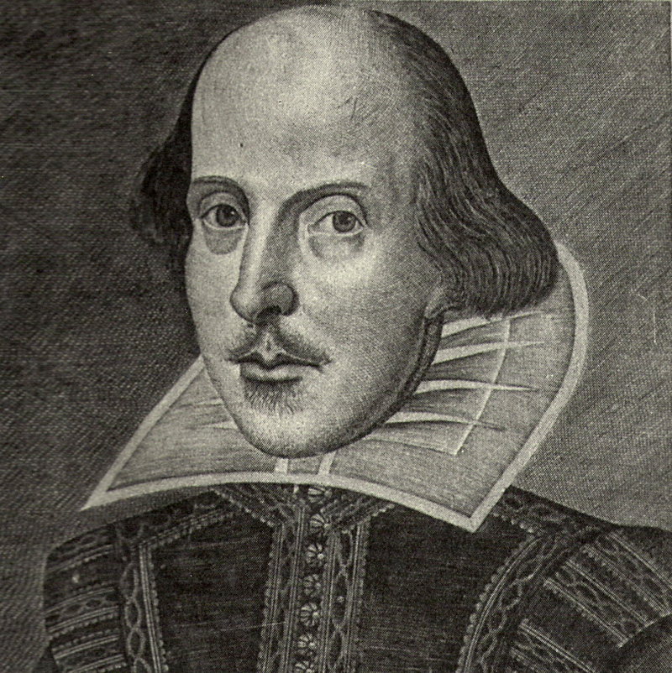

## Music in the Time of Shakespeare

Celebrating the 400th Anniversary of the publication of the 1623 Folio

## Wednesday, November 8, 2023

## 2:00 pm

### Archives and Special Collections

J. D. Williams Library

### The University of Mississippi

*Oxford, MS*

**The Performers:**

Irene Kaufmann Cotelo, *Recorders*

Susan Marchant, *Viola da Gamba and Recorders*

Warren Steel, *Harpsichord, Recorders, Baroque Guitar*

Ronald Vernon, *Viola da Gamba and Recorders*

www.mockingbirdensemble.org

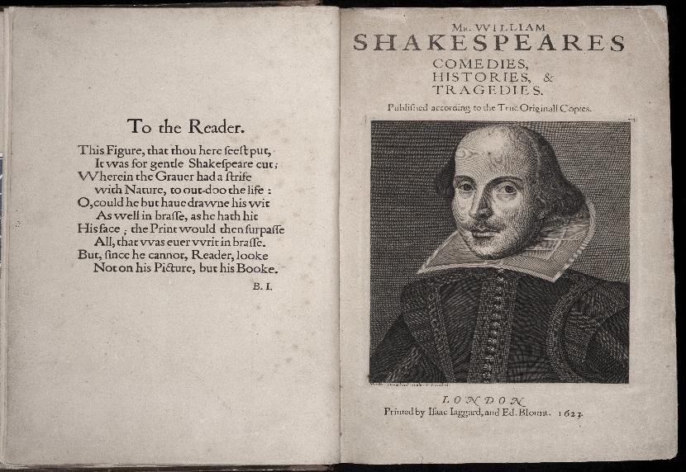

**For more information, may we suggest:**

American Recorder Society: www.americanrecorder.org

Early Music America: www.earlymusic.org

Viola da Gamba Society of America: www.vdgsa.org

Ross Duffin, “Shakespeare’s Songbook,” W.W. Norton & Co., 2004

**The Program**

Pavane d'Angleterre …………… Claude Gervaise (ca. 1510-1560)

avec sa Gaillarde

Greensleeves to a Ground …………………………………. Anon. (1706)

The Carman’s Whistle ……………………… William Byrd (1543-1623)

Two Fantasias for 3 viols ………………………………….. Byrd

Engelse Fortuyn …….... Jan Pieterszoon Sweelinck (1562-1621)

SwWV 320

Two Fantasias for 3 viols ……….. Orlando Gibbons (1583-1625)

Fantasy ………………….………… Thomas Morley (1557-1602)

*from Plain Introduction to Music*

Honie-suckle …………….…….. Anthony Holborne (1545-1602)

Fairie-round