Program Notes

Music was an essential aspect of the theatrical experience in Elizabethan England. Shakespeare’s plays contain songs that would have been well known to his audiences, including folk melodies and songs by eminent composers.  Plays would be preceded by a concert, often lasting as much as an hour. After the play had concluded, the actors would gather on stage, often rising from the place at which they had just “died,” to dance a *jig*, not necessarily the lively dance that we associate with that name. Among the most common instruments in Elizabethan England were the viols, recorders, harpsichord, organ, and lute.

William Byrd was one of the great masters of European Renaissance music. He was also an important and influential teacher, among whose students was Thomas Morley.  His most significant positions were as organist and choirmaster at Lincoln Cathedral beginning in 1563, and as a Gentleman of the Chapel Royal in 1572.

“Greensleeves to a Ground” was published in *The Division Flutist* (1706). Although appearing well after Shakespeare’s death, this selection demonstrates the enduring popularity of many Elizabethan-era melodies, as well as the practice of improvising virtuosic variations over a repeated progression of harmonies.

*Der Fluyten Lust-hof (The Flutist’s Pleasure Garden)* by Jacob van Eyck is a collection of about 140 solos for soprano recorder, including variations on well-known melodies and psalm tones, as well as freely composed fantasies. It is the largest publication of unaccompanied recorder solos known and an invaluable resource for understanding the art of ornamentation as practiced in the 16th and 17th centuries.

The story of *Daphne* comes from Ovid’s *Metamorphoses*, translated into English by Arthur Golding and published in 1567.

The Manchester Lyra-viol Book is a late 17th century manuscript located in the Manchester (UK) Public Library.  It is the largest collection of solo viol music from the period, containing some 258 compositions.

Tielman Susato opened the first music publishing house in the Netherlands using movable type in 1543. He also composed or arranged instrumental works, and his *Danserye*, published in 1551, was well-known in England.

Thomas Morley was an important composer, theorist, organist, and publisher. His famous setting of “It Was a Lover and his Lass” is one of only two musical settings of Shakespeare’s own verse.

Mockingbird Early Music Ensemble

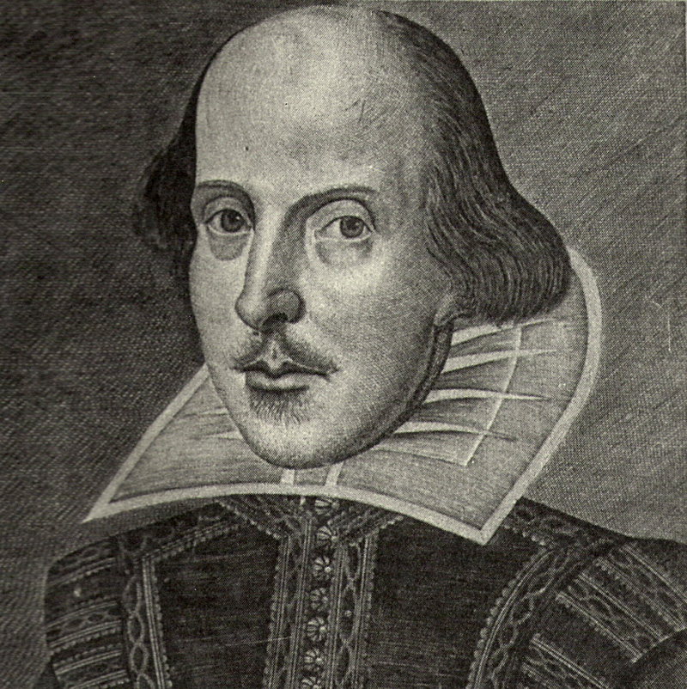

## Music of Shakespeare’s Theatre

In conjunction with the Folger Shakespeare Library touring exhibition *First Folio! The Book That Gave Us Shakespeare*

## Sunday, May 1, 2016

## 3:00 pm

### Nutt Auditorium

### The University of Mississippi

*Oxford, MS*

**The Performers:**

Irene Kaufmann, *Recorders*

Susan Marchant, *Viola da Gamba and Recorders*

Jos Milton, *Tenor*

Warren Steel, *Harpsichord, Recorders, Baroque Guitar*

Ronald Vernon, *Viola da Gamba and Recorders*

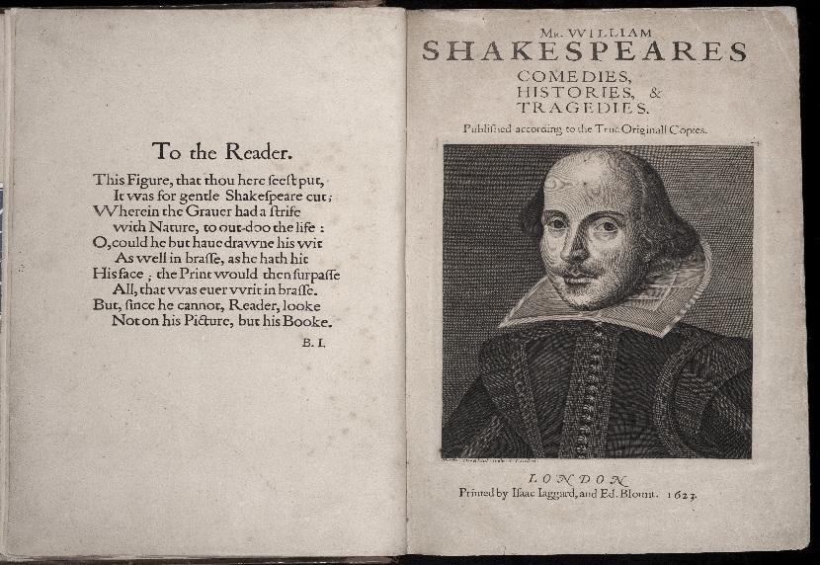

**For more information, may we suggest:**

Folger Shakespeare Library: www.folger.edu

American Recorder Society: www.americanrecorder.org

Early Music America: www.earlymusic.org

Viola da Gamba Society of America: www.vdgsa.org

Ross Duffin, “Shakespeare’s Songbook,” W.W. Norton & Co., 2004

www.mockingbirdensemble.org

**The Program**

It was a lover and his lass ………….Thomas Morley, *First Book of Ayres*

As You Like It (1600)

The Carman’s Whistle ………………………… William Byrd (1543-1623)

Henry IV

Goe from My Window ………………..…… Richard Alison (*fl* 1592-1606)

Lucrece

Greensleeves ………………..…….……. arr.by Gerald Moore (1939-2010)

Greensleeves to a Ground ……………………………………. Anon. (1706)

Merry Wives of Windsor

Fortune My Foe …………………………..…….………… William Byrd

Merry Wives of Windsor

When Daphne from fair Phoebus did fly ……………..…. Anon. (17th cen)

Daphne (Der Fluyten Lust-hof, 1644) …... Jacob van Eyck (ca.1590-1657)

Theme, Variations 1, 2, 3

Midsummer Night’s Dream, Taming of the Shrew

Whoope doe me no Harme . Richard Sumarte (Manchester Lyra-viol Book)

A Winter’s Tale

Ronde and Salterelle ………………….. Tielman Susato, *Danserye* (1551)

Heart’s Ease ……………………………………..…. arr. by Gerald Moore

Romeo and Juliet

When Griping Grief ……………….….….. Richard Edwards (1524-1566)

Romeo and Juliet

Pavane II and Gaillarde VIII: *La dona* …………………. Susato, *Danserye*

A Robyn, Gentil Robyn …………..…….. William Cornysh (died c. 1523)

Twelfth Night

Aire ………………………………………….. Thomas Morley (1557-1602)

O Mistress Mine ………………….……………………………… T. Morley

Twelfth Night