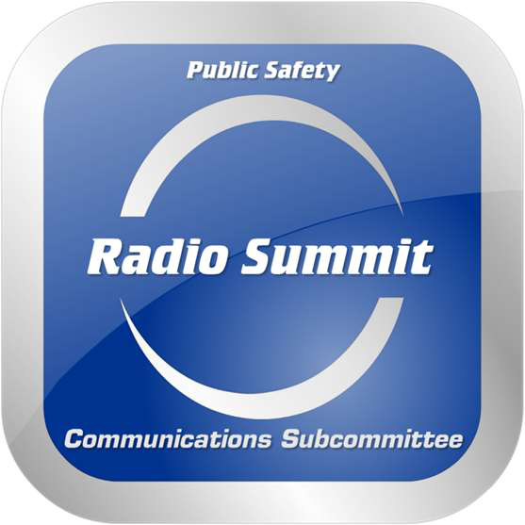

DESCRIPTION

The 2023 Statewide Public Safety Radio Summit (“Summit”) will be held on May 3-4, 2022. The Planning Committee is looking for dynamic speakers with great stories and insights about what's new and relevant in the world of communications technology to present at the Radio Summit.

**Benefits:**

|  |  |
| --- | --- |
| - - - | **Free** - admission to the event  **Exposure** - for you and your company to speak before your industry peers  **Publicity** - the Statewide Radio Summit promotes you, your company and your presentation to |

its attendees through a promotional campaign

|  |  |
| --- | --- |
| - | **Networking** - with peers and an opportunity to provide insight to them. |

**Submission Guidelines:**

What We Are Looking For…   
Timely, relevant, future-thinking insights, research, trends and educational topics that are driving the public safety communications industry. The Summit’s attendees come from all levels of government, and public safety organizations including, but not limited to, law enforcement, fire services, emergency medical services, 9-1-1 dispatch, transportation. Please understand that the Summit is an educational and training opportunity, not a marketing and sales event.

**DEADLINE FOR SUBMISSION: March 1, 2023**

**TIPS:**

|  |  |
| --- | --- |
| - - - | Don’t submit pitches/PR sessions promoting your firm or product.  Please complete the proposal form as thoroughly as possible.  Proposals will be grouped with other like topics to provide a broader viewpoint from several |

sources within a topic.

|  |  |
| --- | --- |
| - | Topics and speakers are selected based on overall relevance to the Summit’s audience. |

**Terms & Conditions**

As a speaker at the Statewide Public Safety Radio Summit, you have committed to present this session, and all the preparation that it entails. In return, the Summit leadership agrees to promote you, your company and your presentation to its attendees through a promotional campaign. Both you and the Planning Working Group have made a promise to our attendees to deliver the session as published, including the topic and the speaker.

**Terms & Conditions Cont.**

By presenting, you acknowledge and agree that the working group shall have the non-exclusive worldwide right, in perpetuity, to record, copy, reproduce, display, distribute and otherwise use, for the Summit’s account, all or any portion of the content of your presentation (the “Licensed Material”), in audio, video, written and/or any other format or medium, whether now existing or hereafter developed. In conjunction with any such use by the Summit, both agree to make commercially reasonable efforts to provide an attribution of your ownership of the underlying Licensed Material, and, in any event, none of the foregoing shall limit your ability to use your own copies of the underlying Licensed Material for your own purposes, whether commercial or otherwise.

It is imperative that your presentation is not a sales pitch for you or your company. No speaker may use a conference session for commercial sales pitches, self-promotion or unfair criticism of a competitor. If it is determined that a speaker presented a sales pitch or criticism, that company and speaker will be excluded from future events.

Please direct any questions to Jeff Vaughn, Summit Planning Committee:

[jvaughn@dcsheriff.net](mailto:jvaughn@dcsheriff.net) or 303-660-7506.

2

|  |  |
| --- | --- |
|  | Public Safety Radio Summit  **Presentation Data Sheet** |

Please complete this form if you wish to submit a topic for the Radio Summit. For additional presenters for your topic, please complete a separate form with their information. Submit the completed form(s) by email to   
**jvaughn@dcsheriff.net**. Once a determination has been made whether the presentation is accepted, the presenter will be notified by **March 1, 2023.**

|  |
| --- |
| **Presenter Information** |

Name: 

Organization: 

Address: 



Email:  Phone: 

|  |
| --- |
|  |

**Presenter Information**

|  |  |  |
| --- | --- | --- |
| Biography: | |  | | --- | |  | |

|  |
| --- |
| PRESENTATION INFORMATION |

Session Title



Session Description: