David Stockwell
Evangelistic Association
P.O Box G Katy, Texas 77492 USA
281-391-8777
www.davidstockwell.org

DSEA Philippines
presents

Victorious Life! Leadership Development & Evangelism Training Conference

Equipping Leaders for
Evangelistic Ministry

November 8-9, 2019
Grand Harvest Ministry Sanctuary
Barangay Maahas, Purok K
Los Banos, Laguna, Philippines

Training Conference Packet

Victorious Life!
Leadership Development & Evangelism Training Conference
Equipping Leaders for Evangelistic Ministry

A Ministry of David Stockwell Evangelistic Association
Evangelist David Stockwell is now in his 50th year of serving God in full-time evangelism, traveling internationally and managing his own faith ministry since committing his life to full-time service at the age of 17.
David employs a variety of evangelistic strategies in differing outreach circumstances. David has preached the Gospel throughout the USA and in many nations worldwide. Multitudes of people have prayed to receive Jesus Christ under the preaching ministry of David Stockwell.
David seeks opportunities to train and disciple people who are gifted and called to preach and committed to evangelism. The Victorious Life! Leadership Development & Evangelism Training Conference provides an opportunity for people to receive practical and applicable training in the work of field evangelism, as well as in their spiritual walk.

Leadership Development and the Victorious Christian Life
The Bible declares in I Cor. 15:57: “Thanks be to God, Who gives us the victory through our Lord Jesus Christ!” We ALWAYS have victory in our lives through the birth, life, suffering, shed blood, death, burial and resurrection of our Lord Jesus Christ, the only begotten Son of God, our Savior, our Redeemer, our Lord. Jesus tells us in John 10:10: “I have come that they may have LIFE, and have it more abundantly!”

God means for you to live a Victorious Life! As we study together this weekend, we will look at many aspects of the Christian life, and how to have VICTORY in your life. That includes overcoming Satan by the word of your testimony, and understanding that the blood of the Lamb of God, Jesus Christ, gives us that ability to be victorious.

It also means we must learn to give everything we have and everything we are to Christ, and to be willing to sacrifice everything for His sake and for the sake of the Gospel. Revelation 12:11 says: “And they overcame him (Satan, the devil) by the blood of the Lamb and by the word of their testimony, and they did not love their lives to the death.”

As Christians, we are called to learn, to grow, and to become mature in our faith. Leaders are mature Christians, and are also servants. Jesus humbled Himself and became a Servant. Jesus said in John 13:14, “If I then, your Lord and Teacher, have washed your feet, you also ought to wash one another’s feet.” Philippians 2:8 tells us: “And being found in appearance as a man, He humbled Himself and became obedient to the point of death, even the death of the cross.”

Christian leaders joyfully serve other Christians as they serve the Lord. They are mature, trustworthy, faithful, honest, dependable and self-less. The scripture is clear; Mark 8:34-38 tells us in Jesus’ own words:

“If anyone would come after Me, he must deny himself and take up his cross and follow Me. For whoever wants to save his life will lose it, but whoever loses his life for My sake and for the gospel will save it.

What good is it for a man to gain the whole world, yet forfeit his soul? Or what can a man give in exchange for his soul? If anyone is ashamed of Me and My words in this adulterous and sinful generation, the Son of Man will be ashamed of him when He comes in His Father’s glory with the holy angels.”

Our duty and responsibility before God is to deny ourselves, to take up the cross of Christ, and to live for Him. Our first responsibility to Him is to love Him and secondly, to love others in the same way we love ourselves. The scripture tells us in Luke 10:27: “‘You shall love the LORD your God with all your heart, with all your soul, with all your strength, and with all your mind,’ and ‘your neighbor as yourself.’”
If we love Jesus Christ, then we will obey His commandments, and if we love others, we will serve them, and realize that if any person does not know Christ, then he is going to spend eternity in hell forever, without God, in the tormenting flames of hell. We must do everything we possibly can to tell every person about Jesus, and to evangelize the world.
To live a Victorious Life! of abundance that is pleasing to God, we must:
- Love God with all our heart, soul, mind, and strength
- Follow Christ, obey His commandments, worship Him
- Repent from sin, allow Jesus to change us and purify us through brokenness
- Overcome Satan, learn to pray and recognize spiritual warfare
- Learn to testify of God’s greatness and changing power at work in our lives
- Become a witness for Christ and tell others about Him

Field Evangelism Training and Reaching Youth

DSEA is seeking to find and train leaders, men and women who are serious about serving Jesus Christ, and about telling others the Good News of Christ. Through the NEST (National Evangelist Support Team) program, DSEA trains people who are gifted and called into evangelism, and helps equip them for full-time ministry by providing practical training in field evangelism.
David and other DSEA Team Leaders work personally with trainees, mentoring and discipling them in their Christian faith and calling. Through practical training in the field, David teaches the men how to effectively communicate the Gospel with clarity and the power of the Holy Spirit, how to give an effective invitation, how to communicate with young people through the David Stockwell Speaks Out School Program, and a variety of techniques which help the young evangelist in his ministry.
YOUTH EVANGELISM AS A TARGET
Statistics show that 90% of people who hear and respond to the Gospel do so before the age of 18. David believes that evangelism targeting youth around the world is one of the most effective strategies for reaching the world with the Gospel.
SCHOOL PROGRAMS
David has presented his student ministry School Program, David Stockwell Speaks Out, in countries around the world, to hundreds of thousands of students. He has created a program which is humorous, based on Scripture, and both motivational and instructive. His program keeps the students’ attention and finishes with a clear presentation of the Gospel. Topics covered in the School Programs include:

SOCIAL AND MORAL VALUES

- Drug, Alcohol, and Tobacco Abuse
- Respect for Authority and Positive Motivation
- AIDS Awareness, Abstinence Education
- Gospel Presentation

The Work of the Evangelist
The Bible teaches that all Christians are called to be witnesses for the Lord Jesus Christ. It is the believer’s responsibility to follow Jesus’ command by telling other people about Him, and by training and discipling others in our Christian faith. (Matthew 28:18-20, Acts 1:8) I Timothy 4:5 encourages us to “do the work of an evangelist,” and as Paul taught Timothy, so David Stockwell seeks to teach others about the calling and the work of the evangelist through DSEA Training Conferences and other evangelistic programs.

November 8-9, 2019 – Grand Harvest Ministry Sanctuary

Los Banos, Laguna, Philippines
The Victorious Life! Leadership Development & Evangelism Training Conference will be hosted by David Stockwell Evangelistic Association. DSEA President David Stockwell will provide the bulk of the evangelistic training, along with other American and Filipino ministry leaders.

TOPICS OF STUDY MAY INCLUDE:
- A Passion for Souls
- Brokenness
- The Compassion of Jesus
- Winning Disciples & Training Disciples
- Victorious Life in the Battle
- How To Share The Gospel
- Creative Methods in Evangelism
- The Work of the Evangelist
- School Programs: Reaching Youth for Christ

TENTATIVE CONFERENCE SCHEDULE

Fri, Nov 8
- · 6:00pm Kick-Off Dinner
- · 6:45pm Praise & Worship
- · 7:15pm Session One
- · 9:00pm Dismissed

Sat, Nov 9
- · 9:00am Coffee & Devotional
- · 9:30am Praise & Worship
- · 10:00am Session Two
- · 12:00pm Lunch
- · 12:45pm Praise & Worship
- · 1:00pm Session Three
- · 2:00pm Session Four
- · 3:15pm Break
- · 3:30pm Praise & Worship
- · 3:45pm Session Five
- · 5:00pm Dismissed

VENUE INFORMATION
- Grand Harvest Ministry Sanctuary
- Barangay Maahas, Purok K
- Los Banos, Laguna, Philippines
- Mobile: 0919-460-8438

COSTS
Conference registration is free of charge. Dinner on Friday evening, and lunch on Saturday will be provided. Each attendee will be responsible for his or her own transportation to and from Los Banos, Laguna and the conference venue.
QUALIFICATIONS FOR ACCEPTANCE

The Victorious Life! Leadership Development & Evangelism Training Conference is open to men, women and young people who are called, gifted, and committed to evangelism and leadership within the church. Applicants are invited to fill out and submit the application provided in our separate brochure to our DSEA Philippines NEST Leaders, Rolando Guico or Gene DeLeon for registration and follow-up purposes. Contact details follow.
STUDENT MINISTRY & COMMUNITY OUTREACH OPPORTUNITY
Conference attendees are invited to participate in our upcoming school program project in Laguna as a Team Volunteer, November 11-15, 2019. Through our school programs, we will educate students about drug and alcohol abuse, respect for authority, abstinence, and other social and moral values, and make a clear presentation of the Gospel in each school. Attendees are also invited to participate in our CityCelebration Community Outreach project November 15-16 at Caingin Elementary School Covered Court, Barangay Caingin, Purok 3, Sta. Rosa City, Laguna from 6:00pm-8:30pm. Please contact Rolando Guico or Gene DeLeon for details and locations so that you may join the effort as we reach out in your community with the Good News of Jesus Christ.

CONFERENCE & SCHOOL MINISTRY CONTACTS:
- Rolando Guico, DSEA NEST Leader
- Mobile: 0917-460-8438
- Email: rdguico@gmail.com

- Gene DeLeon, DSEA NEST Co-Leader
- Mobile: 0915-325-7395
- Email: genedavisdeleon@gmail.com

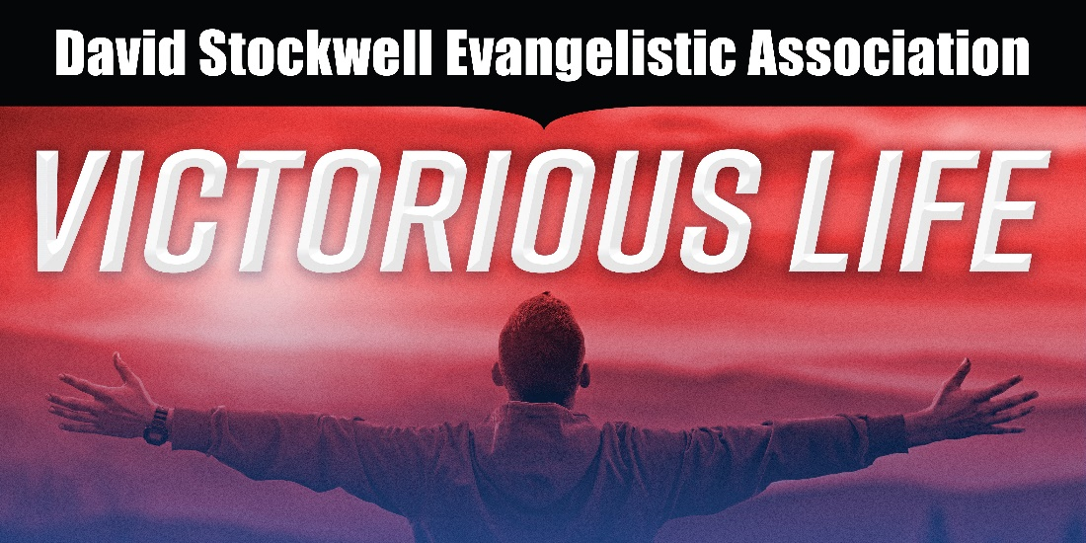

“For I am come that they might have LIFE,
and have it more abundantly!” John 10:10

Victorious Life! Conference Notes

A PASSION FOR SOULS

Victorious Life! Conference Notes

BROKENNESS

Victorious Life! Conference Notes

THE COMPASSION OF JESUS

Victorious Life! Conference Notes

WINNING DISCIPLES & TRAINING DISCIPLES

Victorious Life! Conference Notes

VICTORIOUS LIFE IN THE BATTLE

Victorious Life! Conference Notes

HOW TO SHARE THE GOSPEL

Victorious Life! Conference Notes

CREATIVE METHODS IN EVANGELISM

Victorious Life! Conference Notes

THE WORK OF THE EVANGELIST

Victorious Life! Conference Notes

SCHOOL PROGRAMS:
REACHING YOUTH FOR CHRIST

Victorious Life! Conference Notes

