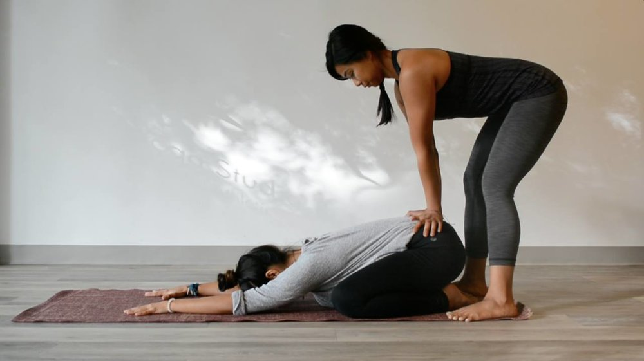

Small Group - Modified Yoga Workshop Wednesdays: 6:00 p.m. to 7:15 p.m.
New Classes begin: Wednesday Oct. 13, 2021
Boutique-style, small group Yoga Personal Training- A hybrid between a private lesson and regular class. Experience a detailed, therapeutic and mindful approach to Yoga.
* Great format for anyone with injuries/limitations* who feels lost/neglected or *can’t keep up with pace of large studio and gym classes * those not getting their needs met with online virtual classes.
*Designed with modifications relevant to YOUR needs!

You will Experience:
- Small size beginner- friendly class
- Individual Attention
- Modifications
- Gentile corrections from an experienced Yoga Teacher
- Qi Gong techniques
- Special props and chairs used to make each pose accessible to YOUR body.
We focus on increasing:
- Functional range of motion
- Flexibility
- Strength
- Balance
- Pain relief through meditation
- Mindfulness and focus

Weekly Themes:
- Yoga for a Healthy Back and Core
- Neck and Shoulders
- Hips and Hamstrings
• Knees and Feet
And much more

Workshop led by Renée Bogard, E-RYT® (Experienced Registered Yoga Teacher & Certified Qigong Instructor) a former Personal Trainer, who has been teaching Yoga since 2005/ in the fitness industry since 1989.
Location: 4450 S. Keystone Ave. Indpls, IN 46227 (Rosedale Hills UM Church)
Cost: ** $25 Drop in week to week basis during pandemic (space available)
Class size very limited- Call Today to register (520) 401-1662
Mail payments to: Renée Bogard PO Box 7924 Greenwood, IN 46142 www.EssentialElementsYogaQigong.com
to download waiver, register online and for more information

