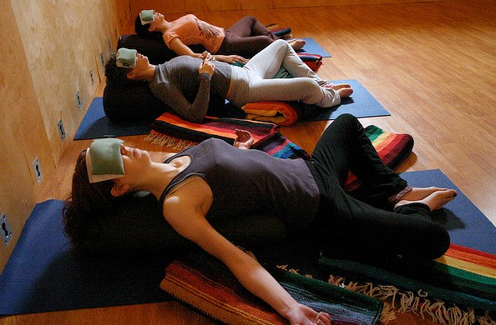
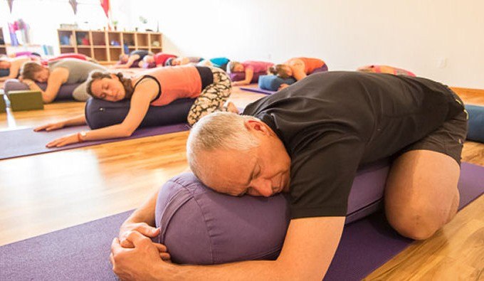

The Yoga of Undoing
date: Thursday Dec. 16th, 2020
time: 6:15PM to 7:50PM
cost: $25.00* early bird cash/check if prepaid

*no later than Thurs. Dec. 9, 2020 or $28.00 online after Dec.9th
location: Rosedale Hills United Methodist Church
address: 4450 S. Keystone Avenue

Indianapolis, IN 46227
Class led by: Renée Bogard, E-RYT®, Yoga Instructor
To register: call Renée at 520-401-1662
Visit www.EssentialElementsYoga.com to register and download waiver
Mail payments to: Renée Bogard PO Box 7924 Greenwood, IN 46142
Space limited!! Only 12 bolsters! Call today to reserve your space!

This introspective Restorative Yoga Workshop uses props to support the body in releasing tension, quiets the mind for deeper meditation, and calms the spirit from our
Fast paced and technology driven lives.
Experience long- held postures on special yoga bolsters to help open your back, shoulders and hips; essential oils for stress relief and Sound Healing music to enhance mindfulness. *Complimentary herbal tea and refreshments provided after class.

Here are a few things participants have said of Renée’s Restorative Yoga Workshop:
“I feel like I just got out of a massage”.
“Wow, my back pain went away!” “I was so energized after this workshop... and yet very calm.”
“This Restorative Yoga has led me to one of my deepest experiences in Meditation - I highly recommend it for those brand new to yoga or the advanced yogi looking for a more meditative practice”.

.

Wonderful for those with:* Injuries* Illness* Recovery* PTSD* Pregnant Women* Seniors* Athletes

If you

If you can lie on a cushion, you can do this class!

