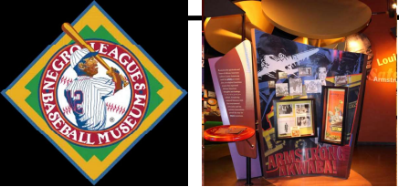

SHEPHERD’S CENTER DAY TOUR
WEDNESDAY, MARCH 30, 2022, $89 Negro Leagues Baseball Museum Kansas City Jazz Museum Federal Reserve Money Museum Lunch at André's Confiserie Suisse

Motorcoach spots at 7:45 am at Lowman Methodist Church. We will leave as soon as loaded. The Federal Reserve Money Museum is our first stop. The Money Museum; a billion-dollar experience! See how the Bank processes millions of dollars in currency each day, lift a real gold bar, view the historic Harry S. Truman coin collection, and enjoy fun, interactive exhibits while learning about the U.S. economy. Then it’s off to lunch at the scrumptious Andre’s for a choice of entrees and the best dessert ever! It is also a chocolate store! The Nego Leagues Baseball Museum that stewards One of America’s Most Meaningful Stories! It is a story about Black Baseball Players who were not allowed to play on white teams. Next door is the American Jazz Museum that preserves the history of American jazz music, with exhibits on Charlie Parker, Duke Ellington, Louis Armstrong, Ella Fitzgerald, and others. On the way home, we will stop at Crown Center for Sheridan’s Ice Cream. Should be home by 5 pm.
GREAT ADVENTURE TOURS email: greattours@gmail.com, Phone 785-633-8761
Mail checks to: PO BOX 4126 TOPEKA, KS 66604. No Credit or Debit Cards Accepted.

