

***Who We Are >>>***

***Core Services >>>***

*Professionally prepared documents of all kinds. Any form or document necessary for the administrative support of your rental business.*

We create custom leases and rental applications. We also perform background/credit checks using the highest rated background checking systems. We can notarize signatures and provide witness to legal documents.



*Document Preparation, Mailing, Emailing, etc.*

*Rest Easy. We will do all the work!*

We understand the challenges of being a Landlord/Property Owner. We are Landlords too! From renovations to maintenance and repair, we know first-hand how difficult it can be to get things done professionally and affordably. In order to maintain your property’s value for maximum profitability. These issues can be compounded by bad behaviors of tenants. Whose bad behaviors are many and can work to turn your property into a constant loss of revenue, rather than a consistent source of increased revenue.

But, what can the Landlord do, when most states and municipalities are AGAINST the Landlord. As though he/she is a monster who is hell-bent on causing distress to the tenants. These issues cause many smaller Landlords, under 6 units to have to take off work and other important activities in order to address these concerns. Without having to bear the additional cost of attorneys. With non-payment of rent, and the resulting need for eviction being the number one issue facing most Landlords. It is important to successfully navigate through the maze of documents, and regulations in order to even file for an eviction in New Jersey.

The process is cumbersome and time consuming. And you can never be certain of the Information that you receive at the Court. It can be very frustrating. But! That’s where we come in. We are now your Administrative Assistant. We do all the work! We prepare the appropriate documents for eviction. We deliver them to the appropriate Court Agency in a timely manner. We appear at the hearings on your behalf. We then acquire and prepare all relevant documents pertaining to the approved eviction and lock out schedule. All at a price far lower than hiring an attorney.

*For many years, Landlords and Property Owners have been vilified, disregarded and basically hung out to dry. When all they are trying to do is profit from their business, like any other business. Other businesses are allowed to grow with SUPPORT and encouragement. Unless you are a Landlord!*

*Leveling the Playing Field*

***Mission***

*Our*

**A voice and Administrative Support resource for the Rental Industry Investors**

*Advocate for Landlords*

*Information resource to Landlords*

*Licensed Real Estate Agent*

*Licensed Notary Public, NJ*

*Administrative Management*

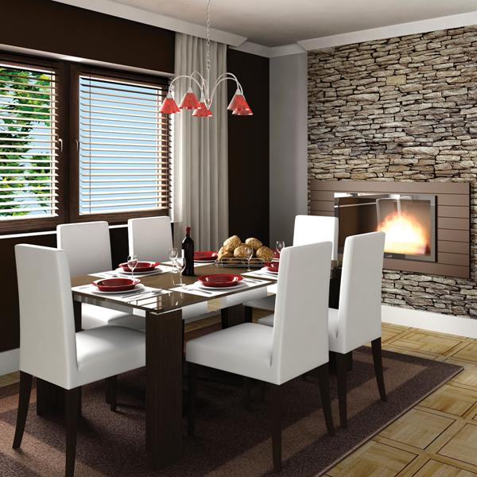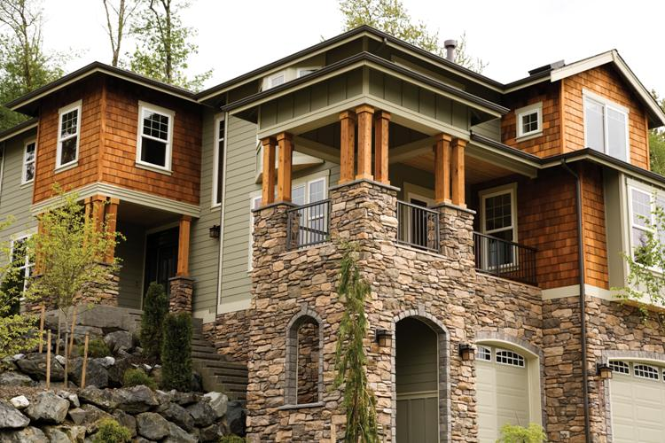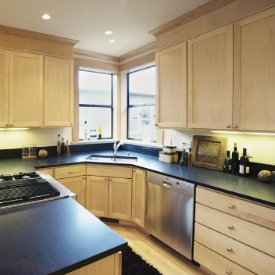

*On Location!*

**Kitchens**

Congue nihil imperdiet do

ming id quod mazim placerat facer minim veni am ut wisi enim ad minimeniam, quis erat nostr uexerci tation ullamcorper nostru exerci tation ullam corper et iusto

***property advice >>>***

*A Buyer’s Market*

*vs. A Seller’s Market*

*Option congue nihil imperdiet doming id quod mazim placerat facer minim veni am ut wisi enim ad minimeniam, quis erat nostr uexerci tation ullamcorper nostru exerci tation ullam corper et iusto odio dig nissim qui blandit praesent lupta. Tummer delenit augue duis dolore te feugait nulla facilisi.*

*Option congue nihil imperdiet doming id quod mazim placerat facer minim veni am ut wisi enim ad minimeniam.*

*Enim ad minimeniam, quis erat nostr uexerci tation ullamcorper nostru exerci tation ullam corper et iusto odio dig nissim qui blandit praesent lupta.*

Option congue nihil imperdiet doming id quod mazim placerat facer minim veni am

ut wisi enim ad minimeniam, quis erat nostr tation ullam corper et iusto odio dig nissim qui blandit praesent lupta.

**For more information go to**

**www.yourwebsitehere.com**

Option congue nihil imperdiet do

ming id quod mazim placerat facer minim veni am ut wisi enim ad min

imeniam, quis erat nostr uexerci tation ullamcorper nostru exerci tation ullam corper et iusto odio dig nissim qui blandit praesent lupta. Tummer delenit augue duis dolore te feugait nulla facilisi. Con erattis sectetuer adip iscing elit, sed erat diam nonummy nibh magna erat aliquam erat volutpat. Nam liber tummy nibh ut wisi enim ad minim veni am, quis nostruexerci tation.

***set the stage >>>***

*Staging Your Home for Prospective Buyers*

Option congue nihil imperdiet doming quod



**Living Rooms**

Congue nihil imperdiet doming id quod mazim placerat facer minim veni am ut wisi enim ad minimeniam, quis erat nostr uexe

rci tation ullamcorper nostru exerci tation ullam corper et iusto odio dig nissim qui.

**Dining Areas**

Congue nihil imperdiet doming id quod mazim placerat facer minim veni am ut wisi enim ad minimeniam, quis erat nostr uexe rci tation ullamcorper nostru exerci tation ullam corper et iusto odio dig nissim qui blandit praesent lupta. Tummer delenit augue duis dolore te feugait nulla facilisi. Con erattis diam nonummy nibh magna erat.

nissim qui blandit praesent lupta. Tummer delenit augue duis dolore te feugait nulla facilisi. Con erattis sectetuer adip iscing elit, sed erat diam nonummy nibh magna erat aliquam erat volutpat. Nam liber tempor cum soluta nobis sed diam nonummy.

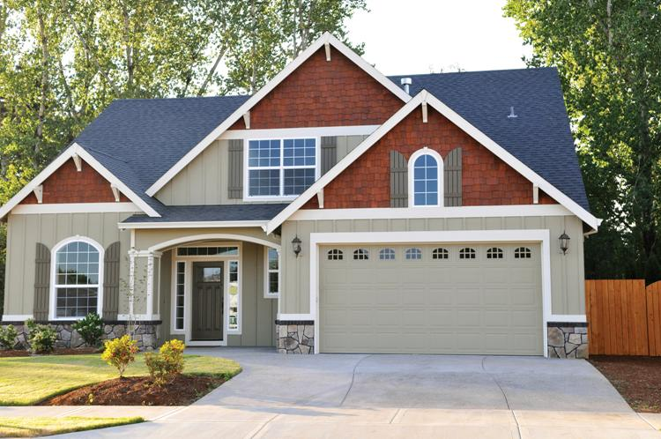

Option congue nihil imperdiet doming id quod mazim placerat facer minim veni am ut wisi enim ad minimeniam, quis erat nostr uexerci tation ullamcorper nostru exerci tation ullam corper et iusto odio dig nissim qui blandit praesent lupta. Tummer delenit augue duis dolore te feugait nulla facilisi.

Con erattis sectetuer adip iscing elit, sed erat diam nonummy nibh magna erat aliquam erat volutpat. Nam liber tempor cum soluta nobis sed diam nonummy nibh ut wisi enim ad minim veni am, quis nostruexerci tation ullam corper.

Option congue nihil imperdiet doming id quod mazim placerat facer minim veni am utte wisi enim ad minimeniam, quis nostr uexerci tation ullamcorer. Nostru exerci tation ullam corper et iusto odio dig nissim qui blandit praesent lupta tum delenit augue duis dolore terra feugait. Option congue nihil imperdiet doming id quod mazim pla

cerat facer minim veni am ut wisi enim ad minimeniam, quis erat nostr uexerci tation ullamcorper nostru exerci tation ullam co

rper et iusto odio dig nissim qui blandit.

***ask the experts >>>***

*Should I Refinance?*

*Historically Low Interest*

*Rates May Make Refinancing Sense*

*The True Cost*

*of Buying a Home*

*Option congue nihil imperdiet doming id quod mazim placerat facer minim ve*

*ni am ut wisi enim ad minimeniam, quis erat nostr uexerci tation ullamcorper nostru exerci tation ullam corper et iusto odio dig nissim qui blandit praesen.*

Tummer delenit augue duis dolore te feugait nulla facilisi. Con erattis sectetuer adip iscing elit, sed erat diam nonummy nibh magn erat aliquam erat volutpat. Nam liber

por cum soluta nobis sed diam nonummy nibh ut wisi enim ad minim veni am, quis nostruexerci tation ullam corper. Option congue nihil imperdiet doming id quod

Option congue nihil imperdiet doming id quod mazim placerat facer minim veni am ut wisi enim ad minimeniam, quis erat nostr uexerci tation ullamcorper nostru exerci tation ullam corper et iusto odio dig nissim qui blandit praesent lupta. Tummer delenit augue duis dolore magna erat aliquam erat volutpat. Nam liber tempor cum soluta nobis sed.

*Q:*

*A:*

*Signing on the dotted line...*

*Expenses to expect when buying a home*

Option congue nihil imperdiet doming id quod mazim placerat facer minim veni am ut wisi enim ad minimeniam, quis erat nostr uexerci tation ullamcorper nostru exerci tation ullam corper et iusto odio dig nissim qui blandit praesent lupta. Tummer delenit augue duis dolore te feugait nulla facilisi. Con erattis sectetuer.

Option congue nihil imperdiet doming id quod mazim placerat facer minim veni am ut wisi enim ad minimeniam, quis erat nostr uexerci tation ullam corper nostru exerci tation ullam corper et iusto odio dig nissim qui blandit praesent lupta. Tummer delenit augue duis dolore te feugait nulla facilisi. Con erattis sectetuer adip iscing elit, sed numm.

*Essential Tips for*

*First-Time Homebuyers*

*Option congue nihil imperdiet doming id quod mazim placerat facer minim veni am ut wisi enim ad minimeniam, quis erat nostr uexerci tation llam corper nostru exerci tation ullam.*

[](https://www.layoutready.com/?utm_source=microsoft&utm_medium=file&utm_campaign=office_online)

Tummer delenit augue duis dolore te feugait nulla facilisi. Con erattis sectetuer adip iscing elit, sed erat diam nonummy nibh magna erat aliquam erat volutpat. Nam liber tempor cum soluta nobis sed diam nonummy nibh ut wisi enim ad minim veni am, quis nostruexerci tation ullam corper. Option congue nihil imperdiet doming id quod mazim placerat facer minim veni am utte wisi enim ad minimeniam, quis nostr uexerci tation ullamcorer. Congue nihil imperdiet doming id quod mazim placerat facer minim ven.

*Finding An Agent That’s Right For You*

Congue nihil imperdiet doming id quod mazim placerat facer minim veni am ut wisi enim ad minimeniam, quis erat nostr uexerci tation ullamcorper nostru exerci tation ullam corper et iusto odio dig nissim qui blandit praesent lupta. Tummer delenit augue duis dolore te feugait nulla facilisi. Con erattis sectetuer adip iscing elit, sed erat diam non ummy nibh magna erat aliquam erat volutpat. Nam liber tempor cum soluta nobis sed diam nonummy nibh ut wisi enim ad minim veni am, quis nostruexerci.

5432 Any Street West Townsville, State 54321

COMPANY

REAL ESTATE

***coming soon >>>***

*In The Next Issue*

*Local Property Guide*

*Determining Your Home’s Value*

*Mortgage Rates 101*

*Downpayment Help for Young Buyers*

*Imperdiet doming id quod mazim placerat facer minim veni am ut wisi enim ad minim niam, quis erat nostr uexerci tation ullamcorper nostru exerci tation ullam corper et iusto odio dig nissim qui blandit praesent lupta tummer delenit augue duis dolore.*

***thoughts...***

*final*

Contact us at **555-543-5432** www.yourwebsitehere.com