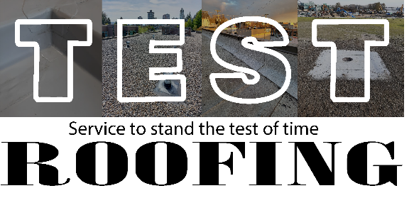

Test Roofing Warranty

Test Roofing provides peace of mind to clients by offering a 5 year warranty on repairs and installations. A repair by Test Roofing that fails within 5 years of completion will be repaired again at no cost to the client. If the roofing provided by Test Roofing around an installation fails within 5 years of completion, Test Roofing will repair or replace at no additional cost to client. This includes:
EPDM Roof Systems
SBS Roof Systems
TPO Roof Systems
PVC Roof Systems
Asphalt Shingle Roof Systems
Cedar Shingle Roof Systems

Exclusions:
- Roof systems in poor condition or past life expectancy will not be included in this warranty. Roof systems in such condition cannot be warrantied and should be replaced.
- Blisters in SBS: Blisters form in SBS usually from trapped moisture or air when installed. This typically happens from poor installation practices, or a leak forming in an old roof. Once this moisture is in the roof system, it is very difficult to completely remove, resulting in new blisters forming under new repairs. Test Roofing uses high quality repair practices that eliminate normal sized (3’L x 1’W) blisters from coming back 80% of the time. Since we cannot guarantee 100% elimination, we cannot warranty the repairs.
- A split in a Tar & Gravel (BUR) roof will not be covered under this warranty. Test roofing will repair splits with the best roofing practices, but splitting will usually extend underneath the repair until it opens up past the repair – causing another failure. A Tar & Gravel roof that is splitting will also usually be in poor condition. If we inspect our repairs and they are faulty in any way, we will repair at no additional cost.
- Caulking, mastic, and liquid repairs are only warrantied for 1 year
Addendum:
The 5 year warranty also extends to repairs to stop leaks. However, this warranty only applies to the repair itself, not the leak. A leak in one area can be caused by multiple failures in the roof, and there can not be a warranty provided for a stopped leak. Should a leak return after permanent repairs are completed, Test Roofing will come to the site and inspect the repair. If the repair is faulty in any way, it will be repaired at no additional cost to the client.

