***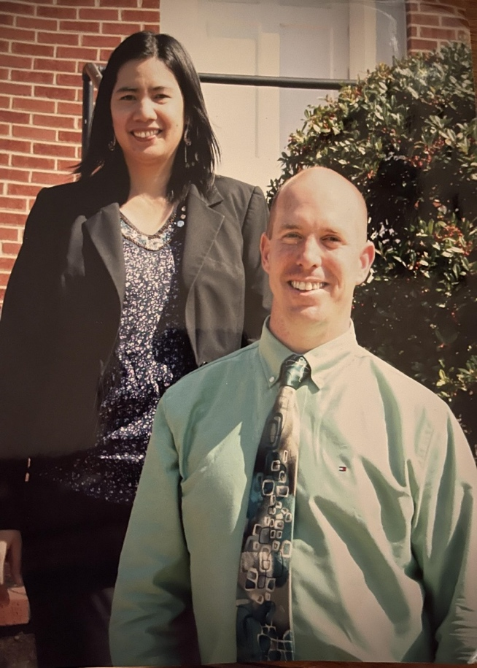*Jason Burns’ Biography**

*Jason and Shiela Burns*

Jason Burns is a native from Bedford County, Virginia. He was born to his parents, Preston and Dianne in the year 1975. Born with Cerebral Palsy, doctors declared that he wouldn’t be able to lead a normal life, explained to his parents he would never play sports or ride a bicycle. To God be the glory and to the surprise of many, that didn’t happen. Jason was able to learn how to ride a bicycle. While Jason attended Liberty High School, engaged fully in sporting activities by joining the wrestling team.

Through complete determination and hard work, he defied science and performed like every other normal boy his age. When Jason was 13 his father bought him a riding lawn mower. Jason come up with the idea to start a lawn care service in the neighbourhood he grew up in, ‘Jays Lawn Care’, was born. By 16, Jason already knew what he wanted to do in life. He wanted to be a core member of the group of people who provided efficient services to the world. From that age, he began working his way up, and has gained valuable customer service experience so far, while working in different companies. For eleven years and some, he has been married to Shiela Burns, who completely supports his vision.

Currently, Jason has spent over fifteen years in the cleaning and sanitizing industry, and thirty years in general, dedicating his time, resources, and services to his people in the community, with the sole aim of making their lives easier.

Outside of work, Jason spends a lot of time with his wife, going to church, and occasionally, camping. With his gathered experience through his years, Jason Burns established his own company, ‘**Burns Ducts Cleaning Service Inc.'.** The purpose of the establishment is to further make the lives of every individual he reaches, easier and healthier.

To contact the company for a perfect duct cleaning service, kindly refer to the **Burns Ducts Cleaning Services Inc.** business info below: