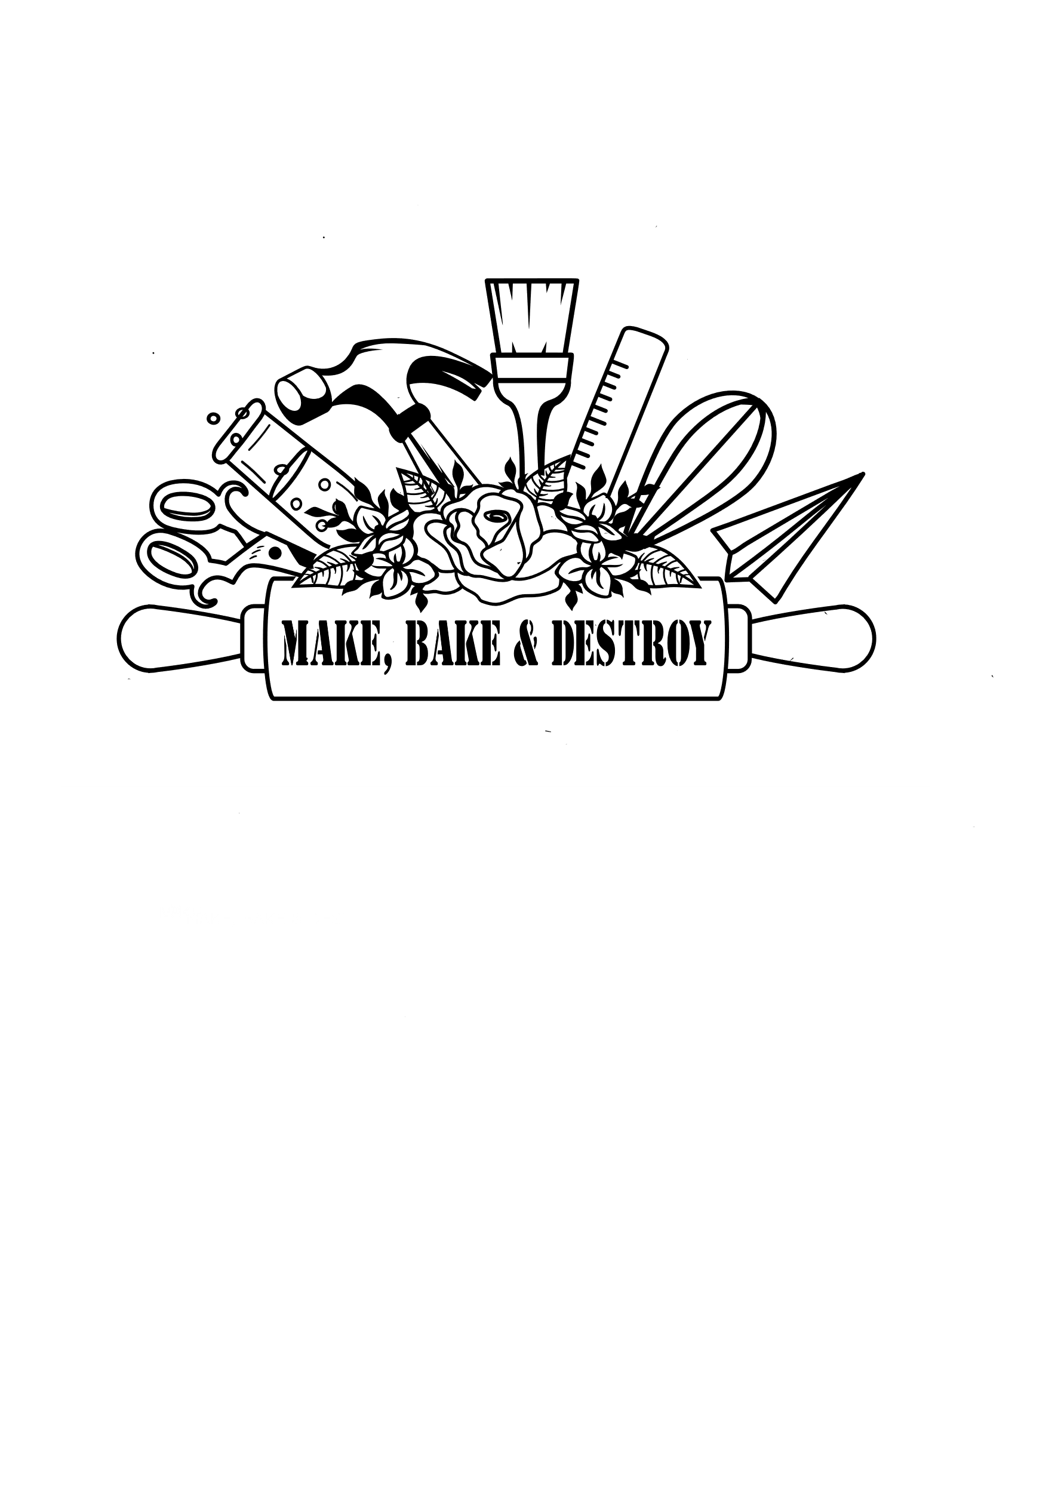

**SCHOOL AND CAMP workshops**

Make, Bake and Destroy offers hands-on STEAM and Maker Workshops for schools, community organizations, events, summer camps, and more! Workshops are 30-45 minutes long for up to 30 participants per workshop. Discounts are available for multiple workshops. All workshops are divided into different grade levels and are aligned with Sunshine State Standards.

Contact Make, Bake and Destroy for more information or to book at program at: [MakeBakeandDestroy@gmail.com](mailto:MakeBakeandDestroy@gmail.com)

**Workshop Cost for Schools/Organizations (each workshop is for a maximum of 30 students):**

**$120/1 workshop $75 each additional workshop**

**Add on a Live Science Show for $200**

*Plus mileage fee based on the location of the program

* Multiple workshops in one day must all be the same workshop or split the day in half with a break in the middle for new set up for 2 different workshops

* Some workshops have a higher fee based on supplies

Robotics & technology workshops

**Noodle Bots (Grades K-1):** Learn what makes something a robot, how we use robots every day, and make your own Noodlebot to take home!

**Mini Spheros Racers (Grades K-1)(COMING FALL 2023):** Learn how to maneuver a Mini Sphero Droid and then race your classmates!

**Snap Circuit Creations (Grades K-1):** Use snap circuits to learn about circuits while turning on lightbulbs, making motors spin, and sirens wail.

**Nano Playground (Grades K-1):** Learn about nano robotics, build a playground for a nano hex bug and combine supplies with a neighbor to expand your playground.

**Mini Spheros Maze Runners (Grades 2-3(COMING FALL 2023)):** Learn how to program Mini Sphero Droids and get them to complete a maze.

**Tiny Technology (Grades 2-3):** Explore the tiny side of science – Nano Technology! Learn how nano technology affects our everyday lives as you experiment with kinetic sand, scented balloons and thin films.

**Unplugged Coders (Grades 2-3):** Learn about coding and programming without a computer! Program a friend to complete a task, make a binary code bracelet, and guide a Mars Rover through an obstacle course.

**Junk Bots(Grades 2-3):** Pull parts out of a toy dumpster and use them to assemble junk bots that buzz, spin, and move.

***(Workshop is $150/30 students and $100 for each additional workshop for students to take home their project)***

**Circuit Builders (Grades 2-3):** Learn how to build different types of circuits and then work together to build a giant circuit!

**Mini Spheros Olympics (Grades 4-5) (COMING FALL 2023):** Program Mini Sphero Droids to complete different challenges, such as an obstacle course or race around an object.

**Scribble Bots (Grades 4-5) :** Build a Scribble Bot to take home and make art!

***(Workshop is $150/30 students and $100 for each additional workshop)***

**Robot Rumble (Grades 4-5) (COMING FALL 2023):** Build Lego based Circuit Cube Battle Bots and use Bluetooth technology to control them as they head into battle!

**Virtual Circuits (Grades 4-5):** Use Tinkercad to learn about circuits, breadboards, and Ohm’s Law. Then build virtual different types of circuits and experiment with breadboards virtually.

**Snap Circuits Coding Robots (Grades 4-5):** Use mechanical, unplugged coding blocks to program your robot to play basketball or soccer.

**Hack the Lab (Grades 4-5):** Use technology tips and tricks to solve riddles and challenges Escape Room style!

**Squishy Circuits (Grades 4-5):** Create circuits in a whole new way- using conductive modeling dough!

Engineering

**Lego Engineers (Grades K-1)**

Work alone, in pairs, and in teams to complete engineering challenges with Legos, like building a wind car, a bridge or a catapult!

**Playground Engineers (Grades K-1):** Learn about simple machines, use challenge cards to build a mini playground, and make a simple machine to take home!

**Magnetic Marble Maze Engineers (Grades K-1):** Build a vertical marble maze on our portable magnetic walls and race your classmates in a marble maze race!

**Pirate Ship Engineers (Grades K-1):** Work as a team to build a pirate ship with mystery supplies and see if your ship will float!

**How It’s Made (Grades K-1):** Use reverse engineering to learn how some every day (and some silly) things are made. Then put your engineering skills to the test and make something fun to take home!

**Sandcastle Engineers (Grades K-1):** Become a sandcastle engineer as you test different types of sand for building, design your creation, build it and make revisions.

**Rollercoaster Engineers (Grades 2-3):** Use pre-made plastic marble coasters and maker-style supplies, like foam insulation and duct tape, to design, build and revise roller coasters that meet several challenges!

**Leo’s Lab (Grades 2-3):** Step into Leonardo daVinici’s Engineering Lab! Test out some of his famous engineering projects, like the tension bridge and parachute, and then design your own invention or gadget!

**Balloon Car Derby (Grades 2-3):** For this race you will be the pit crew and the driver! Build a balloon car and then race your classmates!

**Cartesian Diver Races (Grades 2-3):** Learn about buoyancy while building a cartesian diver and then send your diver down to collect items at the bottom of your bottle!

**Crash Test Engineers (Grades 2-3):** Design, build and test a car, rocket, or zipline basket that will protect an egg when it crashes.

**Cardboard Box Engineers (Grades 2-3):** Transform cardboard boxes into cars, trees, animals, and more using the engineering design process.

**Wind Up Car Races (Grades 4-5):** Build rubber band cars and then send them racing across the room!

**Bot Keva Mazes (Grades 4-5):** Use Keva Blocks to build mazes and see if your Hex Bug can make it through! Make changes and try again!

**Wire Mazes (Grades 4-5):** Create twisting wire mazes with a partner that buzz when touched and challenge other teams to make it through without buzzing!

**Rube Goldberg Machine with Sci Fi Tubes (Grades 4-5):** Learn about electricity and circuits while building giant circuits out of household items and Sci Fi Tubes!

**Balloon Jousting (Grades 4-5):** Put your design skills to the test and take balloon races to a new level: balloon jousting! See if you can pop your opponent’s balloon first!

**Design the Future (Grades 4-5):** Learn how different types of engineers are improving our present and future- then create your own futuristic engineering project.

Physics

**Conduction Experiments (Grades K-1):** Learn about electricity and the difference between conductors and insulators through electrifying hands-on experiments!

**Pom Pom Popper Physics (Grades K-1):** Learn about forces, gravity and motion while building and using a pom pom popper- and completing several challenges!

**Magnet Artists (Grades K-1):** Explore the properties of magnets and the role magnetism plays in our world while constructing magnetic sculptures.

**The Science of Baseball (Grades K-1):** Explore the physics behind America’s favorite pastime! Learn about potential and kinetic energy, momentum, and transfer of energy related to pitching and hitting baseballs!

**Stomp Racers (Grades 2-3):** Learn about physics while racing stomp racer cars. Take it a step further by completing physics stunts!

**Paint Stirrer Catapults (Grades 2-3):** Make BIG catapults you can take home and learn about forces, Newton’s Laws, potential and kinetic energy!

**Reflection and Refraction Art (Grades 2-3):** Learn about the electromagnetic spectrum and some of the properties of visible light while creating mini art pieces using refraction and reflection.

**Air Zooka Olympics (Grades 2-3):** Learn about Newton’s Laws and Bernoullii’s Principle while using air cannons to complete different challenges.

**Carnival Physics (Grades 2-3):** Learn how physics are involved in carnival games and try them out!

**Defying Gravity (Grades 2-3):** Learn about physics and magnetism while make paper clips seem to defy gravity using magnets and engineering.

**Spinning Motors (Grades 4-5):** Discover how electricity and magnetism are related while constructing spinning motors that rely on magnets and batteries.

**Water Rocket Engineers (Grades 4-5):** Design, build and launch soda bottle rockets propelled by pressure from a water launcher.

**Electroscopes (Grades 4-5):** Construct an electroscope while learning about static electricity and conductive vs. insulating materials.

**Radical Rockets (Grades 4-5):** Learn about Newton’s Laws, combustion, and engineering while constructing and launching a chemical or air rocket in teams.

***(Workshop with chemical rockets is $150/30 students and $100 for each additional workshop)***

**Dinner Table Physics (Grades 4-5):** Learn some fun and silly dinner table tricks involving Newton’s Laws- particularly the Law of Inertia! Try to pull a tablecloth off a table without dumping the dishes, knock an egg in a cup, and more!

Chemistry

**Bubble Scientists (Grades K-1):** Explore the science behind bubbles while testing different bubble solutions, wands, and methods for making bubbles.

**Little Lab (Grades K-1):** Learn about the states of matter, physical and chemical changes, and more while conducting some fizzy, foamy experiments.

**Colorful Chemists (K-1):** Experiment with color mixing in this colorful chemistry lab! Sometimes you will get surprising results!

**Rainbow Reactions (Grades 2-3):** Conduct colorful chemistry experiments that change colors, create a rainbow in a tube, and even make a rainbow disappear!

**Experimenting with Elements (Grades 2-3):** Learn about different elements, like Oxygen and Hydrogen, while conducting experiments with water, hydrogen peroxide, carbon dioxide, and more!

**Beaker Buddies (Grades 2-3):** Conduct a series of bubbling, colorful experiments in test tubes while learning about different chemistry concepts.

**Soda Scientists (Grades 2-3):** Use fizzy, bubbly soda to learn about chemical and physical reactions, states of matter, and more!

**Slime Scientists (Grades 2-3):** Learn about everyday polymers as you make slime, experiment with water beads, and learn a new “magic” trick.

**Campfire Chemists (Grades 2-3):** Discover how a campfire can teach you chemistry concepts while making an indoor S’Mores!

**Let It Glow (Grades 4-5):** Learn about luminescence as you conduct different types of glow in the dark experiments!

**Play With Your Food (Grades 4-5):** Become a kitchen chemist and learn about the chemistry behind the foods we love!

**Cryo Chemists (Grades 4-5):** Explore the colder side of chemistry with dry ice and liquid nitrogen!

***(Workshop is $150/30 students and $100 for each additional workshop if it includes liquid nitrogen. Minimum of 2 workshops.)***

**Drop the Base (Grades 4-5):** Conduct some fun acid and base reactions that change colors and even disappear!

**Zip Loc Chemists (Grades 4-5):** Learn about chemistry- using different sizes of Zip Loc bags! Make your bags fizz and foam, expand, get hot or cold or change color!

**Tinder, Spark and Flame (Grades 4-5):** Learn how combustion and chemical reactions are connected through some fiery demonstrations and experiments.

Earth & space

**Sunny Days and Starry Nights (Grades K-1):** Explore the concept of day and night while learning about the sun, moon, and stars.

**Weather Watchers (Grades K-1):** Become a Jr. Meteorologist while learning about the science behind every day weather phenomena through hands-on experiments.

**The Rock Kitchen (Grades K-1):** Discover the “recipes” behind different types of rocks, soil, and clay while learning how they are a part of our daily lives.

**Dino Mystery (Grades K-1):** Solve a Dinosaur mystery while learning about different types of dinosaurs, prehistoric creatures, and fossils.

**Planet Passport (Grades K-1):** Grab your Intergalactic Passport and journey into space to learn about the different planets in our solar system.

**Solar Artists (Grades K-1):** Let the sun help you create art! Learn about UV light, the sun, and shadows while making sun prints, UV bead jewelry, and more!

**Go With the Flow (Grades 2-3):** Learn about the underground and aboveground movement of magma and lava; explore how volcanoes and tectonic plates help shape our planet, and erupt a volcano!

**Constellation Creatures (Grades 2-3):** Discover the animals hidden in the stars and their stories while making tools you can use to look at the stars at home.

**Storm Chasers (Grades 2-3):** Become a Storm Chaser-in-Training while learning about the science behind storms and natural disasters.

**The Big Blue Marble (Grades 2-3):** Learn facts about the planet Earth and how it compares to other planets in our solar system. Discover why it is called “The Big Blue Marble” and is considered our “Goldilocks Planet.”

**H-2-Whoa (Grades 4-5):** Learn about the important role water and the water cycle play in our world.

**Tectonics Testers (Grades 4-5):** Learn how tectonic plates and their movement affects our planet while testing out earthquake proof structures, using a DIY seismograph machine, and more.

**Lunar Lab (Grades 4-5):** Step into our lunar lab to learn about the geology of our moon! Learn about craters, moon rocks, the atmosphere and more!

**Seasonal Stars (Grades 4-5):** Learn about the stars and how they seem to change in our night sky throughout the year using tools you can also use at home.

**Stories in Stone (Grades 4-5)**: Discover the stories hidden in stone as you learn about fossils and the importance of understanding the past.

Life sciences

**Green Thumb Artists (Grades K-1):** Learn how plants grow and what they need to survive while making a little greenhouse to take home.

**Jump, Slither and Fly (Grades K-1):** Get ready to jump, slither and fly while learning about the different types of animals all around us and how they move.

**Home Sweet Habitat (Grades K-1):** Learn about the different places animals call home and why they are different.

**Head, Shoulders, Knees and Toes (Grades K-1):** Learn about how the different parts of your body work together to help you move, eat, talk, and live.

**The Nose Knows (Grades K-1):** Discover how our senses work together to help us experience the world around us and protect us.

**Flower Power (Grades 2-3):** Learn about the role flowers play in our world while dissecting a flower, conducting a capillary action experiment and making flower seed paper to take home.

**My Real Beanie Baby (Grades 2-3):** Learn about the roles of seeds in the life cycle of plants and make your very own “Beanie Baby” to take home and grow.

**Backyard Safari (Grades 2-3):** Go on a safari in backyard to discover what kinds of plants, insects, and animals may live there.

**Habitat Passport (Grades 2-3):** Travel around the world to learn about different types of animal habitats why they need to be different.

**A Case of the Clues (Grades 2-3):** Use clues left behind by people and animals to solve a case!

**Monster Genetics (Grades 2-3):** Build a silly felt or magnetic monster while playing a genetics game!

**Superhero Genetics (Grades 4-5):** Learn how genetics can play a role in some of your favorite superheroes’ special powers!

**Nature Scene Investigators- mystery plant and animal (Grades 4-5):** Solve a mystery by collecting clues left by nature!

**Florida Ecosystems (Grades 4-5):** Discover the different types of ecosystems that plants and animals call home in Florida!

**Forensic Detectives (Grades 4-5):** Use clues like fingerprints, hair, and DNA to solve a mystery!

**You Are What You Eat (Grades 4-5):** Learn about the roles of vitamins, minerals and a balanced diet play in your health and how digestion really works.

**DNA Detectives (Grades 4-5)-** Learn about DNA, extract DNA from fruit, and create a silly character without crazy characteristics.

Smart workshops (Science + math + art)

**Lego Monster Makers(Grades K-1):** Create Lego Print Monsters and recreate your prints with actual Legos!

**Roll-a-Creature(Grades K-1):** Play a dice game to build a colorful, wacky monster.

**Art Gears (Grades 2-3)** Build a set of gears that work together to create colorful, repetitive designs.

**Pizza Party(Grades 2-3):** Learn about fractions and money math while constructing made-to-order magnetic pizzas.

**Chromatography Weaving (Grades 2-3):** Create colorful strips of paper using chromatography and create a paper weaving.

**Kaleidoscope Prints (Grades 2-3):** Create colorful prints with radial symmetry like a kaleidoscope!

**Pi Catchers (Grades 2-3):** Learn about the concept of Pi and create a colorful suncatcher to take home.

**Fruit Fraction Animals (Grades 4-5):** Construct animals good enough to eat while learning about fractions.

**Mobius Mobile(4-5):** Create a SMART piece of art with Mobius Strips and learn about the concept of infinity.

**Terrific Tessellations(4-5):** Use wooden tessellation blocks to create tessellation patterns and learn how to make your own, too!

**Fractal Suncatchers (Grades 4-5):** Create a suncatcher inspired by fractals in nature.

**Agamographs (Grades 4-5):** Create artwork that changes before your eyes from special folds.

Maker workshops

**Gadgets, Gizmos and Giggles (Grades K-1):** Put on your safety goggles and learn how to use real tools to make your own gadget or gizmo!

**DIY Kaleidoscopes(Grades K-1):** Use assorted Maker supplies to create a unique kaleidoscope.

**Calder Mobiles (Grades K-1):** Use circular lids of all sizes and wire to create Calder inspired mobiles.

**Junk Deli (Grades 2-3):** Fill your lunchbox at the junk deli and create a project based on one of our Challenge Cards.

**Build It: Toys (Grades 2-3):** Grab some tools and build a toy made on the laser cutter!

**String Artists (Grades 2-3):** Use nails, wood and string to create geometric works of art.

**Carnival Makers (Grades 4-5):** Use household recyclable items to create carnival inspired games, like ring toss and bowling.

**Spin Artists (Grades 4-5):** Build a circuit that will control a spin art machine and make colorful spin art!

**LED Origami (Grades 4-5):** Transform normal origami into something brighter with LED lights!

Contact Make, Bake and Destroy for more information or to book at program at: [MakeBakeandDestroy@gmail.com](mailto:MakeBakeandDestroy@gmail.com)