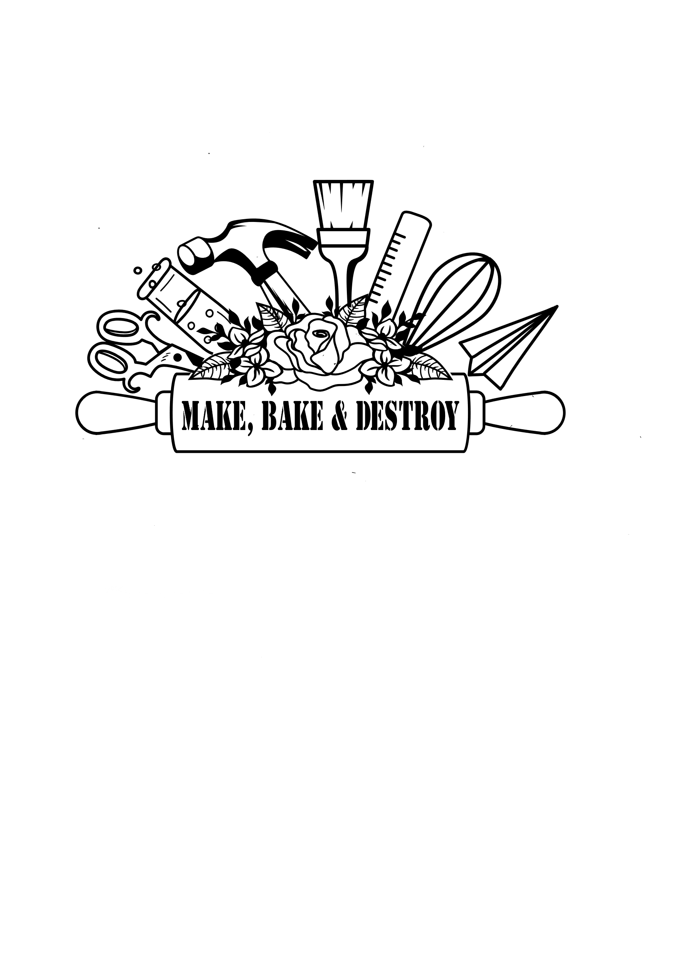

**SCHOOL AND CAMP Science Assemblies**

Make, Bake and Destroy offers large scale, live science assemblies for schools, community organizations, events, summer camps, and more! Shows are 30-45 minutes long and can be adjusted for all ages.

Contact Make, Bake and Destroy for more information or to book at program at: [MakeBakeandDestroy@gmail.com](mailto:MakeBakeandDestroy@gmail.com)

**Show Cost for Schools/Organizations (each show is a maximum of 250 students):**

**$250/ 1 show $450/ 2 shows $650/ 3 shows**

**$850/4 shows $1000/ 5 shows $1,150/ 6 shows**

**\*plus mileage fee based on location of program**

**\* Multiple shows in one day must all be the same show or split the day in half with a break in the middle for new set up for 2 different shows**

**Chill Out:** Explore the colder side of science! We’ll use dry ice to make bubbling concoctions, create giant smoky bubbles, and make solutions magically change color. Then we will get even colder as we use liquid nitrogen to freeze and smash flowers; shrink balloons; and more!

**Fire Bender:** Learn about the science of combustion as we demonstrate some awesome fiery experiments! Watch as make a swirling fire tornado, demonstrate combustion in a Whoosh Tube, show how simple engineering can make a flamethrower, and more!

***\*\* Must be indoors***

**Fire and Ice:** Explore the hottest and coldest sides of chemistry in this awe-inspiring show! We take some of the most fun demonstrations from Chill Out and Fire Bender to create a chemistry show that explores combustion, temperature, states of matter, physical and chemical changes, the fire triangle and more! We will use dry ice, liquid nitrogen and fire elements to create this awesome show. ***\*\* Must be indoors **$50 Nitrogen Fee***

**Just Glow With It:** Get ready to glow in the dark as you learn about different types of luminescence! Learn about the difference between bioluminescence, chemiluminescence, fluorescence and phosphorescence through glowing demos. We will deconstruct glowsticks, make swirling, glowing lava lamps, erupt an indoor, glowing Mentos fountain, and inflate glowing baking soda balloons!

***\*\*\* This show needs to be indoors in a room with the ability to turn the lights on/off and as few windows as possible for the full effect.***

**Bernoulli Blast Off:** Learn how things fly through awesome demonstrations with a toilet paper launcher, paper airplane flingers, giant gliders, air cannons, and more!

**The Mixed-Up Chemist:** Explore chemistry concepts in our wild, fizzy, foamy, messy mobile chemistry lab! We will make giant, swirling concoctions that fizz, foam, change color and erupt! Learn about the states of matter, chemical and physical changes, and more from our Mixed-Up Chemist!

**3, 2, 1… Launch!** Become a honorary rocket scientist while learning about Newton’s Laws of Motion, Physics, and Bernoulli’s Principle! We’ll launch Alka Seltzer rockets, send stomp rockets soaring across the room, and demonstrate rocket engine combustion!

**Use the Forces:** Discover how we all “Use the Force” every day as you learn about physics and Newton’s Laws of Motion through fun demonstrations! We will launch stomp rockets, learn some table tricks that use inertia, swing glasses of water upside down without spilling them,

**Behind the Scenes:** Discover some of the science concepts used to make some of the magic in movies and check out some experiments inspired by some of your favorite films! We’ll use liquid nitrogen to shatter flowers, create green flames inspired by Harry Potter’s Floo Powder, use the “Force” to make cans move by themselves, turn special powder into a ball of flames, and more!

**The Science of Magic:** Learn how science is used for different magic tricks and illusions! Watch as we make water and glass disappear, drawings change direction, flowers change colors before our eyes, rainbows appear and disappear, and more!

**Zip, Zing, Zap!** Experience electrifying science demonstrations about electricity! We will use a Van de Graaf machine, static wands, charged pvc tubes, large sci fi tubes, and more to learn all about electricity!

**Silly Engineers:** Learn about the importance of engineering through silly and fun engineering demonstrations. We will show how engineering can solve problems and make fun science demonstrations even more awesome! We will create a toilet paper launcher, mini flamethrower, paper airplane launcher, a giant human circuit, and more!

**Science Facts and Myths:** Get ready to prove and disprove some science facts and myths! Does diet soda and pop rocks create a harmful reaction for people? How many times can you fold a piece of paper? Can you lift a heavy book off a table with just a thin sheet of paper? Answer these questions and more with this show!

**Storm Chasers:** We will take on some of Mother Nature’s wildest weather phenomena in this show! We will use dry ice and fire to make wild tornados, demonstrate how hail is made using a toilet paper launcher, explore how lightning and static electricity are alike with a Van de Graaf machine, and more!