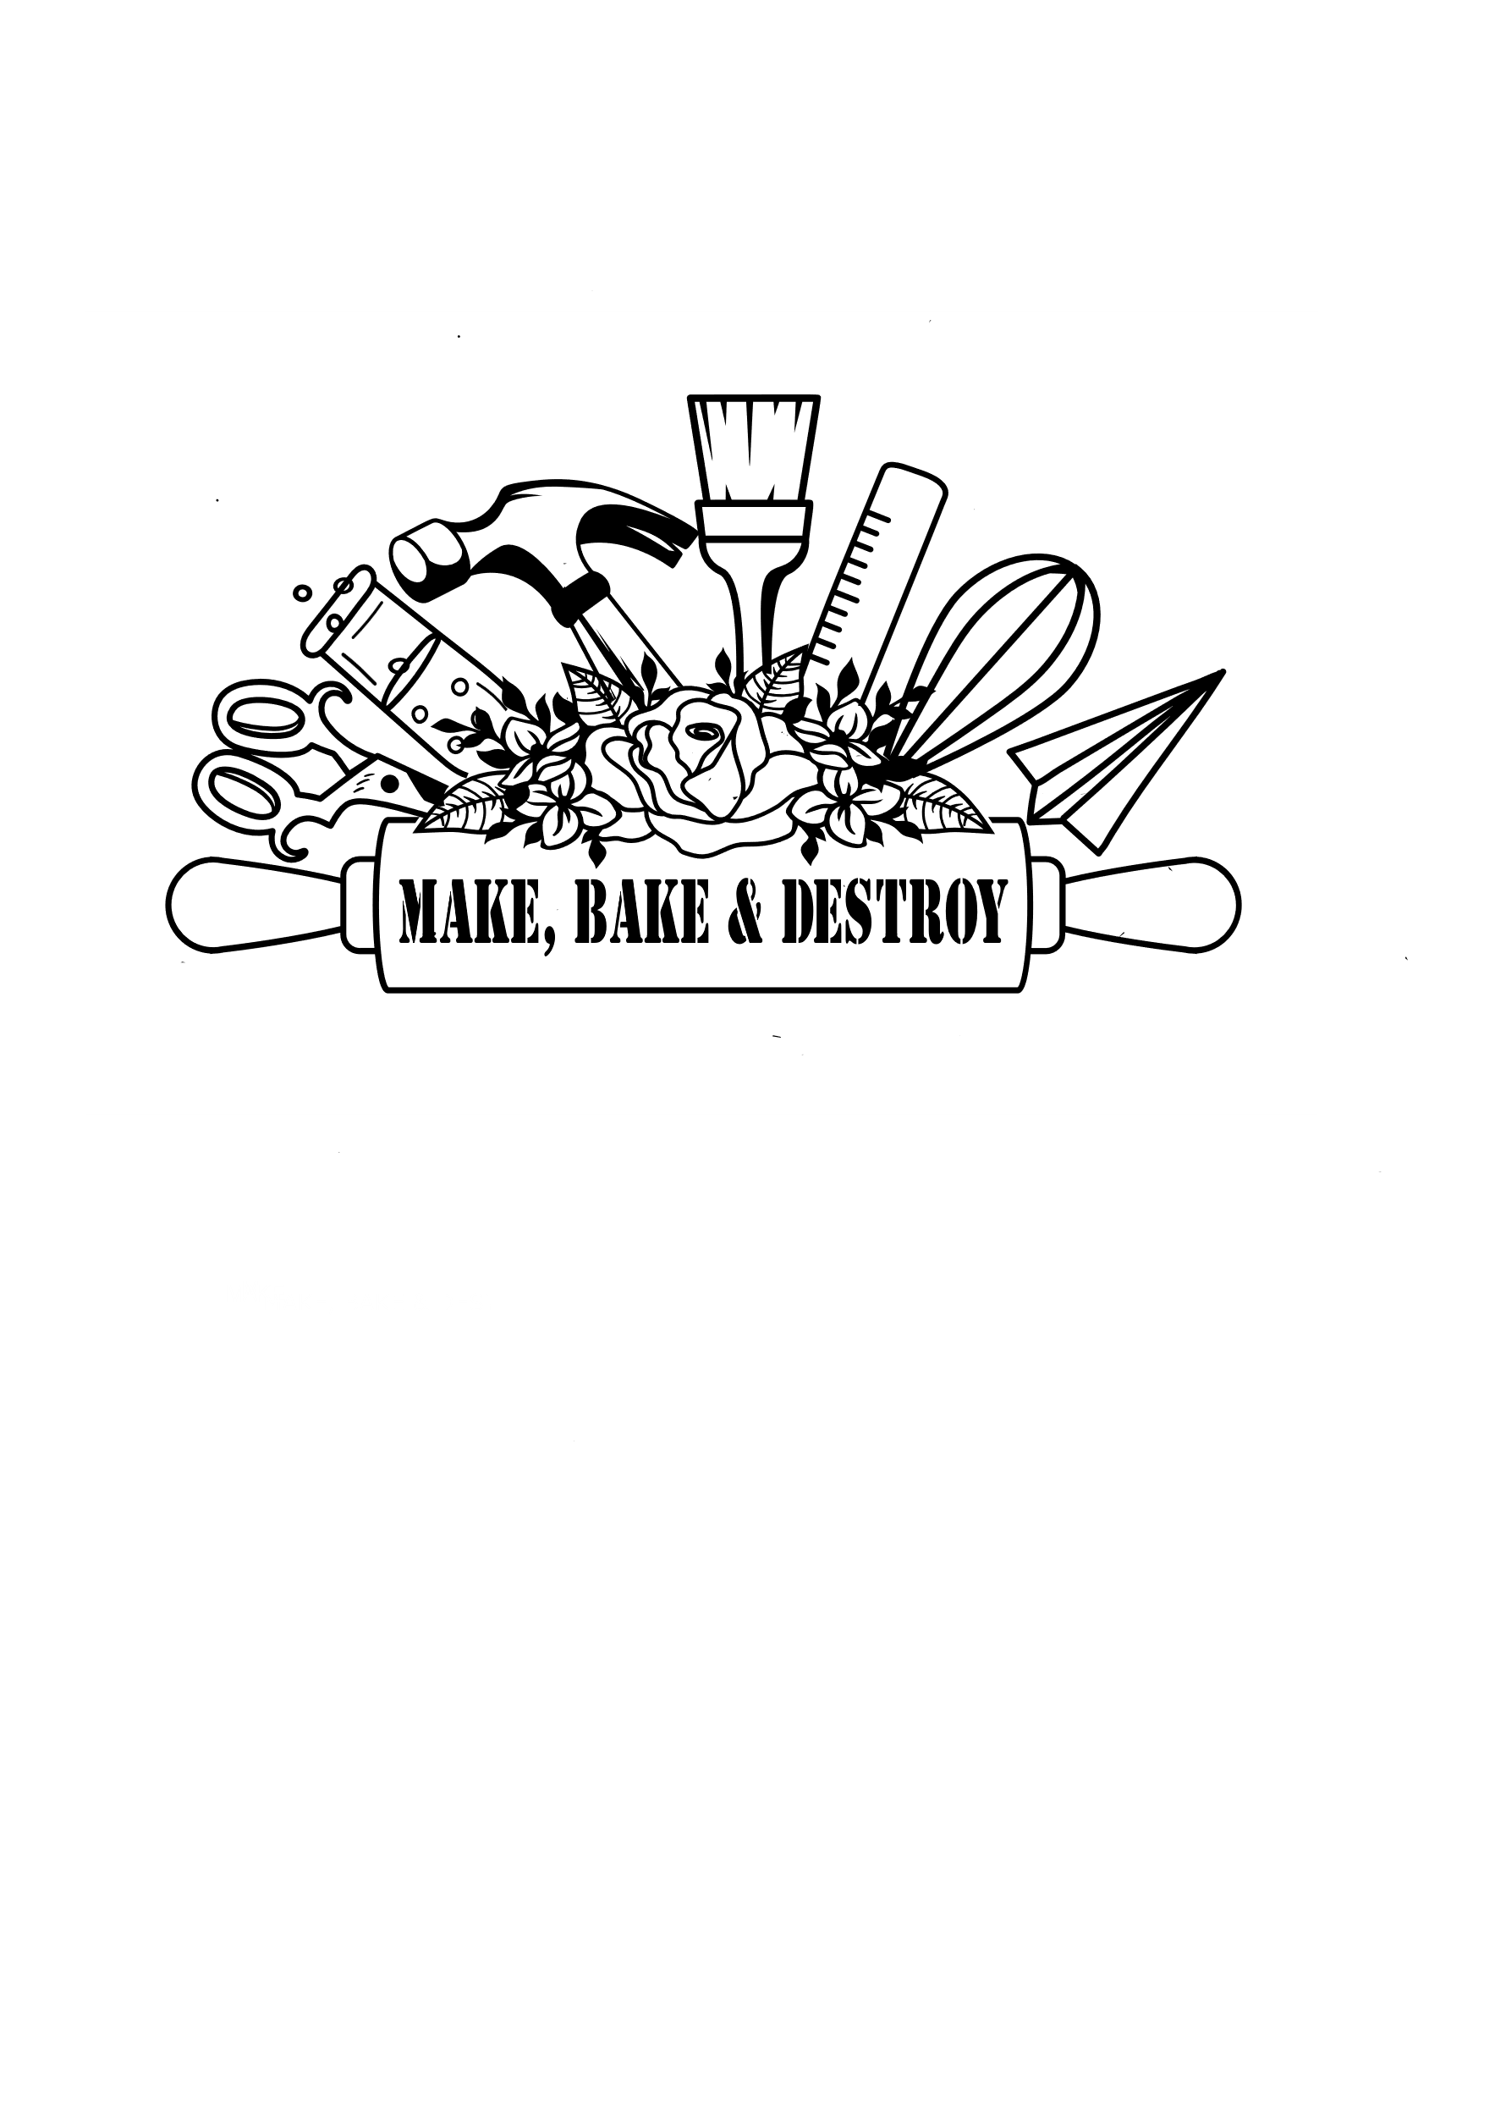

**Cub scout & Scouts BSA workshops**

Make, Bake and Destroy offers hands-on STEAM and Maker Scouts BSA and Cub Scout Workshops as an Outreach Program- this means we come to you! We can lead workshops at your troop meetings and events. Workshops include all the supplies needed to complete all requirements for the badge.

Contact Make, Bake and Destroy for more information or to book at program at: [MakeBakeandDestroy@gmail.com](mailto:MakeBakeandDestroy@gmail.com) or (239) 406-3243

In-person Workshop Costs: virtual workshop costs: Badge-in-a-Box Cost:

Cub Scout 2 Hour Workshops: $12 per Scout 2 Hour Workshops w/Supplies: $12/Scout Cub Scouts: $10/Box

Scouts BSA 3 Hour Workshops: $21 per Scout 2 Hour Workshops w/out Supplies: $6/Scout Cub Scouts: $90/10 Pack Box

Scouts BSA 4 Hour Workshops: $28 per Scout 3 Hour Workshops w/ Supplies: $21/ Scout Scouts BSA 3 Hour Workshop: $15/Box

* Minimum of 10 Scouts 3 Hour Workshops w/out Supplies: $14/ Scout Scouts BSA 3 Hour Workshop: $140/10 Pack Box

*plus $2 per mile travel fee 4 Hour Workshops w/ Supplies: $28/ Scout Scouts BSA 4 Hour Workshop: $22/Box

4 Hour Workshops w/out Supplies: $21/ Scout Scouts BSA 4 Hour Workshop: $200/10 Pack Box

* Shipping is Not Included * Shipping is Not Included

* Minimum of 10 Scouts

lion workshops

Build It Up, Knock It Down Ready, Set, Grow On Your Mark

Gizmos and Gadgets Rumble in the Jungle

Tiger workshops

My Tiger Jungle Tiger Bites Floats and Boats Tiger: Safe & Smart Sky is the Limit

Games Tigers Play Tigers in the Wild Good Knights Stories in Shapes Tiger Tag

Team Tiger Curiosity, Intrigue & Mystery Rolling Tigers Tiger-iffic!

wolf workshops

Call of the Wild Digging in the Past Spirit of the Water Code of the Wolf

Air of the Wolf Finding Your Way Germs Alive!

bear workshops

Fur, Feathers, and Ferns Critter Care Grin and Bear It Roaring Laughter Super Science

Bear Picnic Basket Forensics Marble Madness Salmon Run

Webelo/ Arrow of Light

Building a Better World Art Explosion Build It Castaway Earth Rocks

Engineer Game Design Into the Wild Into the Woods

Scouts BSA Merit badge workshops

Animation Communication Environmental Science Gardening

Architecture Digital Technology Exploration Geocaching

Art Electricity Fingerprinting Geology

Astronomy Electrconics Forestry Inventing

Chemistry Engineering Game Design Model Design & Building

Nature Nuclear Science Photography Pets

Plant Science Robotics Sculpture Soil and Water Conservation

Space Exploration Sustainability Weather Wood Carving

Cub scout Nova Awards Scouts BSA Nova Awards:

Science Everywhere Tech Talk Shoot! Let It Grow!

Down and Dirty Cub Scouts Can Code Splash! Medel’s Minons

Nova Wild Swing! Start Your Engines Hello World

Out of this World Up and Away! Whoosh! Up and Away

Unicovering the Past 1-2-3 Go! Next Big Thing Designed to Crunch

Fearful Symmetry

**Contact Make, Bake and Destroy at** [**MakeBakeandDestroy@gmail.com**](mailto:MakeBakeandDestroy@gmail.com) **or (239)406-3243 with questions, to register for a class, or to book a private program.**