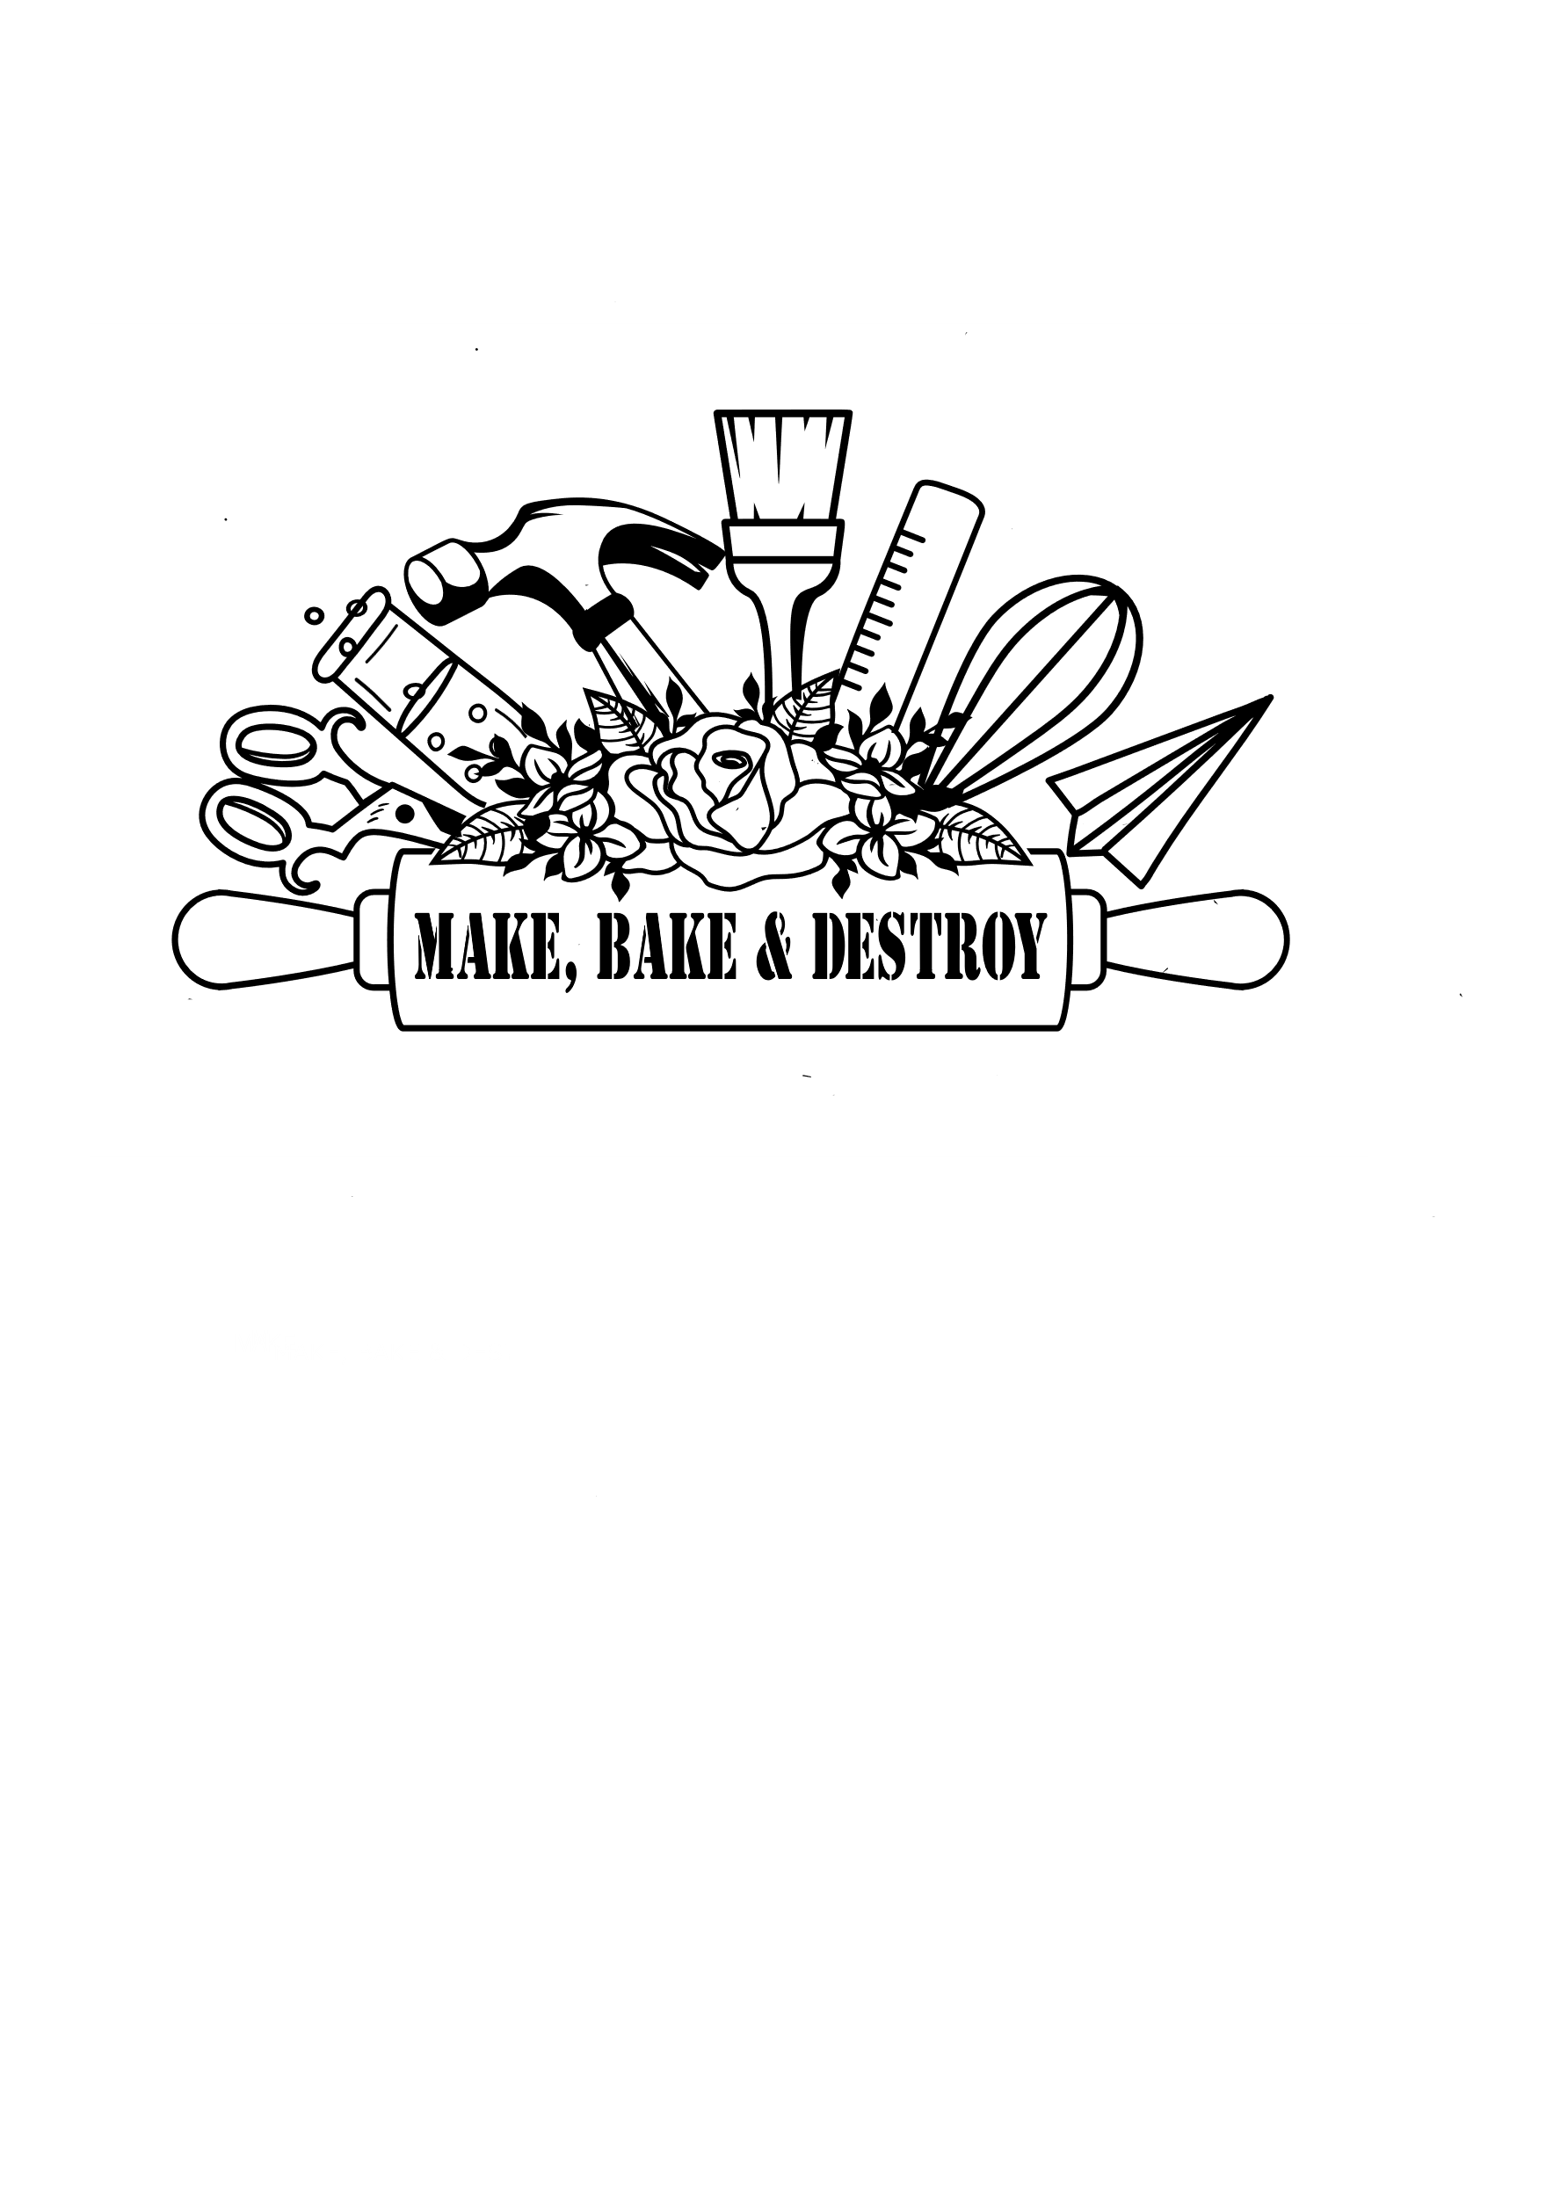

**Family S.T.E.a.M. NIGHTS**

Make, Bake and Destroy offers family S.T.E.A.M. Night programs for schools, community organizations, summer camps, libraries, and more! Programs can accommodate up to 750 participants and different themes are available. Participants can engage in hands-on S.T.E.A.M. learning at 10-25 different stations.

Contact Make, Bake and Destroy for more information or to book at program at: [MakeBakeandDestroy@gmail.com](mailto:MakeBakeandDestroy@gmail.com) or (239)406-3243.

Program fees:

Option 1: $500 for up to 250 participants Option 3: $700 for up to 600 participants

* Includes 10 Stations - Includes 20 Stations

Option 2: $600 for up to 400 participant Option 4: $800 for up to 750 participants

* Includes 15 Stations - Includes 25 Stations

*A mileage fee will be added to the program fees depending on the location of the program

ADD On Options: Program Requirements:

* Add a Live Science Show: $150 - 10-25 Adult Volunteers
* Add The Garage, a Mobile Maker Space: $200/ hour - A Large Space for Activities to be Set Up
* Pop Up S.T.E.A.M. Store – You Keep 25% of Sales - Tables for Activities
* Dinner Option (Pizza, Chips, Cookie and a Drink) - The ability to promote the program

Available program Options:

**Castaways:** You are lost at sea on a deserted island! Use your S.T.E.A.M. skills to survive and find your way home! Make a compass with a needle, learn how to use a map, build a boat, learn about ocean food chains, and more!

*Example Activity: Wind Powered Boats – Build a small boat with a sail and see if it can cross a small pool using a fan for wind.*

**Space Odyssey:** You have been selected for a mission to space. Test your knowledge of Earth and Space and use your S.T.E.A.M. skills to prepare for your journey! Make a pocket solar system model, learn about the phases of the moon, demonstrate how craters are formed, discover what your age would be on different planets, and more!

*Example Activity: Filtered Light & Space – Learn how astronomers use filtered light to see objects in space more clearly and make your own filtered space art to take home.*

**STEM-gineers:** Become a STEM-gineeer as you complete a variety of S.T.E.A.M. based engineering challenges! Launch pom poms with catapults, build a tension bridge, use Snap Circuits to sound an alarm, make a glider launcher, and more!

*Example Activity: Leonardo’s Arched Bridge: See if you can build a mini and a giant version of Leonardo’s Arched Bridge, which uses only tension to be constructed and stand.*

**Kitchen STEAM:** Discover all the S.T.E.A.M. experiments and activities you can complete with common kitchen ingredients, tools and objects! Use a lemon as a battery to light up a bulb, determine if different kitchen ingredients and items are acids or bases, make a bubbling lava lamp, and more!

*Example Activity: Ketchup Packet Cartesian Diver – Learn about buoyancy while using a ketchup bottle and a soda bottle to create a Cartesian Diver.*

**The Art of Science:** Learn all about the A in S.T.E.A,M. through hands-on art activities that incorporate Science, Technology, Engineering, and Math! Make a repeating pattern with no end with Tessellations, use shaving cream to mix colors and make prints, use Snap Circuits to make mini spin art machines, create tiny drawings using microscopes, and more.

*Example Activity: Thaumatropes – Learn about Persistence of Vision while making optical illusion spinners.*

**Newton’s Playground:** Learn how physics shapes the world around us as you use engineering skills to build contraptions that rely on physics and engineering. Learn about friction as you send balloon hovercrafts zooming across a table; explore potential and kinetic energy while launching a catapult; design and build a mini playground that demonstrates how simple machines work, and more!

*Example Activity: Stomp Rocket Basketball – Learn about Newton’s Laws of Motion while launching foam stomp rockets and trying to make into baskets!*

**Spark! (COMING FALL 2023!):** Spark your curiosity about all things tech at this hands-on S.T.E.A.M. event. Turn bananas into bongos with Makey Makey, explore the night sky on an interactive app, program a Mini Sphero to complete an obstacle course, learn about nano-technology while building with kinetic sand, create artwork with a Scribble Bot, and more!

*****Example Activity: Program A Friend – Learn about the important role programmers play in the technology world as you program a friend to replicate a project they can’t see.*

**Off to the Races:** On your mark, get set…. Go! Use your S.T.E.A.M. skills to build cars, boats, planes, and more and head off to the races! Construct and race a balloon car, make paddle boats that zoom across the water, race Mini Sphero droids through mazes, build magnetic mazes for marbles, and more.

*Example Activity: Hex Bug Races – Build a maze and send your nano robot racing through to see if they can make it out before anyone else!*

**STEM Wars:** Learn how S.T.E.M. helps shape a galaxy far, far away through hands-on Star Wars-inspired activities. Use “the Force” to make a can move without touching it, program a droid to complete a task, defy gravity like Luke Skywalker, learn about lightning like Emperor Palpatine’s Force Lightning, and more.

*Example Activity: Star Wars Astronomy – Discover which planets and moons in the Star Wars universe are similar to ours!*

**Wizards’ Night School:** Get sorted into your House for the evening using chemistry and use S.T.E.A.M. to complete magical challenges and tasks. Use static sticks to make something “magically” levitate, create a bubbling potion using an acid-base reaction, launch a stomp rocket flying car across the sky, and use your engineering skills to build a magical broom!

*Example Activity: Snitch Catapults & Tabletop Quidditch – Learn about physics and engineering while you construct a craft stick catapult and play a round of Tabletop Quidditch with your ping pong ball Snitch!*

**\*You may request a detailed list of the activities for each option**

**Contact Make, Bake and Destroy at** [**MakeBakeandDestroy@gmail.com**](mailto:MakeBakeandDestroy@gmail.com) **or (239)406-3243 with questions or to book a program.**