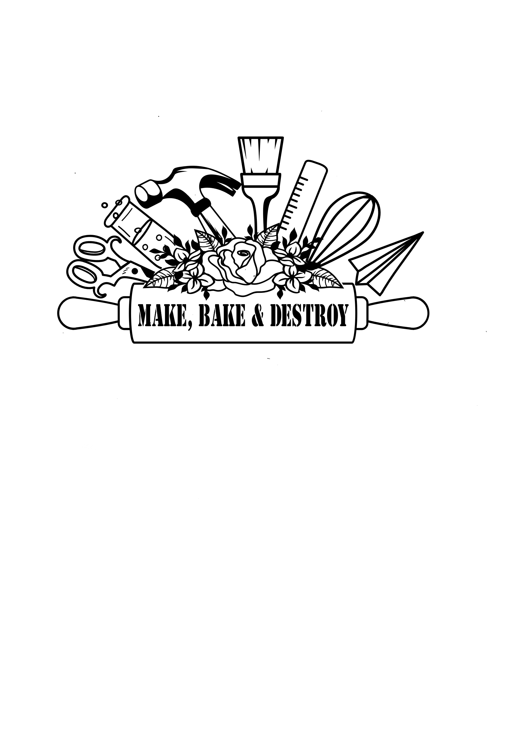

march special: book a party for march or April and take 50% off!

**Birthday parties**

Make, Bake and Destroy offers outreach birthday party packages that include shows and hands-on STEAM workshops- we come to you! Birthday party shows are themed and 30 minutes long for up to 20 children (additional children can be added for a fee). Birthday party workshops are also themed and last 30 minutes. Additional activities can also be booked. Birthday party packages include themed treat bags for the children and a special themed gift for the birthday child. Don’t see a theme you want? We can create a custom STEAM theme for you, as well! For more detailed party descriptions and options, please contact us.

Curious chemists

Let’s step into the Mad Scientist’s Lab and concoct some fun, fizzy, foamy and messy chemistry experiments!

Birthday bots

Let’s do the robot- and make one, too! We will program and race robots, then make one to take home!

The science of birthdays

Learn about the science involved in making birthdays magical and fun! We’ll experiment with birthday candles and balloons, launch presents with catapults, make noisemakers, and more!

Top flight school

We feel the need, the need for speed! Join Top Flight School and learn about principles of flight as we launch gliders of all shapes and sizes.

Dino-mite dinos

Step back into pre-historic times and celebrate your big day with your favorite dino friend! Learn about dinosaurs and fossils through hands-on activities and a show.

Weird science

Explore the weirder side of science as we do wacky, silly, & strange things like using fruit to light a lightbulb, making glass disappear, and more!

Wizard school

Find out of you have what it takes to be a witch or wizard as we make potions and complete spell challenges- with a science twist!

Heroes vs. villains

Get ready to have a super time at your birthday! Decide if you are a superhero or villain- and then perfect your superpowers with science!

Glow Party

This birthday party will be lit! Explore glow in the dark science and even make yourself glow in the dark through hands-on glow in the dark experiments.

Art Maker laB

Let’s get creative with DIY projects, invent new ones, and share ideas- with an Art focus!

STEM Maker lab

Let’s get creative with DIY projects, invent new ones, and share ideas- with a STEM focus!

Don’t try this at home

This is your chance to try experiments you normally don’t get to do at home! We will do some of our biggest, messiest experiments during this party.

Bubblologists

This party will bubble over with fun! We will design bubble wands and make bubbles of all shapes and sizes!

Space cadets

Blast off for outer space birthday fun! Learn about the solar system, bounce around the moon, and become an honorary rocket scientist!

Party package pricing

1 Hour Party Package: $200

* Includes up to 20 children
* 30 Minute STEAM Show
* 30 Minute Hands’ On Activities (choice of 2 activities)
* Level 1 Treat Bags for all children
* Special gift for the birthday child
* Lab coats & safety glasses during party.

2 Hour Party Package: $300

- Everything from the 1 Hour Party Package is included

- Choose 1 Additional Hands-On Activity

- Level 2 Treat Bags for all children

- Staff will assist with party beyond show and activities

Party Add-On Options

* Liquid Nitrogen Demos & Fee: $50-$100 (depending on party size) - Additional children beyond party max for 1 Hour Party Package: $5 each
* Ice Cream-istry (Liquid Nitrogen Ice Cream Add On): $75+ - Additional children beyond party max for 2 Hour Party Package: $6 each
* Level 1-3 Treat Bag Options - Create a custom STEAM party theme: $50+
* Lab in a Bag Options (includes 3-4 experiments with supplies) - Custom Lab Coat for the Birthday Child: $30
* Non-Consumable Party Decorations to Use During the Party: $100+ - Consumable Party Items (Plates, Napkins, etc.): $50+

Facebook: Instagram tiktok etsy pinterest

Check us out and connect with us on social media: @makebakeanddestroy

**Contact Make, Bake and Destroy for more information or to book at program.**

**MakeBakeandDestroy@gmail.com (727)385-8121** [**www.MakeBakeandDestroy.com**](http://www.MakeBakeandDestroy.com)