Biography:

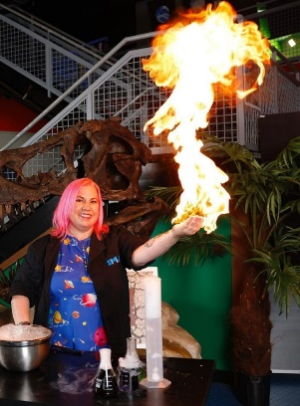Sara Sparks is a native Floridian from St. Petersburg, FL. She is a Maker, Educator, and Entertainer that loves to foster of a love of learning in audiences of all ages, backgrounds, and sizes. Over the past 26 years, she has worked in numerous education organizations overseeing a variety of programs, such as live shows, workshops, field trips, outreaches, virtual programs, and more. She also loves Godzilla, dinosaurs, Star Wars, traveling, reading, crafting, and baking.

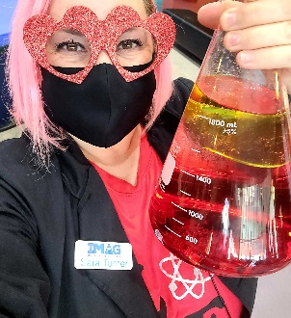available for:

Live STEAM Shows School & Camp Workshops

Birthday Parties Girl Scout Workshops

Homeschool Classes Scouts BSA Workshops

School Family Nights Early Childhood Programs

Events/ Festivals DIY In-Home Parties

work experience:

Director of Awesome and Founder: Make, Bake and Destroy (current)

Resident Scientist: ABC7 More in the Morning Show (current)

STEM Instructor, Skateworld Tampa (current)

Sr. Director of Awesome: IMAG History and Science Center

Education Director: Community Stepping Stones

Sara Sparks

Director of Awesome

Founder & Director of Awesome

of Make, Bake and Destroy

Current Resident Scientist

for ABC7 More in the Morning (Mondays @ 9:45am)

Current STEM Instructor

for Skateworld, Tampa

Former Senior Director of Awesome

for the IMAG History and Science Center

Former Director of Guest Experience

For the Museum of Science and Industry, Tampa

20+ Years of STEAM Education Teaching & Curriculum Development Experience

Dual Master’s Degrees

Licensed & Insured

School District Approved Vendor with Level 2 Clearance

Director of Guest Experience: Museum of Science and Industry

Executive Director and Founder: The PinkCricket

Director of Education: Great Explorations Children’s Museum

Education Programs Coordinator: Hands’ On Children’s Museum Poetry Out Loud Coordinator: Washington State

Arts Liaison: First Lady of the State of Florida

Education:

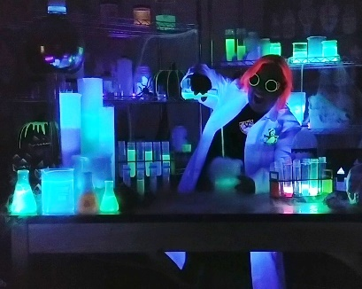University of Miami:

Bachelor’s Degree in Art

Minors in Environmental Studies & Biology

Florida State University.:

Master’s Degrees in Art Education

Master’s Degree in Applied American Policy

Master’s Certificate in Museum Studies

Child Development Associate

Florida Childcare Director’s Credential

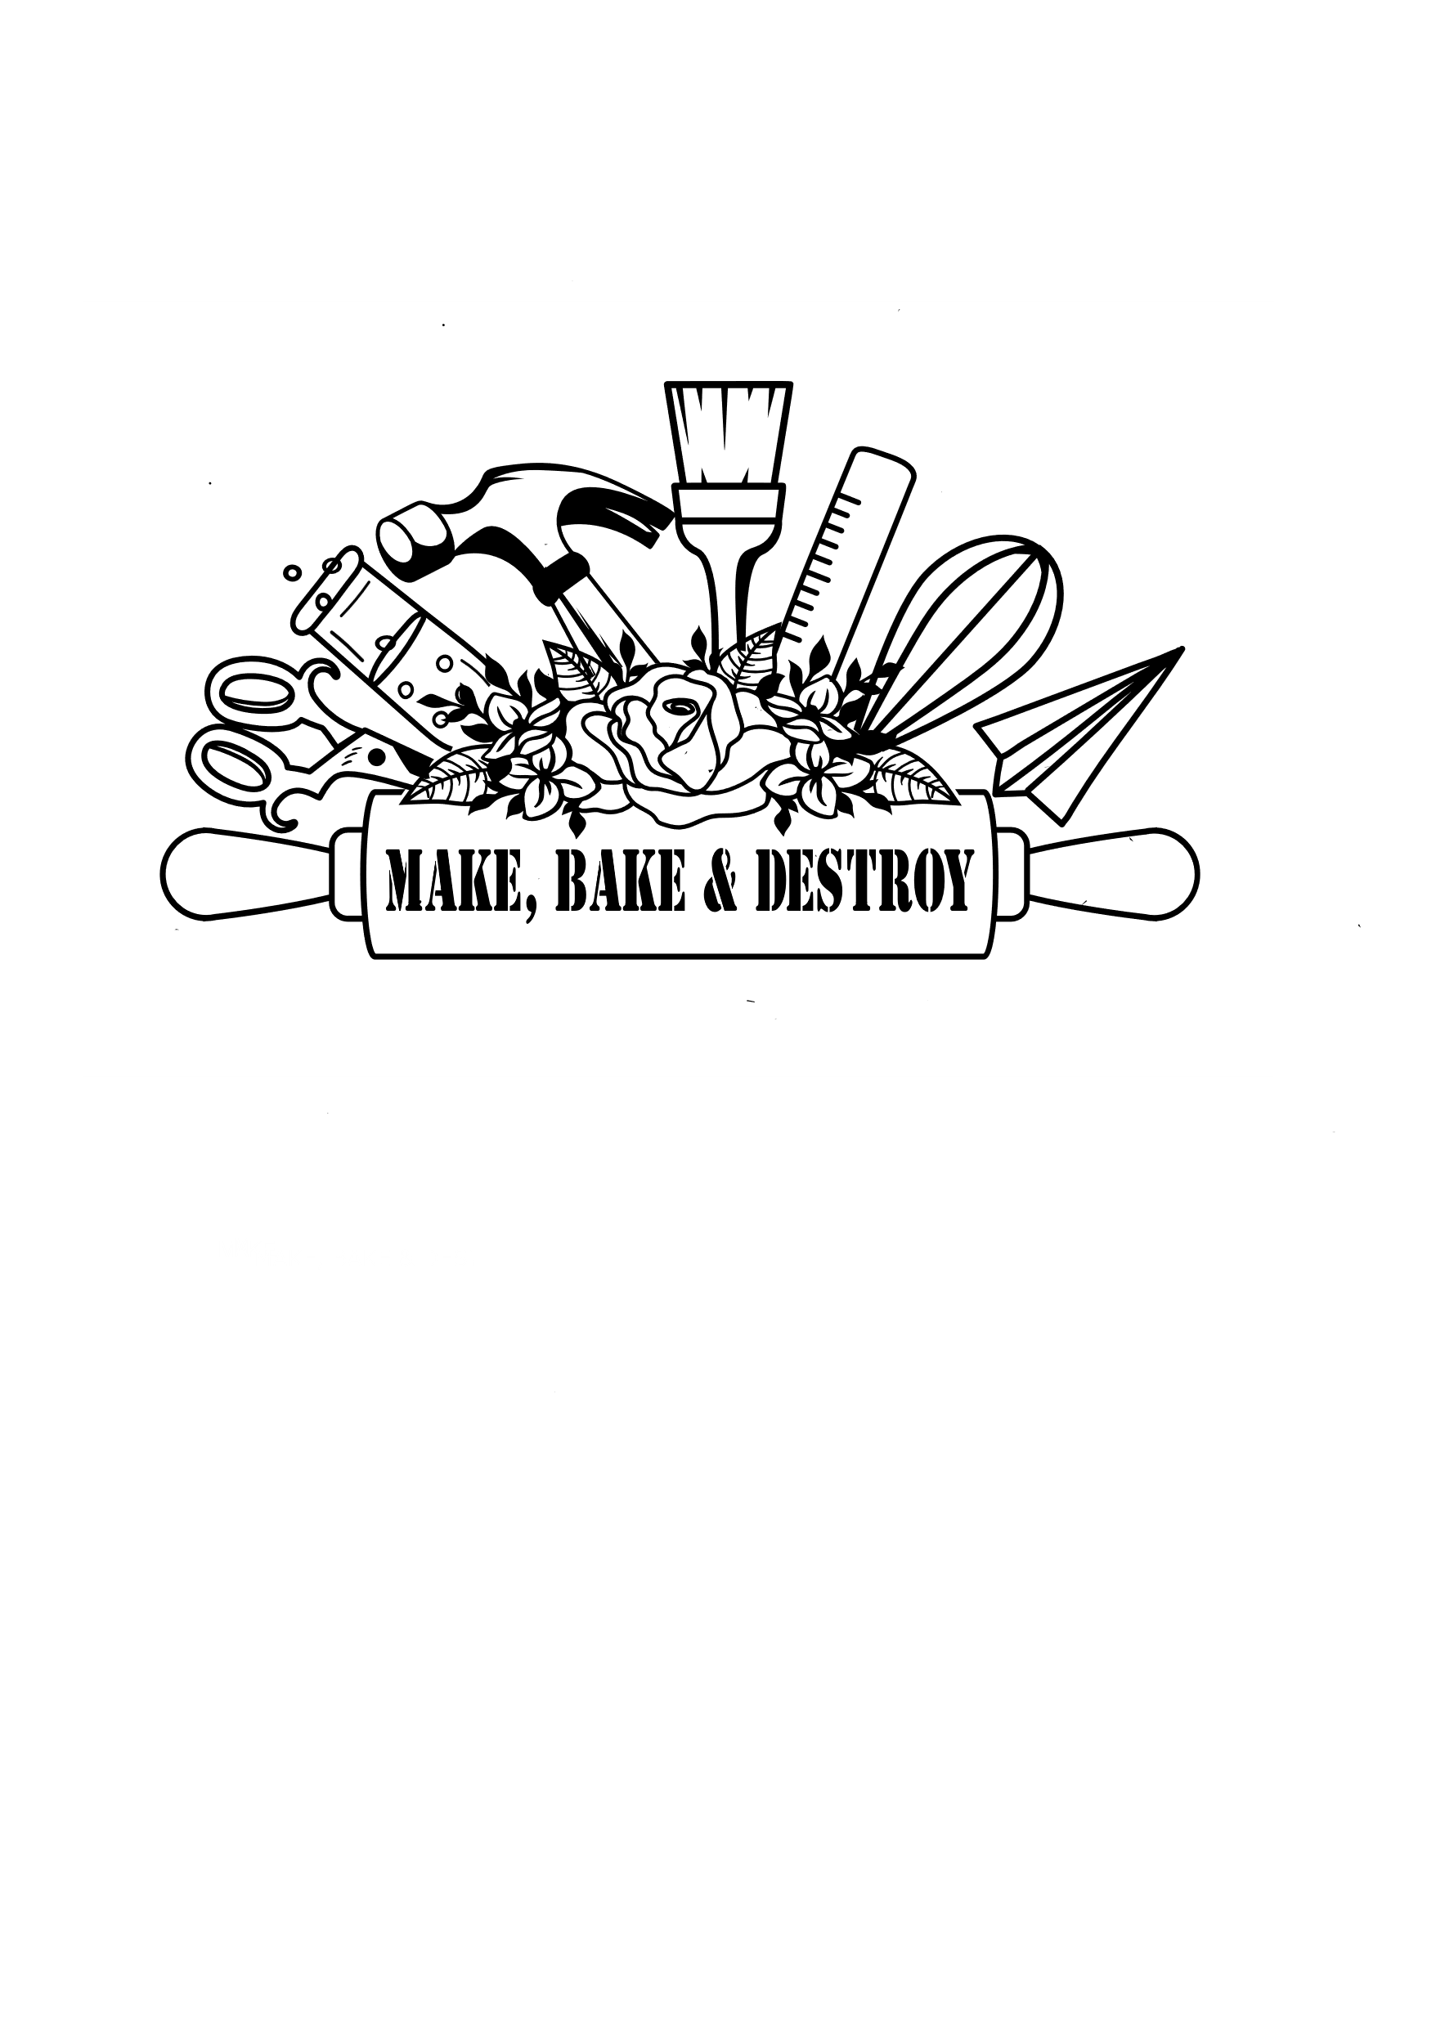

[**MakeBakeandDestroy@gmail.com**](mailto:MakeBakeandDestroy@gmail.com) **(239)406-3243 www.MakeBakeandDestroy.com**