Moses: A high tenor (sings up to Bb) with a thrilling voice and large range. Vocal range top: A4 Vocal range bottom: Bb2
For the Rest of My Life
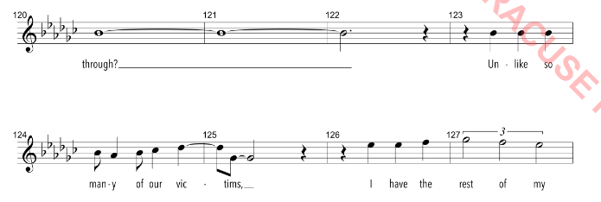
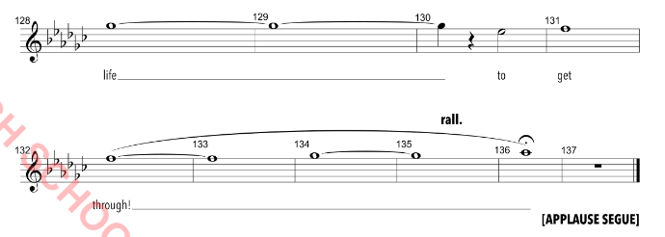

Ramses: A strong tenor (sings up to G#), but with a well-developed lower range. Vocal range top: A4 Vocal range bottom: Bb2
Make it Right
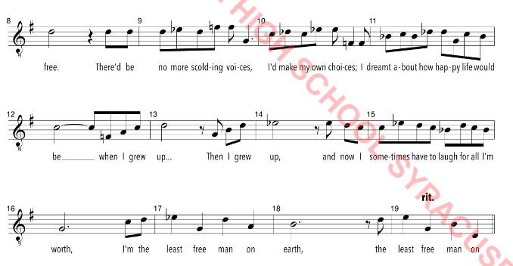

Seti: A low baritone/bass. Vocal range top: E4 Vocal range bottom: B2
One Weak Link
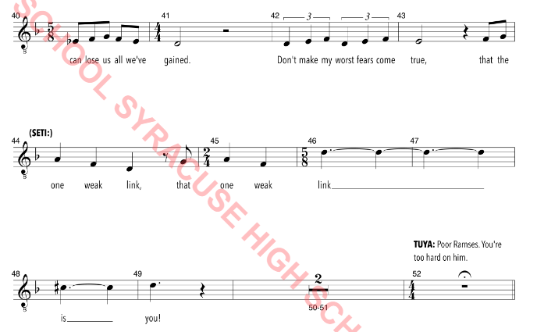

Hotep: Strong baritone. Vocal range top: F4 Vocal range bottom: G#2
Aaron: Tenor or high baritone. Vocal range top: G4 Vocal range bottom: B2

Return to Egypt
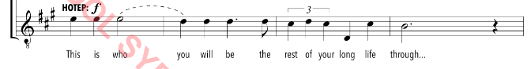
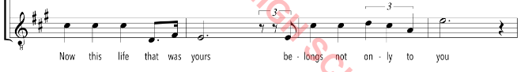

Jethro: A high baritone (must sing up to G) with a strong warm voice. Vocal range top: G4 Vocal range bottom: A2
Heaven’s Eyes
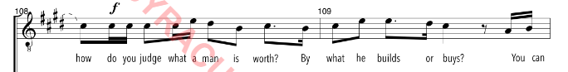
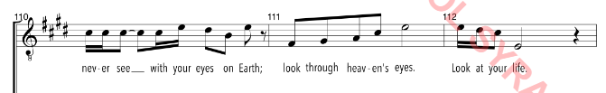
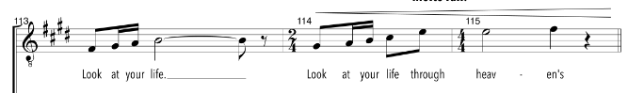
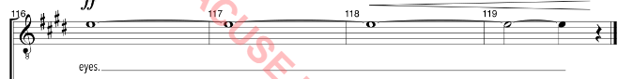

Miriam: Strong rich belt Vocal range top: Eb5 Vocal range bottom: G3
Young Miriam/Young Girl: Vocal range top: C5 Vocal range bottom: G3
Tuya: Rich alto voice. Vocal range top: E5 Vocal range bottom: G3

When You Believe
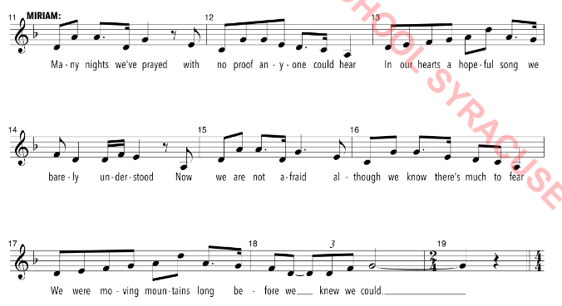

Yachoved: Alto voice, sings in Hebrew and English. Vocal range top: E5 Vocal range bottom: G3
Deliver Us
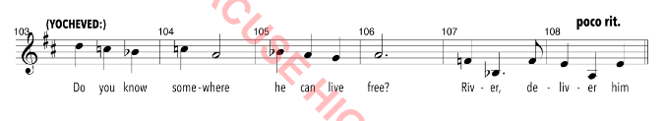
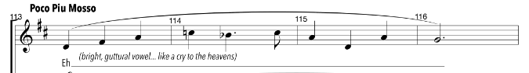
Tzipporah: Must have a thrilling high belt, but also a well-developed mix; must also dance well. Vocal range top: E5 Vocal range bottom: Ab3
Leah & Keturah: Vocal range top: C#5 Vocal range bottom: B3

Dance to the Day
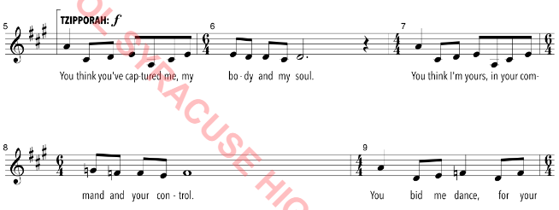
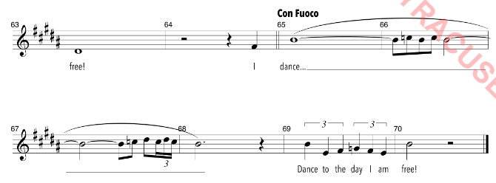

Nefertari: Strong rich belt, high alto. Vocal range top: D5 Vocal range bottom: B3
Heartless
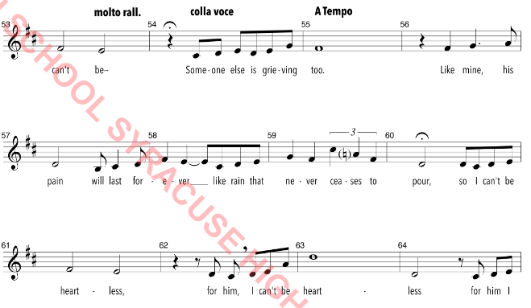

Possible Duets:
Always on Your Side-Moses/Ramses
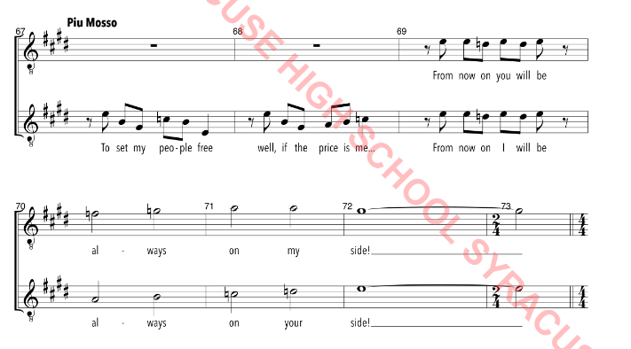

When You Believe-Miriam/Tzipporah
