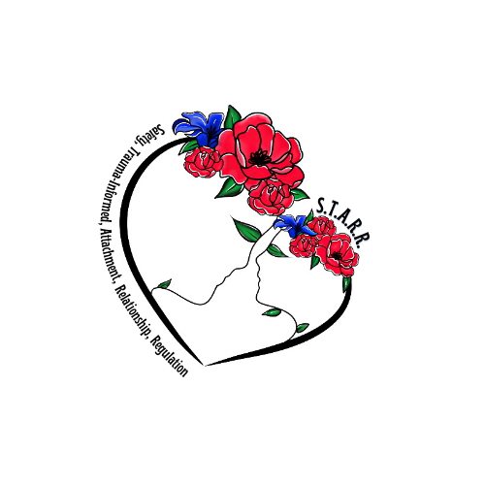

***The STARR Approach 6.5 CEU training for Clinicians:***

***(Safety, Trauma-informed, Attachment, Relationship, Regulation)***

***The STARR program and approach is based on knowledge of early childhood development, impact of trauma and adversity on the brain and body, the sensory systems, individual differences, social emotional development and the nervous system. STARR is a relational based trauma informed approach utilizing coregulation, bottom up and top down strategies.***

***The STARR Approach is also offered as a training for schools, support staff, care givers, as well as any programs working with youth who have been impacted by trauma.***

***Please contact J & H Healing Therapy at 609-636-6440 for further information regarding the STARR approach***

***and trainings.***