**Hydrostatic Test Unit**

**The High-Pressure Test system is an air over hydraulic system. The unit is designed to be low maintenance and user friendly. The test stand lay out is designed to be functional in most any shop location. The unit is provided with casters to be maneuvered in most any position. The side shelves will raise and lower to accommodate tight positions in testing areas or open fully to allow our digital test computer system to be utilized.**

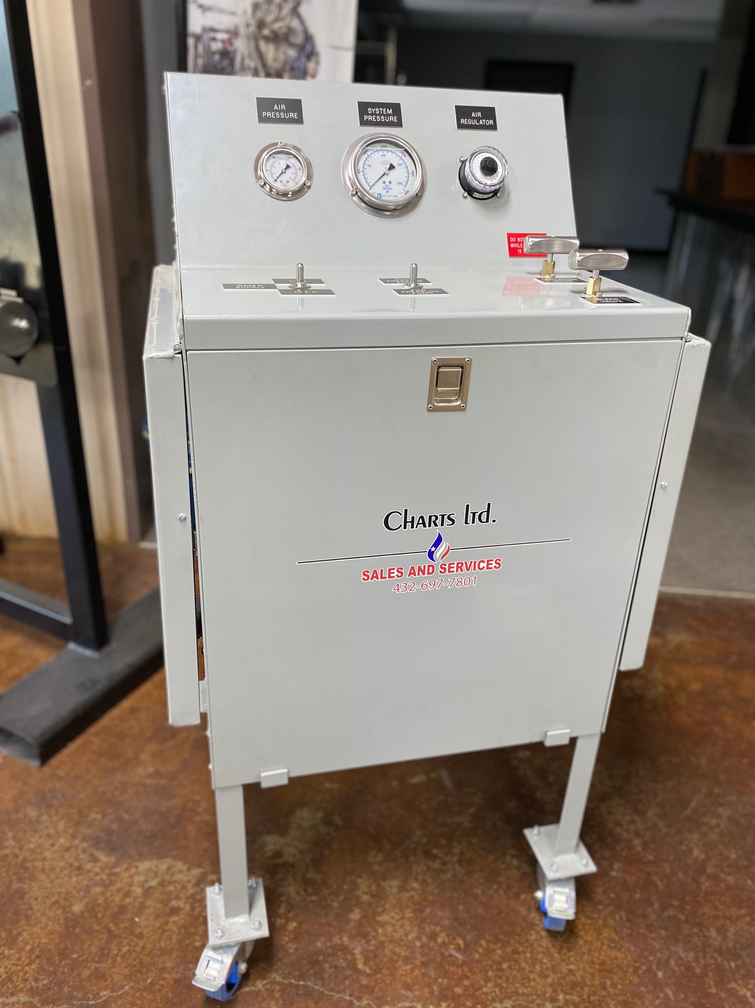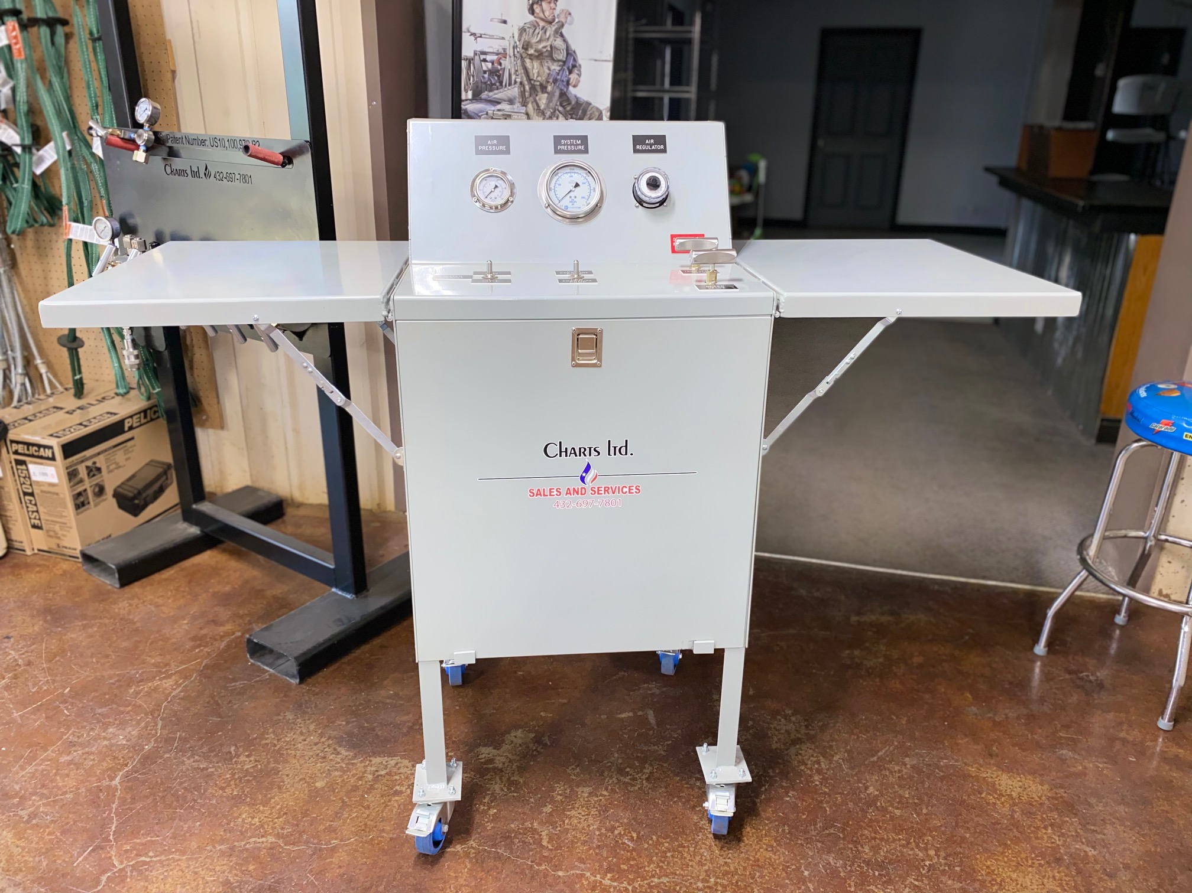

**The pump is supplied with a medium pressure and high pressure air over hydraulic pump manufactured by Hydraulics International. The medium pressure pump will produce approximately 5,500 psi. The displacement per stroke is 1.88 cu in per stroke. The high pressure side is capable of 30,000 psi. The displacement is .48 cu in per stroke. All the pumps are enclosed within the body of the test unit. The pumps are operated through the panel controls at the test unit control center. Pumps are actuated through a momentary safety switch. The user must maintain control of the switch. If it is released then the pump will stop. This is designed to make sure the user has physical and visual control of the pump system at all times. The control unit has an air actuated switch to turn the water on and off. The unit has a 30,000 psi gauge and 200 psi air gauge. The air is operated by an easy to use dial regulator. The unit is supplied with a two turn bleed valve and an isolation valve. Once pressure is achieved the isolation valve is closed and pressure is trapped between the isolation valve, chart recorder (or transducer if using our computer system) and the component being tested .**

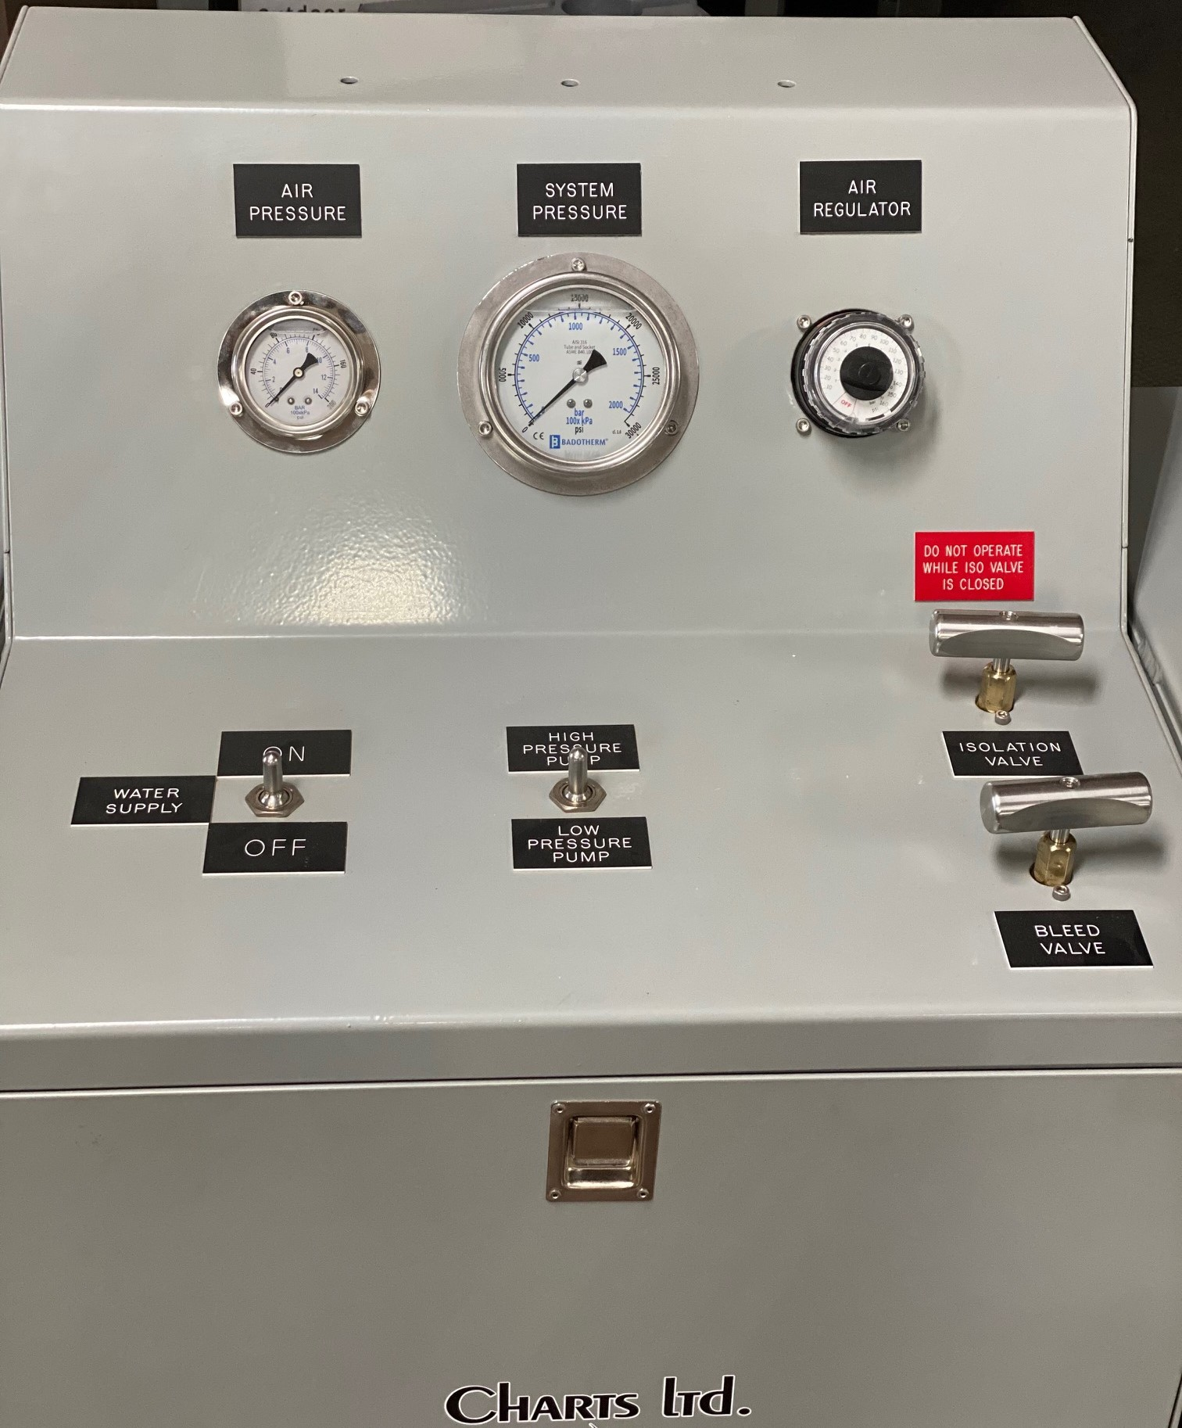

**The water inlet, air inlet, discharge, primary outlet, and secondary outlet are located at the rear of the unit for easy access as seen in the picture below on the left. The unit also comes with the recommended air filter and water filter. The two units combined and maintained are highly recommended to extend the life of the pumps. All units will have the air and water filter piped and installed as seen in the second picture to the right.**

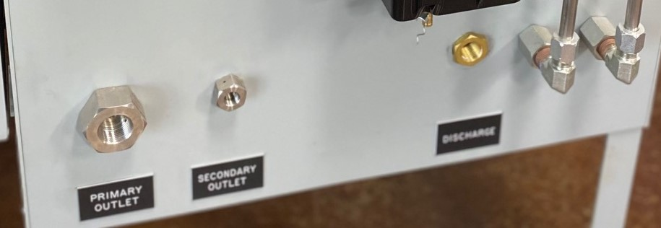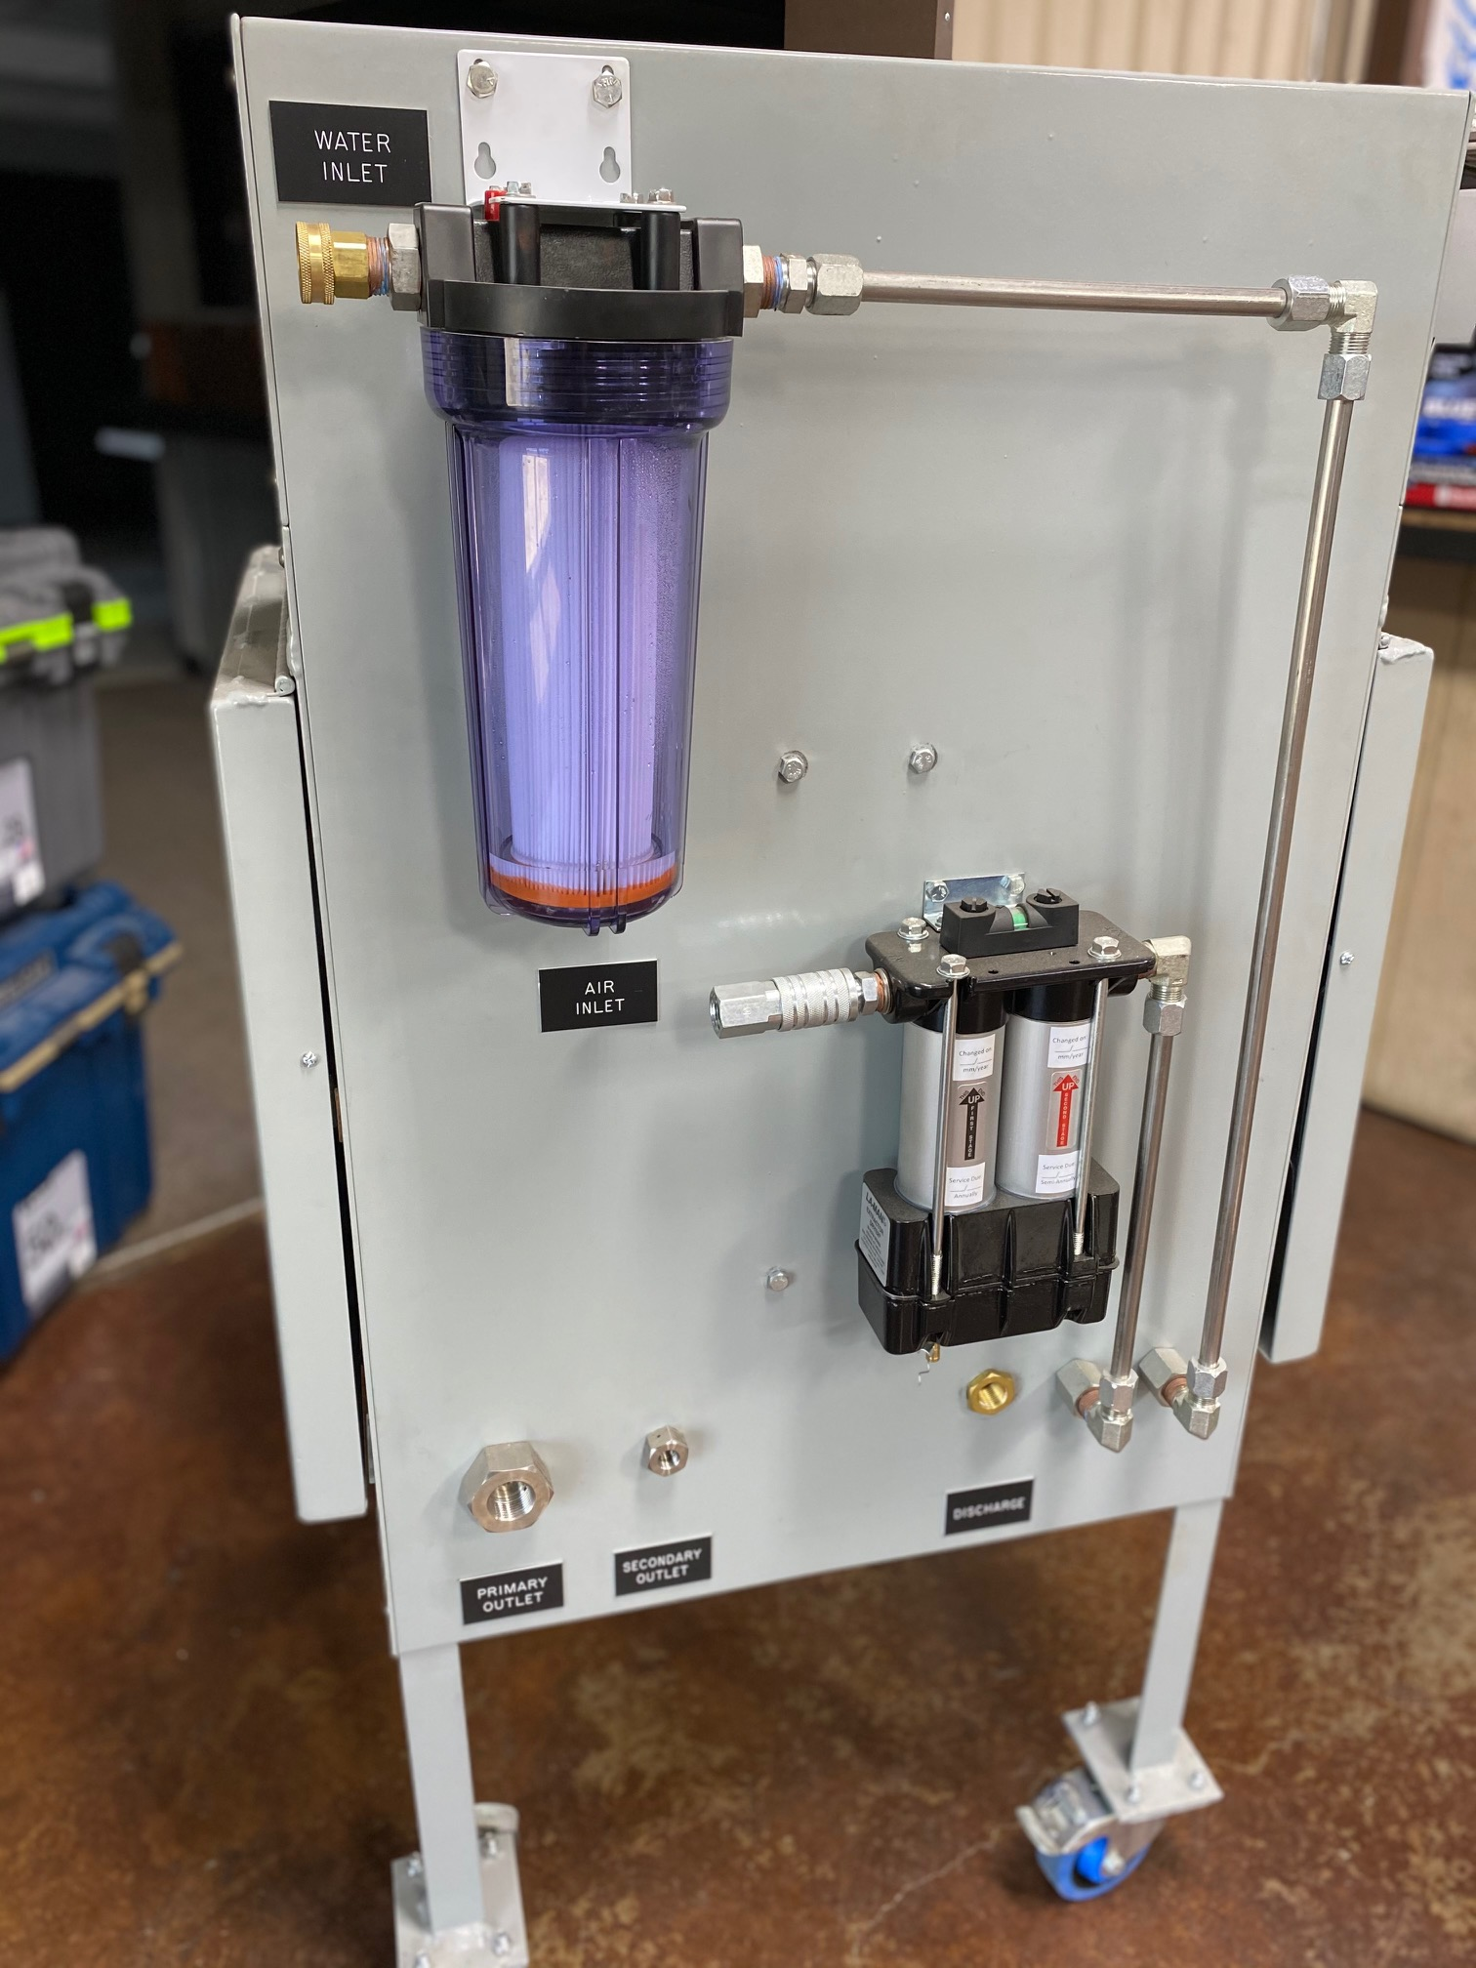

**The test units are designed with the end user in mind. Ease of use, easy to maintain, and versatility. Customer request and modifications can be requested and if feasible the unit can be modified to fit the customers extra needs.**

**For Information Please Contact:**

**Lee Gouge**

**Cell: 318-453-6001**

**Shreveport Air Tool (Owner)**

[**Email: lee@shreveportairtool.com**](mailto:lee@charts-ltd.com)

**Or at:**

**Lee Gouge**

**Cell: 318-453-6001**

**Charts-Limited Division Manager / Sales**

**Email:** [**lee@charts-ltd.com**](mailto:lee@charts-ltd.com)