Grease Manifold System

patent number: US 10,100,978 B2 date October 2018

The patented grease manifold system is a multi port manifold system designed to greatly reduce time involved while greasing during fracking or other greasing operations. The tedious job of removing the WKM grease adapter fitting and moving it from one grease port to another is eliminated with this process. With the ability to grease up to 12 grease fittings, the manifold can either be mounted on the valve with the custom bracket, on the stand, on one of our custom mobile grease units or trailers near the tree. This allows the operators direct accessibility to the main manifold for operation. Once the grease pump has been attached to the grease manifold, the operator will be able to control the flow of grease to each individual grease fitting without having to leave that station. The way the manifold system works is the output of the pump is directed to the inlet of the main manifold bank where it is distributed through mini manifolds that are already attached to the grease fittings on the tree. The operator will turn on the grease pump to allow it to provide the appropriate amount of PRESSURE; from there all the valves on the main manifold are closed. once the operator is ready to grease he will open each independently operated manual needle valve allowing grease to go into each fitting. The operator will open one needle valve at a time assuring that the one grease fitting will be getting the amount of grease required. The operation continues until all fittings have been properly lubricated to the manufacturers specification or that particular companies standard operating procedure. The grease unit (pump) would then be able to be shut off and the residual pressure would be captured.

I have included varied safety systems incorporated into the grease manifold system to prevent damage to the pump and/or preventing “runaway pressure” due to failure in A grease fitting. Each mini manifold is equipped with a needle valve, gauge, and check valve. If fitting failure occurs, the mini manifold will show pressure on the gauge. This will visually alert the operator that pressure is present; the operator, in addition to already having checked the fitting, can then close the mini manifold needle valve allowing them to disconnect the hose after the job has been completed. I have included an additional check valve at the grease input connection as an extra safety **MEASURE.**

I have also designed the system to be operated by a single operator. For this operation, the operator would attach the grease manifold system as normal with the exception of closing the needle valves on the mini manifolds and opening the needle valves on the main manifold. This will allow the operator to operate the handles on the tree while applying grease to the valve being operated at each location by the operator through the use of the mini manifolds. The system used in this manner, of course, still maintains the integrity of safety designed within the unit.

This is a picture of the Generation 3 Grease Manifold System.

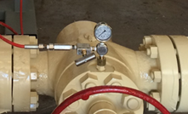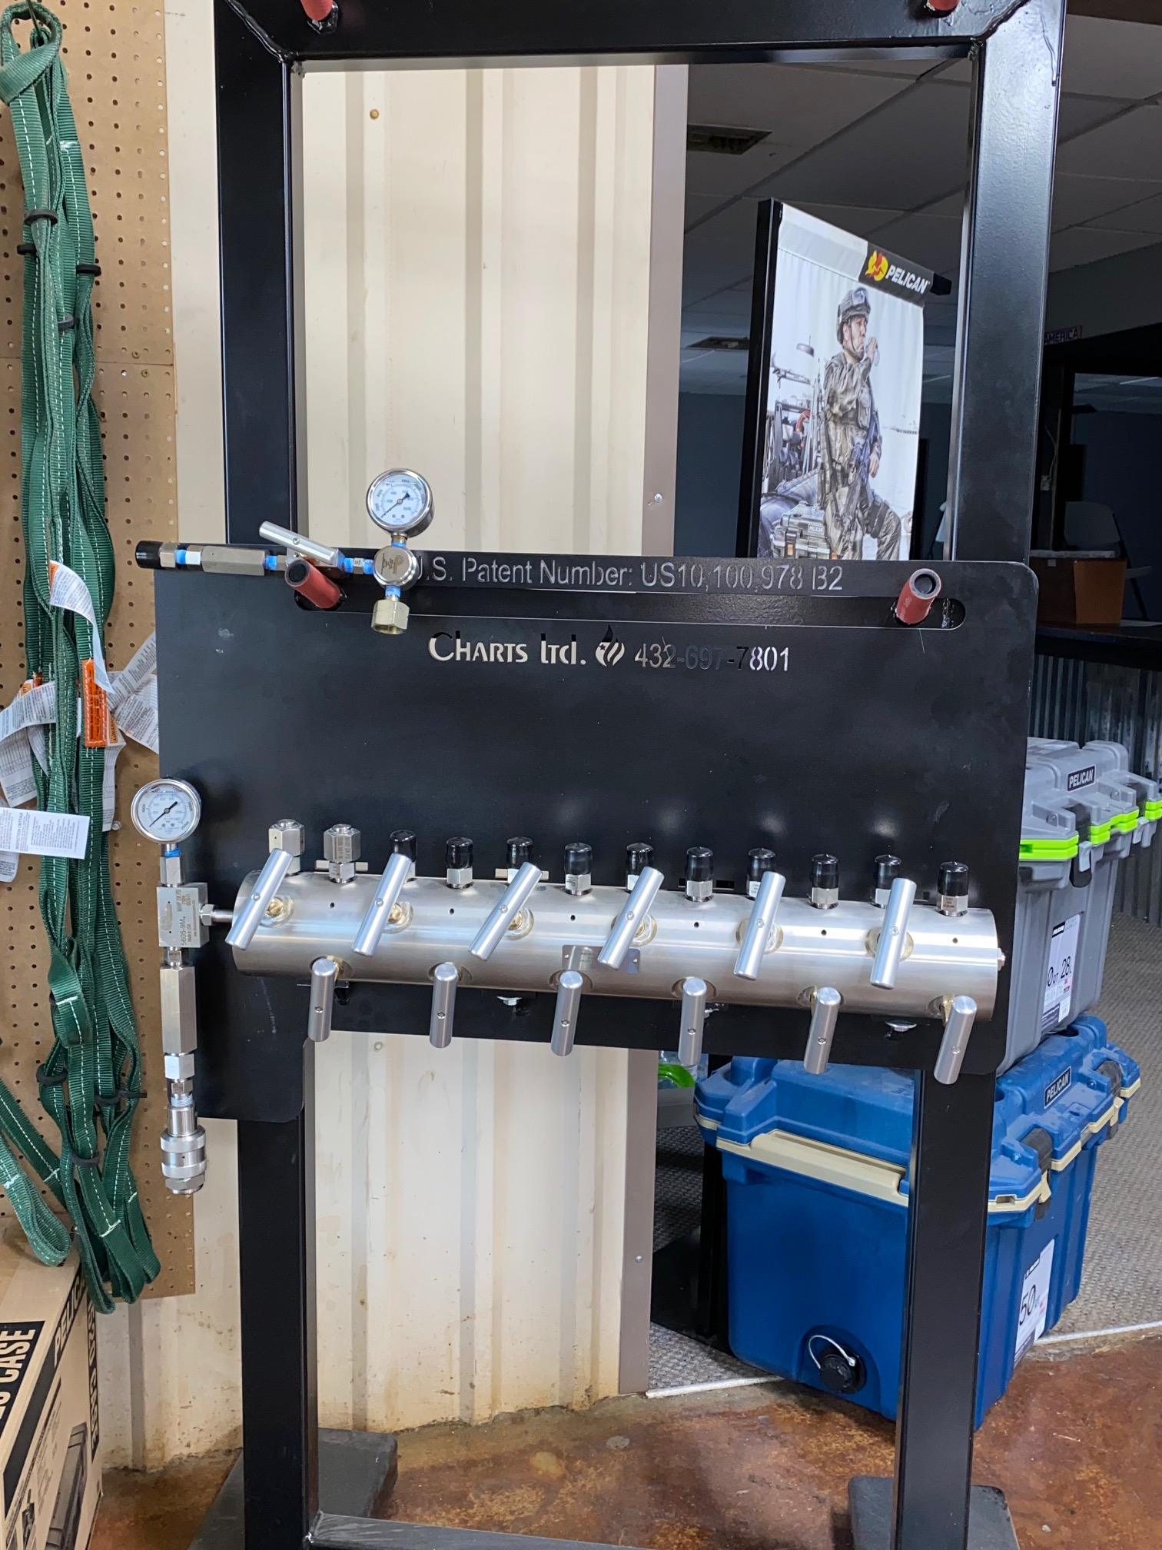

This is one of our MANY Grease units. They can be custom designed for specific customer uses. Size configuration can be small or larger like the mobile unit pictured below.

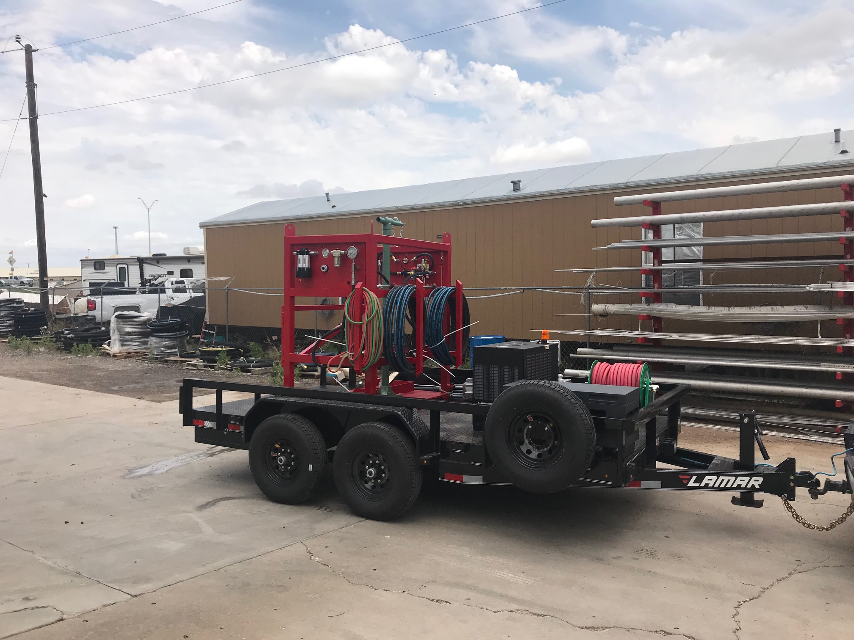

**For Information Please Contact:**

**Lee Gouge**

**Cell: 318-453-6001**

**Shreveport Air Tool Owner**

**Email: lee@shreveportairtool.com**

**or**

**Charts-Limited Division Manager / Sales**

**Email: lee@charts-ltd.com**