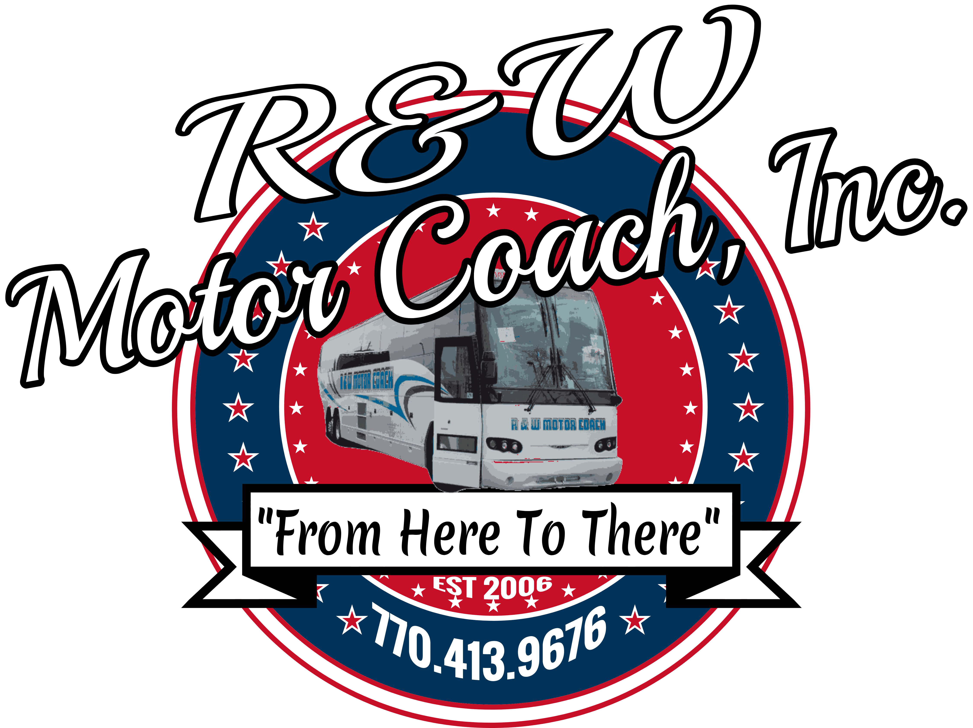

Date of Service:
Number of People:
Pickup Location Address:
Pickup Time:
Departure Time:
Destination Address:

Return Pickup Time:
Return Pickup Location Address:
Return Destination Address:

Email this form to: alan@randwmotorcoach.com and we will respond the next business day

