**Sea Glass Earring Colors**

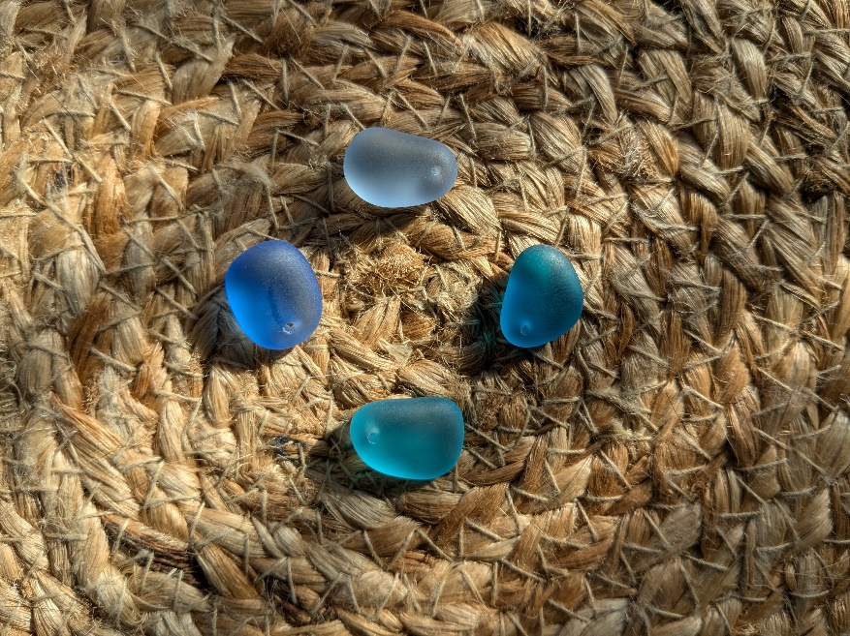

Pale Blue (top)

Dark Turquoise (right)

Light Turquoise (bottom)

Cobalt (Left)

**Wire Choices**

14k gold plated sterling silver plated