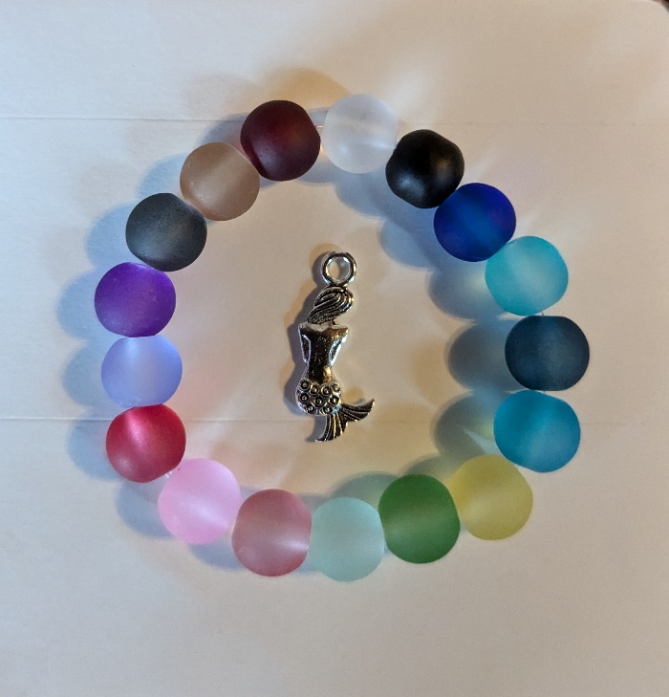
Mermaid Life Bracelet Colors:
White Pink
Black Red
Cobalt Light Purple
Light Turquoise Dark Purple
Navy Dark Gray
Dark Turquoise Light Brown
Yellow Dark Wine
Green
Pale Green
Rose

