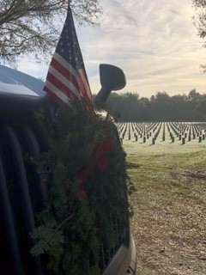
December is a particularly important service project month for the Dade City Woman’s Club. Wreath's Across America is one of the club's main sponsorship projects each year. The Wreath’s Across America mission and core values speak directly to the heart of the Dade City Woman's Club own values and mission. Many of our members have active duty, veteran, or special ties to the armed services. The Dade City Woman’s Club is part of the Wreaths Across America Group Sponsorship Program which helps like-minded charities, community programs and civic groups through the sale of wreath sponsorships for participating locations. Wreaths Across America’s mission is simple: Remember the fallen, Honor those that serve, and Teach the next generation about the value of freedom.
Your donations in 2021 helped to lay 2.4 million wreaths for our nation’s heroes on December 18th, 2021, National Wreaths Across America Day!

