**FLORIDA ANESTHESIA ADMINISTRATORS’ ASSOCIATION **

Friday, June 6, 2025 - 7:00 a.m. – 5:00 p.m.

**The Breakers Hotel**

*1 S. County Road, Palm Beach, Florida*

**MEETING REGISTRATION FORM**

|  |  |  |  |  |  |
| --- | --- | --- | --- | --- | --- |
| **In-Person (FAAA Members)\*** | $350 (**if paid before 03/31/25**  $400 (on/after 03/31/25) |  | **Membership (New)** | $150 |  |
| **In-Person (Non-Members)** | $495 (includes FSA Registration Fee) |  | **Membership (Renewing)** | $125 |  |
| **Virtual (Member)** | $175 |  | **Summer Meeting Late Registration**  (if registering after June 1, 2025) | $50 |  |
| **Virtual (Non-Member)** | $250 |  | ***Total Enclosed*** | $ | |

***\* Meeting fee includes FSA registration fee***

Name:_________________________________________ email:_________________________________________

Name:_________________________________________ email:_________________________________________

Name:_________________________________________ email:_________________________________________

Company:_______________________________________________________________________________________________

Company Mailing Address:________________________________________________________________________________

City:_________________________________ State:__________________________ Zip:_____________________

Phone:_______________________________ Fax:___________________________ Contact:__________________

|  |  |
| --- | --- |
| **Payment Method** | **Payee** |
| ***Zelle*** | [thefaaa2001@gmail.com](mailto:thefaaa2001@gmail.com) |
| ***Credit Card\**** | FAAA (Please provide an email address for delivery of the invoice; You will pay this securely online via Chase). All major credit cards accepted. |
| ***Check*** | FAAA (See address and contact below) |

**\*Your credit card statement will read “DB Healthcare Consulting”**

Check enclosed for: $__________________

Please make your check payable to FAAA and mail it to:

Florida Anesthesia Administrators Association

c/o Kelly Dennis, Perfect Office Solutions Phone: 1-352-787-7869

P O Box 490447 Email: [thefaaa2001@gmail.com](mailto:thefaaa2001@gmail.com)

Leesburg, FL 34749-0447

Hotel Information:

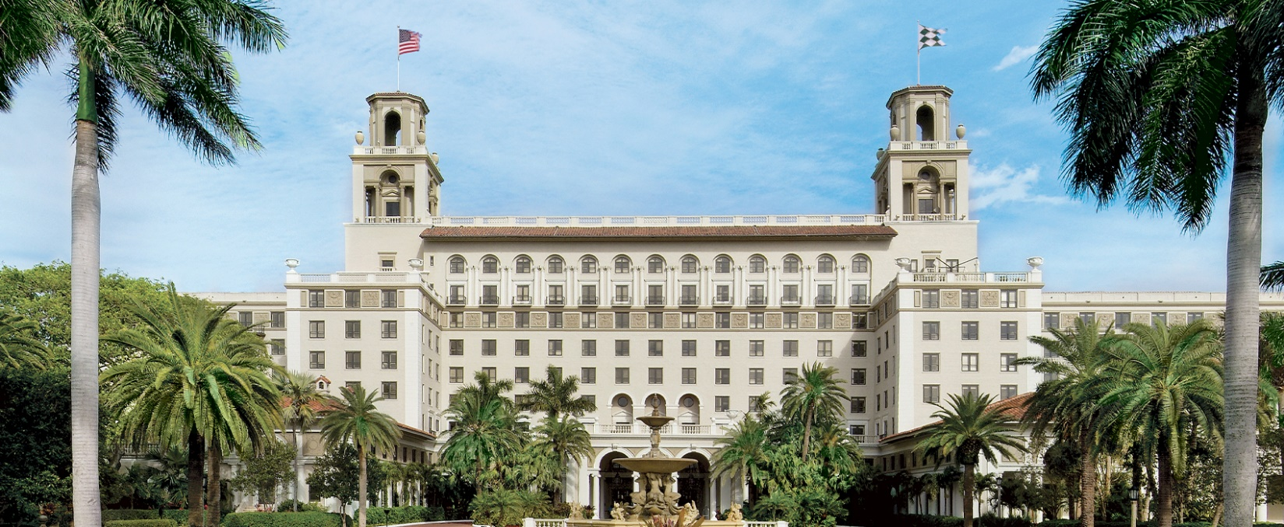

<https://www.thebreakers.com/>

The Breakers – The meeting will be held on Friday. Registration also entitles you to attend the FSA meetings, so check both agendas, when they are available!

Although the FSA is unable to provide rooms from their block for our FAAA members this year, The Brazilian has a shuttle to The Breakers.

<http://www.thebraziliancourt.com/>

The Brazilian Court (1.4 miles from The Breakers) - 10 block rooms for Thursday, Friday, and Saturday are available at $319.00 per night + tax, with discounted valet parking ($29 instead of $40 per night).

301 Australian Ave, Palm Beach, FL 33480,

Group Reservations (561) 655-7740

Must mention FAAA Room Block – register BEFORE 5/5/25 when our block expires.

Individual Cancellation Policy: Reservation must be canceled at least 14 days prior to arrival to avoid: 1-night room rate charge for 1-night reservations and/or 2-night room rate charge for reservations of 2 or more nights.

Feel free to book a hotel nearby, if you are able to find a better rate! Please send questions to any FAAA Board member. We hope to see you there and thank you for continuing to support the FAAA!

|  |  |  |  |
| --- | --- | --- | --- |
| **Board Members** | **Role** | **Group Affiliation** | **Email** |
| Bart Edwards | President | Sound Physicians | [baedwards@soundphysicians.com](mailto:baedwards@soundphysicians.com) |
| Dr. John Koncelik | President Elect | Anesthesiologist | [johnkoncelik@yahoo.com](mailto:johnkoncelik@yahoo.com) |
| Doris Branker* | Legislative Liaison | DB Healthcare Consulting | [Doris@brankercodingcamps.com](mailto:Doris@brankercodingcamps.com) |
| Aaron Beckstedt | Secretary | Coronis | [aaron.beckstedt@coronishealth.com](mailto:aaron.beckstedt@coronishealth.com) |
| Dennis, Kelly | Treasurer | Perfect Office Solutions | [kellyddennis@attglobal.net](mailto:cfaa101@attglobal.net) |
| Sandra Rodriguez* | Past President | Envision | [Srodriguez0315@gmail.com](mailto:Srodriguez0315@gmail.com) |