

Dunscore Pre-school Centre

**Trustees’ Annual Report**

1 April 2023 – 31 March 2024

**Dunscore Pre-school Centre,  
The Old School,  
Dunscore,  
Dumfries,  
DG2 0SY**

**01387820273**

**info@dpsc.org.uk**



**Dunscore Pre-school Centre**

Scottish Charity Number: SC014199

Address:Dunscore Pre-school Centre,  
The Old School,  
Dunscore,  
Dumfries

Postcode: DG2 0SY

Telephone number: 01387 820273

Email address: info@dpsc.org.uk

Website: www.dpsc.org.uk

Facebook profile name: @dunscore

**Charity Trustees**

The following parents and members of the community were the trustees for Dunscore Pre-school centre in 2020/23:

1. Flora Milligan & Claire Henderson (Chairs)
2. Zoe Kirk (Treasurer)
3. Jenny Batchelor (Secretary)

The following parents and members of the community were the trustees for Dunscore Pre-school centre from Nov 2023:

1. Jenny Batchelor (Chair)
2. Fiona Clanachan (Vice-chair)
3. Hollie Carey (Treasurer)
4. Laura Heron (Secretary)

**Structure, governance and management**

Type of governing document

The Pre-school is governed by its constitution. The Pre-school is contracted by Dumfries & Galloway Council to run Early Learning and Childcare provision for 3 to 5-year olds, is registered with the Care Inspectorate under the Regulation of Care (Scotland) Act 2001 and is a member of the Early Years Scotland.

Trustee recruitment and appointment

The Trustees are responsible for the management of the Pre-school in conjunction with the manager, playleaders and administrative personnel. Trustees must either be a parent or guardian of a child registered at the Pre-school or elected to the Pre-school Council by parents/guardians. All parents/guardians of children at the Pre-school are automatically members of the Pre-school Council, from which Trustees and the Parent Forum are elected. Other people with an interest in Pre-school education within the community can become Council members and attend meetings. Members of the Parent Forum including trustees are elected from the Council at the Annual General Meeting by the usual process of nomination, seconding and election.

**Objectives and activities**

**Charitable purposes**

The organisation is a non-profit distributing voluntary organisation, which aims to advance the education and social development of pre-school children and their parents and other appropriate persons, through the provision of early learning and childcare sessions, as well as sessions for parents with their babies and toddlers. It aims to provide a safe, caring environment where children can thrive, help all the children become independent in all aspects of life, play and learning, ensure children know they are important and listened to, inspire a love of learning, equip them with the knowledge and skills for today's society, provide activities which offer appropriate challenges for every child, work with parents and community to provide the best for all the children at the centre. In furtherance of the above aims the group shall seek to: (a) provide safe and satisfying group play and learning (b) to encourage other charitable activities through which parents may support the development of children.

**Summary of the main activities in relation to these objects**

Our setting provides Early Learning and childcare for a maximum capacity of 16 children 3-5 years of age during school term times. Session times are 8:30am to 4pm, Monday to Thursday. Lunch is provided during the sessions. We have a strong and very positive relationship with the Primary School which provides many opportunities for joint activities and makes transitions easier for children. A toddler group operates on occasional Fridays in the pre-school centre. Children attend this with their parents or carers, and it is run by the parent volunteers. This provides an excellent introduction to the centre to both children and families.

**Achievements and performance**

1. **Child Enrolment Overview:**
   * **April 2023:** 14 children enrolled (8 in Rising 5 and 6 in Preschool).
   * **April 2024:** 13 children enrolled (6 in Rising 5 and 7 in Preschool).
2. **Staff Professional Development:**
   * All staff members successfully completed their first aid certificates this year.
   * 2 staff updated their food hygiene certification.
   * The manager is continuing her BA in Childhood Practice.
   * In February 2024, staff attended a professional development session organised by Dumfries and Galloway, where a staff member was asked to share her insights on forest sessions.
3. **Curriculum and Learning Highlights:**
   * **Summer Term:** Focused on space with creative art projects and learning about the universe.
   * **Autumn Term:** Explored "People Who Help Us," where children created their own shops and learned about various community roles.
   * **Winter (December):** The theme was Christmas, with festive activities and learning.
   * **Spring Term:** Covered seasonal festivals, including Chinese New Year and World Book Day, providing enriching cultural experiences.
4. **Field Trips and Special Activities:**
   * **Summer Term:** Trip to Dark Space and Kirkcudbright Cocoa Bean.
   * **Autumn Term:** Visits to Tesco and the Donkey Sanctuary.
   * **December:** The Christmas play brought joy to the preschool community.
   * **February:** Collaboration with the Fair Trade group, focusing on global awareness.
5. **Facilities Update:**

In the summer of 2023, the preschool's roof required repairs. We are grateful to David Crosby from Nithdale Roofing, who generously discounted labour costs and donated materials.

1. **Challenges and Future Considerations:**

One ongoing challenge is determining the ideal hours needed based on the children attending the nursery. We will continue to evaluate this to ensure the best service for our families.

**Conclusion:**

It has been a successful year, thanks to the dedication of our staff, the support of parents, and, of course, the enthusiasm and joy brought by the children.

The trustees would like to thank everyone who has made any contribution to the running of the Centre whether large or small.

A huge thank you to Caroline, Rachel and Laura for all their hard work and enthusiasm in making the Pre-School a happy and fun place for our children. Thank you to our administrator Morag, also without whom the centre would grind to a halt. Also, to Donna who has made a great difference to the cleaning and ease of set up for other staff.

The children have benefited from some wonderful sessions led by parents and we’d like to thank all those that have contributed to these as well as those who helped with ad hoc jobs for the Pre-School. The Pre-School benefits hugely from all the support and involvement that parents can offer. The community spirit is one of our greatest assets.

**Financial review**

Our accounts for the financial year ending 31 March 2024 show an income of restricted and unrestricted funds of £56,141 (£69,619 and £94,812 in the previous two financial years). Expenditure this year was £65,251 (£70,213 and £63,961 in the two previous budget years). So, despite cutting our spending the decrease in income (in particular a decrease of £16,646 in funding from D & G Council) had a significant impact on our financial stability. This year we continued to run four 7.5hour sessions per week.

The Pre-school is funded on a per capita basis by Dumfries & Galloway Council. As well as lower numbers of children enrolled many were split placements leading to lower payments.

A bank balance of £72,980 (compared to £81,915 and £82,358 over the last two years) includes a reserve of £54,346.

We would also like to thank all those who have supported our fundraising, given donations and provided contributions. Fundraising by parents and friends contributed £672 this year towards the running of the Centre.

We appreciate Dunscore Pre-school relies on the good will and expertise of many people and organisations in order to carry out the work we do.

**Statement of the charity’s policy on reserves**

The policy is to keep a reserve to cover closure costs (including statutory wage payments) or emergency building repairs. This benefitted this year from an excellent rate of interest and the sum held was increased by £1,101 to £55,447. This will need a further review / increase in future years in to take cognisance of increased staff wages due to inflation and new staff for the After School Centre, along with the increase in building costs.

**Details of any deficit**

This year there was a deficit of £9,110 in the total costs for the centre. Careful management will be needed next year to ensure that the centre is able to balance costs, particularly with the start-up costs which will be necessary for the new After School group. Once this is accounted for the bank balance will stand at £83,416.

Once this is considered there were no deficits on any of the funds this year.

**Donated facilities and services**

As we own our own premises, we are not reliant on donated facilities. Parents and members of the community generously donate their time to help with a range of activities. In particular, we would like to thank David Crosby of Nithdale Roofing, who generously discounted labour costs and donated materials to make our roof fully weathertight.

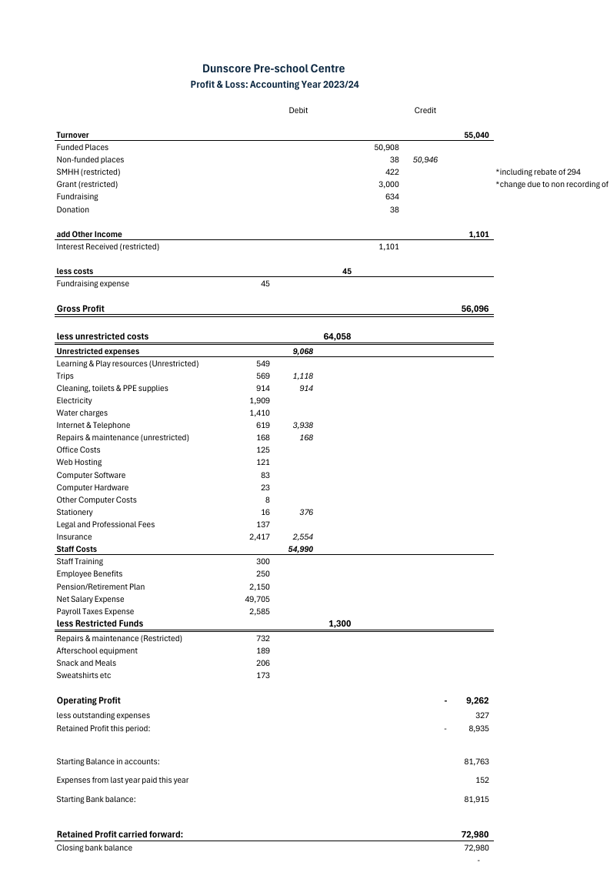

**Future plans**

Moving forward, the setting continues to review our overall capacity for improvement. One key factor is to take on a new after school provision. Staff have been recruited to start once all the relevant permissions have been granted. Hopefully this will go some way to increasing the viability of the centre.

After the Summer the manager will be on maternity leave. Plans are already in place as to how this leave will be covered in order to minimise disruption to the children at the centre. We will continue to work with the Early Years Team at Dumfries and Galloway Council to improve our planning, tracking and monitoring.

Flora Milligan Chair

Jennifer Batchelor Secretary