Can arts-based research practices such as the pedagogy-of-storytelling and narrative inquiry be fused with social and critical practices to aid in the transformation of Swiss education … towards what?

By

Christine Anne Berger

Submitted to

The University of the West of Scotland

In part fulfillment of the requirements for the degree of

**MASTER OF EDUCATION**

(Artist Teacher)

July 2016

ABSTRACT

.

Could the incorporation of arts based research via narrative inquiry and storytelling pedagogy aid in a transformation of Swiss art education leading to a more creative and ultimately more innovative student body? Switzerland has a high ranking as an innovative leader (Bfs.admin.ch, 2015) in Europe; but under what context? When reading reports about Switzerland’s national capabilities, e.g. creativity and innovation, one might consider that 21.7% of the Swiss population are foreigners (Rogers, 2010) who have immigrated to take on innovative jobs because there are simply ‘not enough Swiss ‘available, educated or intelligent enough ?) who qualify for these positions (innovation report, year). The question arises if Switzerland’s high ranking in the innovation leadership report is because of the Swiss themselves or foreigner educated abroad in a non-swiss educational System? Could art education, done differently influence Swiss’ indigenous / domestic c capability and quality to create and innovate? And if so, how would it do that?

Then you need to add a closing statement which connects these questions with the research paper you have done.

Research Question and Aims

Research Question:

Can arts-based research practices such as the pedagogy-of-storytelling and narrative inquiry be fused with social and critical practices to aid in the transformation of Swiss education towards what …?

Aims:

To define art education and its application in a generic (academic ?) sense and to explore how that differs with how art education is being used in Switzerland.

To compare and contrast art education between England British ?? national curriculum and the Swiss curriculum.

To define critical thinking in terms of art education.

To define storytelling pedagogy in terms of critical thinking

To define narrative inquiry in terms of critical thinking

To outline how a pedagogy-of-storytelling and narrative inquiry could be fused with social and critical practices. And in doing so to determine how this would influence the Swiss education systems and toward swhat results / ends.

To determine effects a pedagogy-of-storytelling and narrative inquiry could have on everyday classroom practice (in Switzerland ?).

To establish some specific implications a pedagogy-of-storytelling and narrative inquiry could have for the nature of Swiss learning.

DECLARATION

I hereby certify that this dissertation constitutes my own work, that where the language of others is set forth quotation marks so indicate, and that appropriate credit is given where I have used the language, ideas, expressions, writing or visuals of another.

I declare that the dissertation describes original work that has not previously been presented for the award at this or any other institution.

Signed

***Christine Anne Berger Lyons***

Student, Supervisors and Programme

|  |  |
| --- | --- |
| Student name: | Christine Anne Berger Lyons |
| Student ID number: | B00249008 |
| Supervisors | Dr. Anne Pirrie and Diarmuid McAuliffe |
| Programme | Med Artist Teacher |

ACKNOWLEDGEMENTS

The author’s thank go to Pirmin, Richard, Anne and Diarimuid…

Empty

**Table of Contents**

1. Introduction
2. Literature review
   1. What is art education thought to be
      1. What is art education thought to be in Switzerland
      2. What is art education thought to be in England
   2. What is arts-based research
      1. Arts-based research for care and empathy
      2. Arts-based research for innovative thinking
   3. What is critical thinking
      1. Critical thinking in arts education
         1. Use of narrative inquiry to support critical thinking
         2. Use of storytelling to support critical thinking
         3. Fusing storytelling and narrative inquiry
   4. Fusing a pedagogy-of-storytelling and narrative inquiry with social and critical practice to aid in educational transformation
3. Research questions
4. Rsearch methodology
5. Primary research: Arts Based Research (ABR) project
   1. Step 1
   2. Step 2
   3. Step 3
   4. Step 4
   5. Step 5
   6. Step 6
   7. Step 7
6. Primary research findings: ABR Project
7. Discussion on critical thinking in Swiss art education
   1. Empathetic Aesthetics and qualitative reasoning
   2. Process Versus Product; Where is the Creativity?
   3. The Craft Teacher and the Art Based Research Teacher
   4. A Separation of Art and Life
   5. Fusing the Practical with the Critical; Creating an Innovative Society
8. Conclusion and Reflection
9. References
10. Appendix

1. Introduction

As Swiss primary and secondary educators face the challenge of new reform acts with new objectives in art education there is a need for a new practical application to support the new curriculum aims. ‘Arts-based research (Barone & Eisner, 1197; Siegesmund & Cahnmann-Taylor, 2008) and arts-based curricula provide potentially viable and interesting path ways (Siegesmund, 1999; Zoss, 2009)’ (Zoss, Siegesmund and Jones Patisaul, 2010, pg. 136) for educators to sustainably develop the students ability to make aesthetic judgments (Noddings, 2002) and to form attitudes that value art and culture in global and local societies (Lehrplan21, 2015) while learning to continually create through the interplay of tradition and innovation (Lehrplan21, 2015). The pedagogy-of-storytelling (Kuyvenhoven, 2009) and narrative inquiry (Leavy, 2009; Clandinin and Connelly, 2000) are both arts-based research practices (Siegesmund & Cahnmann-Taylor, 2008) that could be fused with social and critical practices (Noddings, 2002; Atkinson and Dash, 2005) in the aid of formulating identity. “A narrative way of thinking about identity speaks to the nexus of a person’s practical knowledge, and the landscapes, past and present, on which a person lives and works” (Clandinin, 2013, pg.52) it is relative to what Leavy calls “storying” and “restorying” “to reveal multidimensional meanings” (2009, pg. 27). Leavy describes the narrative inquiry method as ‘a collaborative method of telling stories, reflecting on stories, and (re)writing stories’ (2009, p. 27). It could also be argued that such a fusion has the potential to create learning that is ‘sustained beyond the classroom experience (Siggins, Arter, Chappuis, & Chappuis, 2004)’ (Zoss, Siegesmund and Jones Patisaul, 2010, pg. 136).

In 2009 an ‘Intercantonal Agreement on Harmonisation of Compulsory Education’ called ‘HarmoS’ came into effect (Swisseducation.educa.ch, 2015). HarmoS is a federal act agreed upon by all ‘26 cantonal ministers of education’ (Beyeler and Büchel, 2015, pg.3). In addition to aiding in harmonizing educational objectives, HarmoS is also intended to ease the mobility of families with children within Switzerland and aid in the coordination of teaching resources and facilitates (Lehrplan.ch, 2015). Other reasons explained by the federal government for the reform are to harmonize teacher training, ease standardization of assessments, and to support ‘diagnostic performance measurements’ and to do this ‘broad-based and cost-effectively’ (translated by author, Lehrplan.ch, 2015). To aid in the ease of implementing HarmoS ‘Lehrplan21’ (Lehrplan.ch, 2015) was created (D-EDK Deutschschweizer Erziehungsdirektoren-Konferenz, 2015). Lehrplan21 is a curriculum plan intended to guide educational institutions and teachers on how to restructure Swiss primary and secondary education.

In order to understand how arts-based research can aid Swiss education let us first look at the newly founded aims of Swiss art education (Lehrplan21, 2015 translated and interpreted by the author):

The social aims of art education are to develop student’s ability to make aesthetic judgments and to form attitudes that value art and culture in global and local society. The student should also learn to continually create through the interplay of tradition and innovation.

The educational importance of art education is the development of student visual literacy in so far as a student can recognize and compare the effects and functions of images with respect to their cultural and historical contexts. These skills should aid students in the understanding of their own cultural and inter-cultural identity.

The personal significance of art education should aim to develop a student’s curiosity and research-oriented attitude to the point that a student can engage in an aesthetic experience with undivided attention. These attitudes would require the student to be able to formulate their own research questions with the courage to take on the unknown and strange to develop new solutions. Through these experiences the student should be able to create their own image vocabulary as an independent form of expression.

Art education programmes that go beyond process and engage students in critical and social practices using art-based methods of inquiry engage students in research practices or in what Leavy calls ‘methodological innovation’ (2009, pg.20). There are practices such as Room13 (Gibb, 2012) and LiD (Egan, 2011) that “foster a confidence that will enable [students] to lead the way in exploring new applications” (Gibb, 2012, pg.243) because of the “creativity and critical thinking skills demanded” on them in the “studio environment” (Gibb, 2012, pg.243). Gibb (2012) argues these new skills will allow the student to better adapt in their professional carers. In support of Critical thinking Jones (2013) argues arts-based research teaches one to ‘not know’ in order to think independently. It advances our ability to think critically so as not to be as Jones says, ‘thoughtless’ (Jones, 2013, pg. 9) in our social practices.  Leavy argues (2009) artistic process, and arts-based research have a few things in common: experience and reflection. An artist pushes and pulls and idea in out of harmony looking for unified solutions while experiencing all of the potential answers and during this experience the artist ‘does not shun moments of resistance and tension’ (Dewey, 1934, pg. 14). Cahnmann-Taylor and Siegesmund argue, ‘the arts-based researcher can both create and critique, challenge and explain’ (2008, pg. 233) and therefore research, in that place of tension, the knowing of not knowing.  It is ‘a state of being lost in order to find’ (pg.234).

Eisner also argues arts-based research creates ‘multiple perspectives’ (2008, pg.22) which is what critical thinkers (Eisner, 2008), narrative inquiries (Clandininin, 2015) and learners in a pedagogy of storytelling (Kuyvenhoven,2009) are suggested to find. Dewey argues the aesthetic researcher cultivates experiences seeking potentials in order to bring together a holistic union where as a ‘scientific man is interested in problems’ (1934, pg. 14). Dewey goes on to argue, ‘The odd notion that an artist does not think and a scientific inquirer does nothing else is the result of converting a difference of tempo and emphasis into a difference in kind’ (1934, pg. 14). If the Swiss curriculum would include arts-based research practices such as the pedagogy-of-storytelling (Kuyvenhoven, 2009) and narrative inquiry (Leavy, 2009) fused with social and critical practices (Atkinson and Dash, 2005) could art education transform Swiss education? And if so to what end; could it increase Swiss innovation?

This dissertation will first look at what art education is generally and academically thought to be as well as at what the Swiss art education curriculum aims and objectives are. Afterwards we will provide a definition of arts-based research practices including narrative inquiry and storytelling. Next we will look at how critical thinking can be fused within these arts-based research practices to improve innovative thinking. The paper will then endeavour to take a look into the practice of a Swiss Artist Teacher, the author. This particular practice is one of the few arts-based research projects in Switzerland and will be critically reflected upon. There will be afterwards a discussion on critical thinking in Swiss art education and empathetic aesthetics and qualitative reasoning. We will also attempt to compare the difference between an arts-based research practitioner and the traditional Swiss design teacher and open a discussion as to why the name of art education may have a diverse connotation in Switzerland. In conclusion the paper will end with a summary and reflection by the author.

1115 words (need 1000)

Switzerland ranks high as an innovative leader (Bfs.admin.ch, 2015) in Europe. However, 21.7% of the Swiss population are foreigners (Rogers, 2010) who have immigrated to take on innovative jobs because there are simply not enough Swiss who apply to fill these positions (innovation report). Switzerland is also considered the ‘happiest place in the world to live’ (happy report, year). It is also argued that the majority of the Swiss population feel it inappropriate to earn too much and are happy to live more simple lives, owning small business, living local and not making major changes in their lifestyle (Innovation report).

2. Literature Review (2163 need 2000)

2.1. What is Art Education generally thought to be?

Eisner wrote that one of his aims in ‘The Arts and the Creation of Mind’ is to ‘dispel the idea that the arts are somehow intellectually undemanding’ and ‘emotive rather than reflective’ (2002, pg. xi). He argues how the arts ‘contribute to the growth of mind’ (2002, pg. xi) and should be at the core of education curriculum. Eisner also argues schools ‘culture’ students in an ‘anthropological’ and a ‘biological’ sense (2002, pg. 3). Schools, he argues create ‘a sense of belonging and community’ and are a ‘medium for growing things’ (pg.3) and this fosters relationships and ‘shape the experiences that students are likely to have and in the process influence who children will become’ (pg. 3). Eisner points out that Dewey argues that ‘experience is central to growth because experience is the medium of education’ (pg. 3) and to bring it to a point Eisner argues this experience in education is ‘the process of learning to create ourselves, and it is what the arts, both as a process and as the fruits of that process, promote’ (pg. 3). Eisner argues that our human ability to create concepts is what differentiates us from Chimpanzees and that ‘concepts are distilled images in any sensory form of combination of forms that are used to represent the particulars of experience’ (pg. 3). The arts and sciences are particularly concerned with taking private concepts and sharing them publically and ‘helping the young learn how to make that transformation is another of education’s most important aims’ (pg. 3).

2.1.1. What is art education thought to be in Switzerland?

Swiss cantons are allowed to adapt Lehrnplan21 as they see fit and art in the cantonal curriculum has been by Luzern and Basel renamed ‘Image Design’ (Lu.lehrplan.ch, 2015). The Image Design curriculum is based on a foundation structure of three competencies (Lehrplan.ch, 2015);

1. Perception and reflection
2. Processes and products
3. Contexts and orientation

The description of each of theses subjects is oriented towards creating a product and learning to follow a process. Both the Swiss primary and secondary design curriculums (Lehrplan.ch, 2015) include the subjects: Image Design, Textile Design and Technical Design (Erzeihungsdepartement des Kantons Basel-Stadt, 2015) under the forming region of ‘Gestaltung’ (Lehrplan.ch, 2015), which translates as ‘design’ (Duden.de, 2015). Image design is how the faculty of art edcuation is refered to in Swiss curriculum (lehrplan21). However the faculty of art is at the HarmoS level is call ‘Kunst’ (D-EDK Deutschschweizer Erziehungsdirektoren-Konferenz, 2015) which translates to ‘Art’ (Duden.de, 2015). The reason for the change in terms is not known but questioned by the author.

The Swiss Image Design curriculum competencies focus on raising children’s awareness of artistic expression. The goals according to Lernplan21 (Lehrplan.ch, 2015) are the expansion of imagination, development of a presentation repertoire and the development of aesthetic judgment. All of the image competencies and design areas (including textiles and technical design) are connected through pursuing the following competencies: perception and communication, products and processes and lastly contexts and orientation. Art in the Swiss curriculum refers to the area of image competency. Textiles and technical design belong to design and technology (Edubs.ch, 2015), not to image design. The region of image competency includes developing visual literacy skills, image creation technique skills and aesthetic judgment skills (Lehrplan.ch, 2015). According to Lernplan21 a child is competent in visual literacy when firstly they can realize an image, which includes analyzing and interpreting. Secondly when they can produce and tell a story via an image. Thirdly when they can reflect, organize, compare and understand images and lastly when they can communicate via image sharing and via discussing an image (Lehrplan.ch, 2015). In the image design (Lehrplan.ch, pg. 8, 2015) course students learn to utilize a image making process which goes as follows:

1. Collect, order and experiment
2. Decide and plan
3. Compress and develop
4. Present and communicate
5. Compare, classify and contextualize
6. Perceive, observe and reflect

This new curriculum plan was created to help educators define clearer objectives. Among other educational changes, Lehrplan21 increased the amount of time students spend in creative classes (Lehrplan.ch, 2015). Lehrplan21 has asked for more design-oriented classes in lieu to the two previously taught classes which where crafting and drawing. These two classes represented what has been taught for the past century in Switzerland as creative classes. Teacher certificates can be earned at the Fochhochschule Northwestern Switzerland and in 2009 the option to earn a Masters diploma in art and design teaching was created to meet the new standards of the new curriculum (Fhnw.ch, 2015). By January of 2016 ____ students have graduated from this programme. (goal is to show that not many have) In 2015 the Fochhochshule published the following statement;

The teaching of art and design is becoming ever more complex at a time of technological and cultural upheaval. The Academy of Art and Design FHNW (HGK FHNW) and the FHNW School of Education impart the skills required to meet this challenge. The course, which concludes with the awarding of a Master's degree, leads to a qualification that enables the teaching of fine art, technical design and history of art) within the general school system at Secondary Level II (Fhnw.ch, 2015).

2.1.2. What is Art Education in England suggested to be?

The English primary national curriculum titles their creative classes ‘Art and Design’ (England, pg. 176, 2015). Art and design is a foundation subject of the national curriculum (England, pg. 7, 2015). The purpose of art and design in the English national curriculum ‘should engage, inspire and challenge pupils, equipping them with the knowledge and skills to experiment, invent and create their own works of art, craft and design’ (pg.176). The curriculum also calls for the students to ‘think critically and develop a more rigorous understanding of art and design’ (pg. 176). They also must learn how art and design ‘both reflect and shape our (English) history, and contribute to the culture, creativity and wealth of our (English) nation.

2.1.2.1. What is Arts-Based Research (ABR)

Arts-based research is a practice that uses any artistic method to inquire deeper into a subject matter collecting qualitative research as well as quantitative data through alternative lenses. It usually evokes emotional responses and provides a multitude of new perspectives on relationships within and around a subject matter. It often crosses the boundaries of all disciplines creating a deep critical engagement in the topic (Leavy, Sullivan, Eisner). Green suggests that we could demystify the artistic process, by ‘reconceptualising art education’ (1999, pg.80) and it is suggested by the author that ABR could provide that demystification. An education methodology that teaches for critical thinking strategies, teaches to ‘analyze data, identify assumptions, infer solutions, apply the acquired information … and finally to conceptualize’ (Green, pg.81). Leavy (2009) argues that ABR is an attempt to combine science and art practices offering an additional way to research and qualify data and analysis. In traditionally considered academic subjects one looks at the parts rather than at the way ‘those parts interact with each other’ (Eisner, 2002, pg.76).

Students of mathematics search for predefined answers however when a student engages in an arts-based research the answers are practically limitless, enabling and driving innovative solutions to come forth (Eisner, 2002). One can thus suggest that art’s way of working is output rather than input oriented. In continuation of this argument, art seems to offer the academic faculty of holistic innovation and fill a gap for future success as no other academic subject offers. Students engaging in ABR are asked to look at the work of others and are encouraged to walk around, get their own materials and they are free to be flexible in thought and behaviour (Eisner, 2002) unlike in other learning enviornments. Art students are also required to experiment with materials and cross academic borders in search of information to use as ‘media when they mediate’ (Eisner, 2002, pg.80). Adler argues businesses need creative artistic abilities to cross borders when she quotes Friedman;

Change ripples across industries, geographies, and sectors without regard for borders...[and] designing innovative options requires more than the traditional analytical and decision making skills. (2006, pg. 489)

2.3. What is critical thinking suggested to be?

The English national curriculum calls already in Key Stage 1 for critical thinking skills to be developed in Art and Design (pg. 176). The term cannot be directly translated into German but this skill is not developed in the Swiss Image Design cantonal curriculum. The higher up one goes in the English national curriculum the more important critical thinking skills seem to become however in the Swiss national curriculum it is the artistic rendering and image comprehension skills that become important. It is argued here that Swiss image design education differs from English art education as far as the desired outcome; critical thinking. Hooks argues critical thinking can ‘empower us’ but ‘requires all participants in the classroom process to be engaged’ (2010, pg. 10). She further argues that an ‘engaged pedagogy’ can ‘restore students` will to think’ (pg. 8). Scriven and Paul (1996) suggest critical thinking to be

the intellectually disciplined process of actively and skillfully conceptualizing, applying, analyzing, synthesizing, and/or evaluating information gathered from, or generated by, observation, experience, reflection, reasoning, or communication, as a guide to belief and action. In its exemplary form, it is based on universal intellectual values that transcend subject matter divisions: clarity, accuracy, precision, consistency, relevance, sound evidence, good reasons, depth, breadth, and fairness.

If a suggestion is accepted without being reflected on or accepted with ‘the minimum of reflection’ we have what Dewey refers to as ‘uncritical thinking’ (1910, pg. 13). One could then assume the opposite would be critical thinking or reflective thinking. Dewey describes reflective thinking as the

hunt for additional evidence…that will develop the suggestion…It involves overcoming the inertia that inclines one to accept suggestions at their face value; it involves willingness to endure a condition of mental unrest and disturbance…(it means) judgment suspended during further inquiry…maintain the state of doubt and to carry on systematic and protracted inquiry’ (pg. 13).

2.3.1. Critical thinking in arts education

Cahnmann-Taylor and Siegesmund further argue the arts-based researcher ‘negotiates the tension of finding the resonance that provokes widening and deep conversations out of the particular’ (pg.237). It evokes us to ask new questions and not to provide ‘summative conclusions’ (pg.237). Eisner argues this tension to be ‘a psychological state that creates a feeling of mild discomfort, a feeling that can be temporarily relieved through inquiry’ (2008, pg.17). Noddings argues that art education could aid society in the teaching of critical thinking, as it ‘requires a starting point in moral sensibility’ (2002, p. 40). Eisner also argues that the ‘primary justification’ for art education is ‘the development of the thinking skills in the content of an art form’ (2002, pg. xii). What we ‘cannot imagine cannot come into being’ (hooks, 2010, pg. 59). Hooks argues there are ‘spaces not covered by data, facts, and proven information’ (pg. 59) and we need our imagination to synthesize it. She quotes George David Miller that imagination ‘connects those things that were previously disconnected’ (pg. 59). Hooks also argues ‘when a teacher lets loose an unfettered imagination in the classroom, the space for transformative learning is expanded’ (pg. 62) and this space of experience is often the art classroom.

2.3.1.1. Use of narrative inquiry to support critical thinking

Eisner argues artists ‘are often troublemakers, and the trouble that they make is that their work confronts our customary modes of seeing and challenges us to think afresh about how aspects of the world might be experienced’ (2002, pg. 124-125). Clandinin argues there are three main aspects to narrative inquiry, ‘temporality, sociality, and place’ and ‘narrative inquiry is a way of studying people’s experience’ and ‘experience is seen as narrative composition’ (2013, pg.38). These narrative compositions can create places of ‘virtual reality’ where stories can be safely questioned and reinvented ‘is critical to the practice of narrative inquiry’ (Leavy, 2009, p.28).

2.3.1.2. Use of storytelling to support critical thinking

Students have the unique and safe opportunity to ‘practise and try out relationships’ while engaging in storytelling (Kuyvenhoven, 2009, p. 143) and multiple perspectives. Noddings argues we should ‘tell stirring stories’ because ‘this provides a situational starting point for critical thought’ (2002, p. 43). Using critical thought in understanding stories develops ‘relational ethics’ and creates situations where ‘we must care about the people, causes, and problems to whom and to which we will apply our thinking skills’ (Noddings, 2002, p. 44). The previous is a notion that Noddings brings forth from Thayer-Bacon`s work on ‘*Transforming Critical Thinking’ (2000)*. Noddings also suggests using storytelling as to ‘safely establish a starting point for critical thinking’ (2002, pg. 44).

2.3.1.3. Fusing Storytelling pedagogy with narrative inquiry

It has also been argued using ‘narrative inquiry practices’ in art education can ‘generate the possibility of new story arcs’ (Rolling, pg. 6, 2010). These processes appear to cross ‘the boundaries of practice and understanding practice’ (Atikinson and Dash, 2005, pg. xii). ‘Narrative inquirers study the individual’s experience in the world, an experience that is storied both in the living and telling …’ (Clandinin, 2013, p. 18). Clandinin and Connelly (2000) argue Dewey`s theory of experience (1938) lays a foundation for narrative inquiry because of ‘Dewey`s two criteria of experience - interaction and continuity’ (2013, p.12). ‘Narrative inquiry is situated in relationships and in community, and it attends to notions of expertise and knowing in relational and participatory ways’ (Clandinin, 2013, p. 13).

2.4. Fusing a pedagogy-of-storytelling and narrative inquiry with social and critical practice to aid in educational transformation

Leavy argues, ‘art regardless of medium is a product of the time and place in which it was created’ (2009, pg. 216) and because of the artist who made it there is a critical cultural and contextual relationship to be noted. Noddings questions if we should ‘admit that critical thinking does not in itself ensure either moral thinking or moral action’ (2002, pg. 39) so maybe we should do what we can ‘to encourage critical thinking that is morally directed’ (pg. 40). Siegesmund argues (via Schiller) that education could teach for creating ‘functional communities through intra and interpersonal relationship’ and that this ‘was the project of aesthetics’ (2010, pg. 84). Siegesmund further argues that the goal of Enlightenment (via Schiller) entails teaching students ‘to think’ and practice ‘individual responsibility’ (pg.84). Individual responsibility also requires a strong sense of identity, which Kuyvenhoven (2009) argues a pedagogy-of-storytelling creates. Leavy also argues, ‘arts-based practise can be employed as a means of creating critical awareness or raising consciousness’ (2009, pg. 13). This practice would also ‘challenge dominant ideologies’ (pg. 13) and hegemonies (Giroux) especially due to the promoted dialogue ‘which is critical to cultivating understanding’ (Leavy, 2009, pg. 14). Working with artistic methods also creates ‘emotional and visceral’ connections, which facilitates ‘empathy’ (Leavy, 2009, pg. 14). Empathy is a requirement for a caring innovative transformation (Leavy, 2009, Noddings, 2002, Pink, Robison) and ‘one of the important contributions of arts education is to enlarge the appreciation of the cultural and social context in which artist did their work’ (Eisner, 2002, pg. 124).

3. ABR Project

The artist teacher author implemented an eight-week arts-based project in her fifth and sixth grade art classes. The project was called the ‘Creature Project’ and engaged the students into a seven-step process:

1. Choose and reflect on decision
2. Research creature
3. Research relative artists
4. Design own project
5. Make
6. Critique
7. Show

3.1 Choose and reflect on decision

In step one the project was laid out and the aims and objectives where discussed. There was open diaglogue and the students could take part in creating developing the project outline. Each student chose a particular creature to research, i.e. horse, bird, fish. Then they took the time to reflect on why they chose this creature. Some students had difficulty to reflect and write why. They had not be asked to do this before.

All of the research was done in their sketchbooks.

3.2 Research creature

Secondly the students researched their creature and in addition the students where to compare at least three different branches of their creature, i.e. a Fribourger (a Swiss horse breed), a Thoroughbred (an English horse breed) and a Quarter Horse (an American horse breed). Part of the research included sketching the different types of their creature. They where provided initial questions to answer which included quantitative research questions as well as qualitative research questions asking the student to reflect personally on their findings. The questions included researching habitat, social structure, interaction with humans and the creatures affect on their environment and/or visa-versa.

3.3. Research relative artists: ‘Interpretation’ (Eisner, 2002, pg. 123)

Thirdly, the students found and researched at least three different artists that where artistically influenced by the creature of their choice. For example if the student chose horses they maybe researched Deborah Butterfield, Susan Rothenberg and Mary Frank. The answered questions about the artist and artwork, critiqued it, reflected on it and sketched it. Lastly they had to determine if the artwork had an element in which they would like to adopt in their own work. As Eisner also argues, it was important that the students use interpretation as a ‘process of sensemaking’ and looked for a deeper ‘understanding of the context in which the work was made (pg. 123). This contexting included understanding ‘the position and the background of the artist, the meanings of iconography that were used, and the technical means employed to create the image’ (pg. 123). Contexting the artist engaged the student to ‘penetrate the surface features of the work in order to construe meanings that would otherwise not be available’ (pg. 123).

3.4. Design your own project

In the fourth step the students had to design their own project. In designing their project they had to take into account the time restraints, materials available and their own skill level. In their design they also had to decide where and how the finished piece would be presented, the title and the meaning of their piece. One requirement was that the piece had to be meaningfully and aesthetically engaging.

3.5. Making

In this stage the students engaged in making. ‘I never made a painting as a work of art, it’s all research’ (Pablo Picasso).

3.6. Critique

During the critique the students discussed and held open dialogue with one another. The critique was student driven and followed a format of formally as well as aesthetically engaging with one another’s piece. The talks where based on objectively describing, aesthetically reflecting followed by interpreting and ended with taking decisions.

3.7. The ‘Educationally interpretive exhibition’ (Einser, 2002, pg. 176)

The final stage was ended with a group show where parents, teachers and local people where invited to come an view their works. The students placed their pieces and curated their own show. The work was shown with a description of ‘the forms of thinking that the child had to engage in o create such work’ (Eisner, 2002, pg. 176).

4. Primary Research Findings: ABR Project

‘Narrative inquirers study the individual’s experience in the world, an experience that is storied both in the living and telling …’ (Clandinin, 2013, p. 18). Whist working many students came forward with personal stories about experiences they had with the creature they chose. The interaction of these telling of little stories creates a safe place where students create their own identities while crafting relationships amongst one another. Kuyvenhoven`s pedagogy-of-storytelling argues there are three types of storytelling in the classroom: ‘talking, thinking, and imaginating’ (2009, p. 184). In this experiene of Storytelling and Narrative inquiries ‘restorying’ (leavy) during making a place was provided where diaglogue and dialectical thought could act as an agent against hegemony (Giroux, 1997, Frieire, 1970).

The environment of teaching in such a way can create a chaotic environment where teaching practices are challenged and unconventional and this environment can make teaching inconvenient breaking the rules of standardization as each child is learning at an individual pace and place. Sousanis argues, ‘in the name of convenience, we forego care and creativity’ (pg. 4). Often it seems more convenient to stand in front of a room and have children follow a specific art process step by step but art education can offer more if the practitioner is willing to step out of this comfort zone. From the author’s experience, arts-based research practices such as the pedagogy-of-storytelling and narrative inquiry can be fused with social and critical practices to aid in the transformation of Swiss education.

5. Discussions 1439 (2000)

5. 1. Empathetic Aesthetics and Qualitative Reasoning

Dewey argues ‘the nature of the problem (is) that of recovering the continuity of esthetic experience with normal processes of living’ not by studying great works of art but by discovering ‘the esthetic quality such experience possesses’ (1938, pg. 9). The ‘work of art’ is what Dewey argues is important. In other words the making of art is our key to learning everyday empathetic esthetics. Empathy is a key requirement to learning to care for others (Noddings, 2003) and to being able to successfully design solutions for others (Pink, 2006). Eisner argues an ‘effective arts education’ has ‘qualitative reasoning’ as a priority ‘educational aim’ (2002, pg.92). So again what is missing from Switzerland`s image design education that many English art education programs have?

5.2. Product Versus Product: Where is the Creativity?

Eisner argues to assume ‘assessment and evaluation must focus on the results of a process and not on the process itself is also mistaken’ (pg. 180). He argues that that way we look back at a project can change what we view as process and what we view as product. He also argues that arts educators can assess art projects using criteria that evaluates ‘willingness to take risks…manner in which a student goes about his or her work, the ways in which problems are solves, his or her willingness to ask questions or to speculate about possibilities’ (pg. 181). Products are more that beautiful pieces of refrigerator art they are results of different ‘forms of cognitive development’ (Einser, 2002, pg. 175). Eisner also wrote

as long as the visual arts are regarded as occasions for students to make things for the refrigerator door, they will be marginal in our schools, and if they are thought as if they were simply occasions for making things for the refrigerator door, they should be marginal (pg. 193).

5.3. The Craft Teacher and the Arts Based Research Teacher

Eisner argues an effective art education programme enables ‘individuals to learn how to’ apply ‘aesthetic qualities’ (2002, pg. 208) to all faculties of education, not just art. He also argues the excellent teacher would give ‘attention to relationships’ in their lesson plans and know ‘intrinsic satisfactions matter’ (2002, pg. 202). Furthermore Eisner argues that good arts education ‘calls students` attention to the distinctive qualities of the particular’ (pg. 122) and engages students in ‘critical discourse’ (pg.123).

Swiss education seems to favour a very instrumental view of art education and reduces it to design, crafting and textile work. Swiss image design seems to orient itself around learning a prescribed process rather than creative and innovative skills via critical thinking. Lernplan21 is relatively new in Swiss curriculum and many Swiss public schools are still using craft teachers to cover the new art curriculum requirements. It can be still found that crafting teachers do not have the educational training to teach for critical thinking, creative thinking and the other arts-based research skills. Most craft teachers continue to teach from a perspective of training crafting processes and procedures not about critically reflecting.

It is argued that craft (Eisner, Berger) can be taught differently in a way to incorporate critical thinking. Why are craft teachers not automatically re-educated to be able to meet the new Lernplan21 requirements? It could argued they are required to have a bachelors in Fine Arts before they are allowed to earn a Masters diploma in art and design teaching (Fhnw.ch, 2015) and many come from a traditional crafting background, not a fine arts background. They are also usually not teaching other subjects and teach on a part time basis whilst also having their own crafting business. A re-education might require the teacher to spend another five years in education according to the Fhnw.ch web site. However even the new degree does not teach one to teach for critical thinking.

5.4. Focus on the Tangible; Swiss Process Orientation

Switzerland has a direct democracy, which means one would have to conclude that the people support more ‘design thinking’ in education. A publication called the Global Creativity Index (Florida, Mellander and King, 2015) found the United Kingdom to be more creative than Switzerland. What could help Switzerland become more creative would seem to be directly linked to how Switzerland approaches what the report calls ‘creative classes’ and what this paper calls art education. A father referred to art class at our school, as ‘the fun classes, the non academic class’ and asked ‘Do we really need so many of them?’ because he explained, ‘My son is going to be a doctor anyways.’ It appears as if there is a negative connotation with term *art class* but not with the idea of *design class*. Educational expectations may lie in the very name of the course. What does one expect from ‘Art Class’ or ‘Design Class’? What compartment do we focus on; the research to create, the experience of making or the followed technical process? What do educators evaluate and what do parents understand that educators evaluate. How can intangibles be evaluated and proved? How could the course be more holistically designed in order to make the ‘experience complete’ (Dewey, 1938, pg. 11)? Eisner argues, ‘the arts can teach education …the importance of imagination and … of refining and using the sensibilities’’ (2002, pg. 198). Drawing in arts education is about the experience of ‘the aesthetic in the context of intellectual and artist work’ (Eisner, 2002,pg. xiii). It seems through assessments that the emphasis is placed on the finished product in Swiss image design class today so does this mean we compartmentalize the object from the process still today in Switzerland? Is this done to appease standardized curriculum (reference), because another way is not known or out of complacency?

5.5. A Separation of Art and Life

How does gaining competence in qualitative reasoning skills compare with learning technical skills? ‘Imagination expands discourse. In turn, discourse holds the promise of improving the referentially clear by helping us to see the structure of qualitative reasoning’ (Siegesmund, R. and Cahnmann-Taylor, 2008, pg. 233). One challenge in Switzerland could be that art has separated itself so intensely from everyday living and artists have become so extreme to stand apart from the rest of the world that they create art such as ‘plop egg art’ (The Huffington Post UK, 2015) by the artist known as Milo Moiré. Other artists headlining are people like *Lena Marquise* who at Art Basel 2014 put computer chargers in her vagina and sat in the booth with her legs open inviting people to recharge their iPhones (Duran, 2014). If a parent (not seemingly well educated in the arts) experiences this as *art* how will they look at art education? Athenians held the perspective…

art was (not) a literal copying of objects, but that it reflected the emotions and ideas that are associated with the chief institutions of social life. Plato felt … the necessity of censorship of poets, dramatists, and musicians (Dewey, 1938, pg. 6).

Artistic practice and ordinary life where at one time so closely set that Dewey argues there must have been a reason of the ‘compartmental conception of fine art’ (1938, pg. 6). Dewey blames the ‘growth of capitalism’; the ‘neouveaux riches’ and the use of museums to enshrine artwork and promote ‘the idea that they (artworks) are apart from the common life’ (1938, pg. 7). Nations who protect and present their wealth in museums also appear to support this separation of art and ordinary life.

5.6. Fusing the Practical with the Critical; Creating an Innovative Society

If we are to take Noddings (2003), Pink (2006) and Sir Robinson (2011) seriously that our children need more design skills and more empathetic skills in order to sustain first world economic and social success as we move from the Knowledge Age (Drucker, 1989) to the Conceptual Age (Pink, 2006) then art education must move into a more holistic approach to educating. This would also be dependent on the public understanding and supporting a move to change. Does art education need to separate itself from the connotation of the word *art*? If we move that art education should be about teaching artistic research processes and not for refrigerator art, then we need to understand what that process is. Next we need to understand where empathy plays a role in esthetics and the ability to make judgments. We must also look at how these elements influence society in Switzerland. Switzerland has transformed, in the last 200 years; from one of the worst places in Europe to live to the happiest place to live in the entire world (2015) but will that make us complacent? It is said that Innovation is an essential skill for the Swiss economy and that Swiss offer a superior creative environment for innovative companies. However critics argue still that even though Swiss know-how is high they lack creativity and it is argued this can be traced to traditional Swiss educational systems (reference/quote to come) which have recently be reformed and are still under construction. ‘A culture populated by a people whose imagination is impoverished has a static future’ (Eisner, 2002, pg. 5). Eisner argues this because in a culture of compliancy there is ‘little change’ because there is ‘little possibility’ (pg. 5). Possibility requires imagination and the sensibility ‘to attend to the qualities’ of the senses (pg. 5). Eisner argues we need not only imagination and sensibility ‘to make a social contribution to our culture’ but also ‘representation’ (pg.5). Representation is important because it gives form to those ideas and ‘makes possible a dialogue with it’ (pg.6). Eisner then argues that representation has three cognitive functions; ‘inscription, editing and communication’ (pg. 6).

Jones argues that if we are to be innovative and create something new rather than reproducing more of the same it is a ‘necessary condition of creation’ to ‘work without knowing where one is going or might end up (2013, pg.16). Working from a standpoint of "not knowing" allows one a higher possibility of "transformation" (pg. 18). Accepting the unknown and working with the strange makes us uneasy or takes us out of our comfort zone. It would seem to be the opposite of complacency. Complacency would seem to be a killer of innovation.

1. Conclusion and Reflections (1000)

It would seem that the main desired outcome of an excellent art education programme is the education of ‘competence in qualitative reasoning’ (Eisner on Siegesmund, 2002, pg. 92). Eisner argues when this has been done it is visible in the students’ artwork.

**6179 circa totalREFERENCES**

Adler, N. (2006). The Arts & Leadership: Now That We Can Do Anything, What Will We Do?. Academy of Management Learn­ing & Education, 5(4), pp.486-499

Atkinson, D. and Dash, P. (2005). *Social and critical practices in art education*. Stoke-on-Trent: Trentham.

Barone, T., & Eisner, E. W. (1997). Art-based educational research. In R.M. Jaeger (Ed.), Complementary methods for research in educational (2nd ed., pp. 73-94). Washington, DC: American Educational Research Association.

Berger, C. (2014), Ignoring Art Academically

Berger, C. (2013), A mental collaboration

Berger, C. (2013), Soul and Care as Visual Arts Practice

Beyeler, M. and Beetle, K. (2015). *The role of public debates in direct democratic campaigns. A comparative analysis of cantonal referenda on HarmoS*.

Bfs.admin.ch, (2015). *Statistik Schweiz - Indikatoren*. [online] Available at: http://www.bfs.admin.ch/bfs/portal/de/index/themen/15/09/key/ind2.indicator.20401.204.html?open=3,2#2 [Accessed 8 Nov. 2015].

Bildungssystem.educa.ch, (2015). *bildungssystem.educa.ch*. [online] Available at: http://bildungssystem.educa.ch/de/primarstufe-30 [Accessed 14 Jul. 2015].

Cahnmann-Taylor, M. and Siegesmund, R. (2008). Tensions of arts-based research reconsidered. In: R. Siegesmund and M. Cahnmann-Taylor, ed., *Arts-Based Research in Education: Foundations for practice*, 1st ed. New York: Routledge, pp.231-246.

Clandinin, D. (n.d.). *Engaging in narrative inquiry*.

Clandinin, D. (2007). *Handbook of narrative inquiry*. Thousand Oaks, Calif.: SAGE Publications.

Clandinin, D. and Connelly, F. (2000). *Narrative inquiry*. San Francisco: Jossey-Bass Publishers.

De.langenscheidt.com, (2015). *werken - Englisch-Übersetzung - Langenscheidt Deutsch-Englisch Wörterbuch*. [online] Available at: http://de.langenscheidt.com/deutsch-englisch/werken [Accessed 10 Jul. 2015].

Dewey, J. (1934). *Art as experience*. New York, Minton, Balch & Company.

Drucker, P. (1989). *The new realities*. New York: Harper & Row.

Duden.de, (2015). *Duden | Suchen | Gestalten*. [online] Available at: http://www.duden.de/suchen/englisch/Gestalten [Accessed 10 Jul. 2015].

Duran, J. (2014). *Meet Lena Marquise, the Performance Artist Behind the Vagina*

*Phone Charger (NSFW)*. [online] Miami New Times. Available at: http://www.miaminewtimes.com/arts/meet-lena-marquise-the-performance-artist-behind-the-vagina-phone-charger-nsfw-6494788 [Accessed 3 May 2015].

D-EDK Deutschschweizer Erziehungsdirektoren-Konferenz, (2015). *Beuteilen*. Luzern: D-EDK Geschäftstelle.

EDK CDIP CDEP CDPE, (2015). *DAS BILDUNGSSYSTEM SCHWEIZ (The Swiss Education System)*. http://www.edudoc.ch/static/web/bildungssystem/grafik_bildung_e.pdf, p.1.

Edubs.ch, (2015). *Bildnerisches Gestalten — Willkommen beim Basler Bildungsserver eduBS*. [online] Available at: https://www.edubs.ch/unterricht/faecher/bildnerisches-gestalten [Accessed 14 Jul. 2015].

Educationscotland.gov.uk, (2015). *Curriculum areas - Learning and teaching*. [online] Available at: http://www.educationscotland.gov.uk/learningandteaching/curriculumareas/index.asp [Accessed 14 Jul. 2015].

Eisner, E. (2002). *The arts and the creation of mind*. New Haven: Yale University Press.

Eisner, E. (2008). Arts-Based Researach in Education, Foundations for Practice. In: M.

Cahnmann-Taylor and R. Siegesmund, ed., *Arts-based research in education*, 1st ed. New York: Routledge, pp.17-27.

England, (2015). *National curriculum in England: primary curriculum*. Department for Education, pp.176-177.

Erzeihungsdepartement des Kantons Basel-Stadt, (2015). *Handreichung Studnetafel Primarstufe*. Basel: Volksschulleitung.

Fhnw.ch, (2015). *FHNW - Pädagogische Hochschule - Institut Sekundarstufe I und II - Master Vermittlung in Kunst und Design, Lehrdiplom Sekundarstufe II*. [online] Available at: http://www.fhnw.ch/ph/isek/Sekundarstufe%202/master-lehrberufe-gestaltung-kunst [Accessed 9 Nov. 2015].

Florida, R., Mellander, C. and King, K. (2015). *THE GLOBAL CREATIVITY INDEX 2015*. [online] Toronto: Martin Prosperity Institute, Rotman. Available at: http://martinprosperity.org/media/Global-Creativity-Index-2015.pdf [Accessed 4 Nov. 2015].

Freese, H., Krüger, H. and Wolters, B. (1997). *Langenscheidt's universal German dictionary*. New York: Langenscheidt.

Jones, R. (2013). On the Value of Not Knowing: Wonder, Beginning Again and Letting Be. In: E. Fisher and R. Fortnum, ed., *On Not Knowing: How Artists Think*, 1st ed. Black Dog Publishing, pp.16-31.

Green, G. (1999). New genre public art education. Art Journal, pp.80--83.

hooks, b. (2010). *Teaching critical thinking*. New York: Routledge.

Kuyvenhoven, J. (2009). *In the presence of each other*. Toronto [Ont.]: University of Toronto Press.

Leavy, P. (2009). *Method meets art*. New York: Guilford Press.

Noddings, N. (2003) Caring, a feminine approach to ethics and moral education. University of California Press Second Edition.

Noddings, N. (2002). *Educating moral people*. New York: Teachers College Press.

Lehrplan.ch, (2015). *Lehrplan 21*. [online] Available at: http://www.lehrplan.ch/ [Accessed 16 Jul. 2015].

Lu.lehrplan.ch, (2015). *Lehrplan Kanton Luzern*. [online] Available at: http://lu.lehrplan.ch/index.php?nav=170|41&code=b|7|1 [Accessed 9 Nov. 2015].

Merriam-webster.com, (2015). *art |*. [online] Available at: http://www.merriam-webster.com/dictionary/art [Accessed 16 Jul. 2015].

Merriam-webster.com, (2015). *design | to plan and make decisions about (something that is being built or created) : to create the plans, drawings, etc., that show how (something) will be made*. [online] Available at: http://www.merriam-webster.com/dictionary/design [Accessed 10 Jul. 2015].

Newdeal.feri.org, (2015). *The Declaration of the Rights of American Youth*. [online] Available at: http://newdeal.feri.org/students/ayc.htm [Accessed 6 May 2015].

Pitcher, P. (1997). The Drama of Leadership. 1st ed. New York: John Wiley.

Pink, D. (2006). *A whole new mind*. New York: Riverhead Books.

Robinson, K. (2011). *Out of our minds*. 1st ed. Oxford: Capstone.

Rogers, S. (2010). *Immigration to Europe: how many foreign citizens live in each country? Full data and visualisation*. [online] the Guardian. Available at: http://www.theguardian.com/news/datablog/2010/sep/07/immigration-europe-foreign-citizens#data [Accessed 8 Nov. 2015].

Sahlberg, P. (2006) Education Reform for Raising Economic Competitiveness.

*Journal of Educational Change*, 7 (4), p.259-287. Available at: http://pasisahlberg.com/portfolio-writings/selected-writings/articles/sahlberg-p-2006-education-reform-for-raising-economic-competitiveness-journal-of-educational-change-74-259-287/ [Accessed: April 7, 2013].

Scriven, M. and Paul, R. (1996). *Our Concept and Definition of Critical Thinking*. [online] Criticalthinking.org. Available at: http://www.criticalthinking.org/pages/our-concept-and-definition-of-critical-thinking/411 [Accessed 9 Nov. 2015].

Siegesmund, R. & Cahnmann-Taylor, M., (2008). Tensions of arts-based research reconsidered. In: R. Siegesmund and M. Cahnmann-Taylor, ed., *Arts-Based Research in Education: Foundations for practice*, 1st ed. New York: Routledge, pp.231-246.

Siegesmund, R. (1999). Reasoned perception: Aesthetic knowing in pedagogy and learning. *Arts and Learning Research*, 15 (1), pp.35- 51,

Siggins, R., Arter, J., Chappuis, J., & Chappuis, S. (2004). *Classroom assessment for student learning: Doing it right-using it well.* Portland , OR: Assessment Training Institute.

Swisseducation.educa.ch, (2015). *bildungssystem.educa.ch*. [online] Available at: http://swisseducation.educa.ch/en/primary-education [Accessed 14 Jul. 2015].

Swisseducation.educa.ch, (2015). *bildungssystem.educa.ch*. [online] Available at: https://swisseducation.educa.ch/en/harmos [Accessed 9 Nov. 2015].

Swiss Confederation, (2010). *1 Switzerland's International Strategy for education, research and innovation*.

Wagner, T. and Compton, R. (2012). *Creating innovators*. New York: Sc

Webgate.ec.europa.eu, (2015). *Switzerland:Specific Ongoing Reforms and Policy Developments at National Level - Eurydice*. [online] Available at: https://webgate.ec.europa.eu/fpfis/mwikis/eurydice/index.php/Switzerland:Specific_Ongoing_Reforms_and_Policy_Developments_at_National_Level#Intercantonal_Agreement_on_Harmonisation_of_Compulsory_Education_.28HarmoS_Agreement.29 [Accessed 14 Jul. 2015].

The Huffington Post UK, (2015). *Just A Woman Laying Eggs With Her Vagina In The Name Of Art (NSFW VIDEO, PICTURES)*. [online] Available at: http://www.huffingtonpost.co.uk/2014/04/22/vagina-egg-paintings-artist-milo-moire-video_n_5191877.html [Accessed 3 May 2015].

Zoss, M. (2009). Integrating visual and language arts: A case study of a teacher composing a curriulum (Unpublished doctoral dissertation). University of Georgia, Athens, GA.

Zoss, M., Siegesmund, R. and Jones Patisaul, S. (2010). Seeing, Writing, and Drawing the Intangible: Teaching with Multiple Literacies. In: P. Albers and J. Sanders, ed., *Literacies, the Arts, and Multimodality*, 1st ed. Urbana: National Council of Teachers of English, pp.136-156.

BIBLIOGRAPHY

**APPENDIX**

Appendix 1 (page. 29) Erzeihungsdepartement des Kantons Basel-Stadt, (2015). *Handreichung Studnetafel Primarstufe*. Basel: Volksschulleitung.

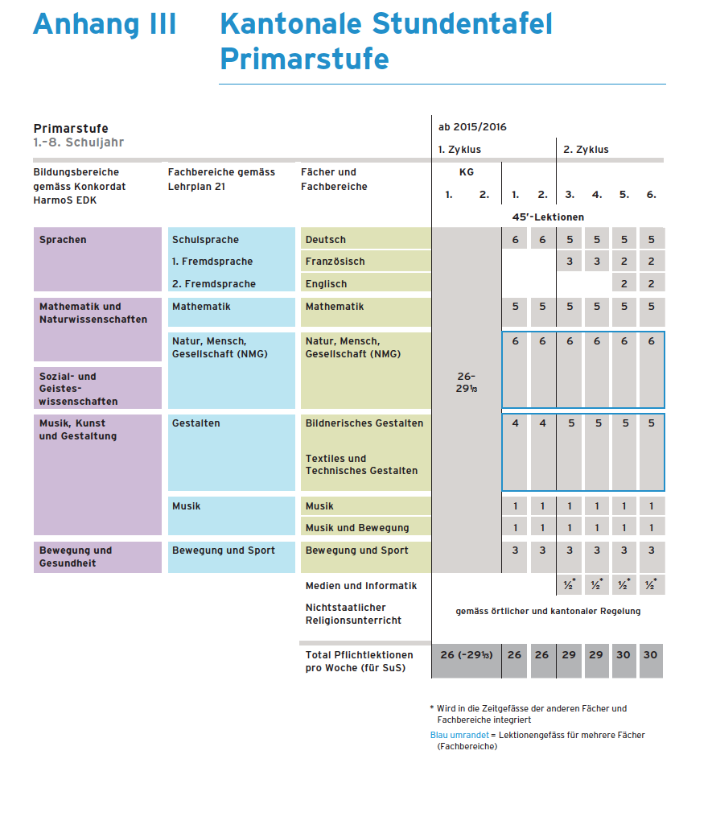

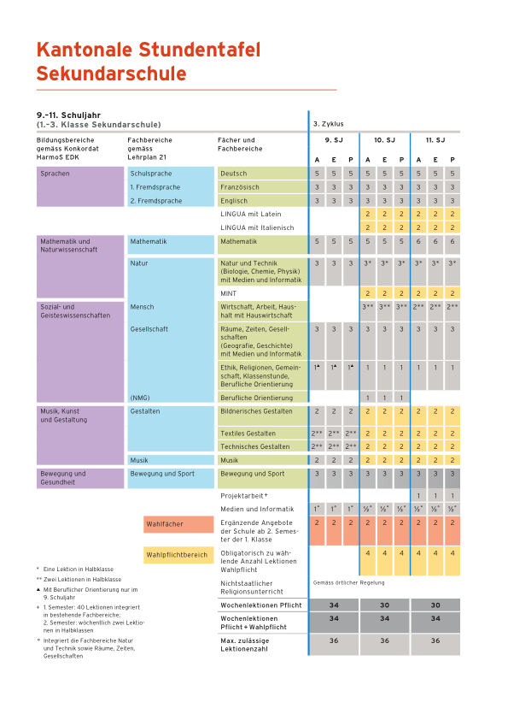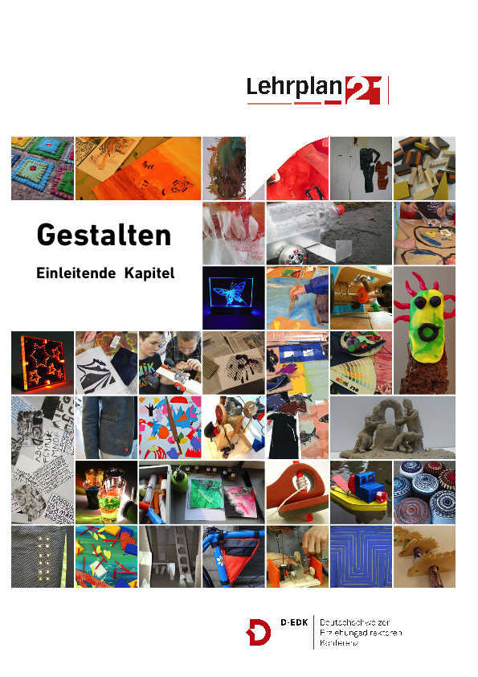

Appendix 2

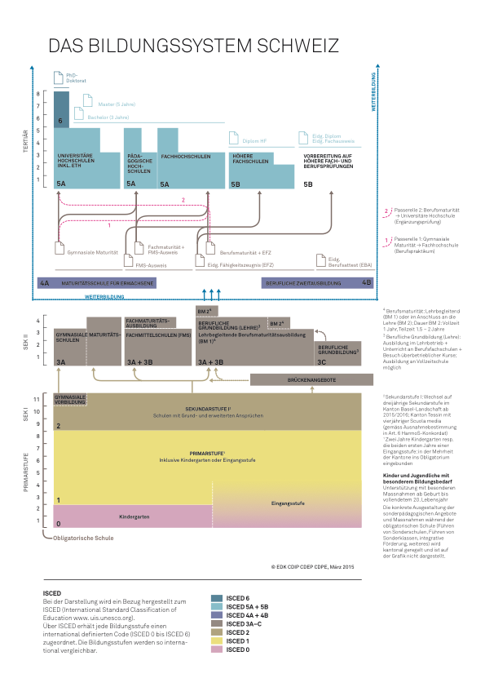

The Process a:

