Slide | Script/Interaction | Notes
1 | Welcome to Customer Service Basics enter your name and click the start button to begin  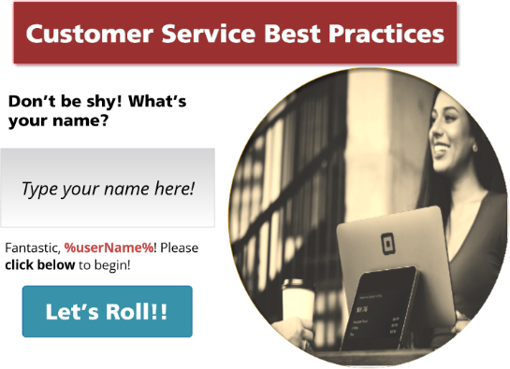 | Text entry box  Validation layer  Start button disabled until name variable change  Alert if user fails to enter name
2 | Learning Goals  First Objective  Identify Exceptional Customer Service  Upon completion of this course, you will be able to identify and apply exceptional customer service skills.  Second Objective  Recognize Barriers to Great Customer Service  Upon completion of this course, you will have the knowledge and skills at your disposal to recognize the barriers that prevent great customer service.  Third Objective  Measure Success  Upon completion of this course, you will demonstrate how to effectively measure customer satisfaction and confidently take corrective actions. | Click and Reveal  Slide from bottom  User clicks Next to continue
3 | Character Selector  Move the slider toward the character you would like to guide you through your course! Then click on character!    Brandon    Laura   | Slider approach  Character welcomes user
4 | Section 1: What is Customer Service to you?  Good customer service requires work and alignment across the entire organization. If we want the company to be successful, it’s important that we adhere to the same principles.  Click “Respond” below and tell us a bit about what customer service means to you. | User clicks Respond to continue  Character Animation
5 | Customer Service Defined  Right Side:  Good customer service typically means providing timely, attentive, upbeat service, both before and after a sale, to a customer, and making sure their needs are met in a manner that reflects positively on the company or business and provides an enjoyable experience for the customer. | Two sides  Left side: Text entry box  “This is what you told us” Validation Layer  Right side: Our definition of Customer Service
6 | Customer Service Experience  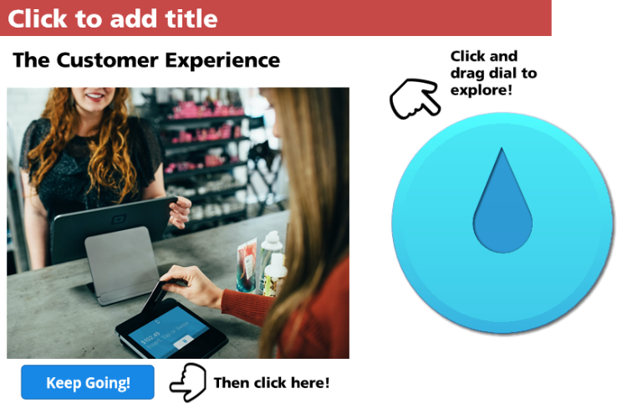 | Dial Interaction  4 Levels  0 – Product Knowledge  2 – Communication  4 – Patience  6 - Attentiveness
7 | Review or Check?    Congratulations! Keep up the great work! Let’s check your knowledge. If you would like to review some of the content move the slider below to REVIEW. Otherwise, let’s get checking! | User can review course prior to knowledge check  Takes them back to previous screen.  Slider interaction
8 | Knowledge Check 1  One of the most important aspects of customer service is:  Communication  Voice Mail  Language  Punctuality  Knowledge Check 2  Without _________________, the customer is not likely to find you reliable.  Name Badge  Product Knowledge  A Tablet  Clarity | Convert to freeform  Multiple Choice Interaction
9 | Call to Action  Over the course of the next month, commit to improving in these areas. Working together, with the same goals in mind, we can improve the quality of our customer service section and promote a a more productive work environment for us and better outcomes for our customers! | Let’s Put These Goals into Action!  User clicks:  Keep Going Navigation
 | Quiz Review  On the next page, you will be asked to review the four principles covered in this course. You may want to review them first. | User clicks Review or Next
9 | Quiz  Please identify the Four Customer Service Objectives covered in this course. | Click multiple  Submit  Results  Close Course
10 | Final Quiz  Welcome to the final quiz. Please choose True or False for each question and hit submit when you are done. | SCORM 1.2  True/False 5 Questions  Question Bank Draw  User clicks submit after each question  Course exit when done.

