**Kiss My Soul’s Wholesale Pricing**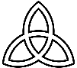



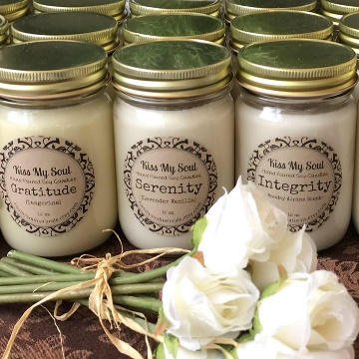**Handmade Scented Soy Candles in Mason Jars (12 oz):**

Retail: $18 per candle

**1 case (12 candles):** **$200** ($16.66 per candle-saving $1.33 ea. candle)

**2 cases (24 candles):** **$372** ($15.50 per candle-saving $2.50 ea.)

**3 cases (36 candles):** **$549** ($15.25 per candle-saving $2.75 ea.)

**4 cases (48 candles): $722** ($15.05 per candle-saving $2.95 ea.)

Quantities over 48: $15 per candle

Scents: custom order of all the same scent (16 day lead time required) or option for mixed case of what’s on hand

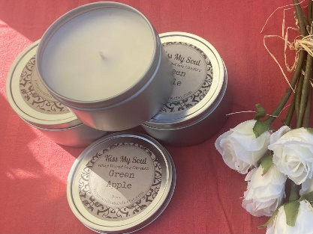**Handmade Scented Soy Candles in Tins (8 oz):**

Retail: $15 per candle

**20 candles-$280**($14 per candle $1 off each candle's retail)

**40 candles-$540**($13.50 per candle-saving $1.50 off ea.)

**60 candles-$765**($12.75 per candle-saving $2.25 off ea.)

**80 candles-$960**($12.00 per candle-saving $3.00 off ea.)

Quantities over 100: $11.80 per candle)

**Fragrance Rollerballs OR Heart Shaped Organic Shea Butter Lotion Bars (in Picture):**

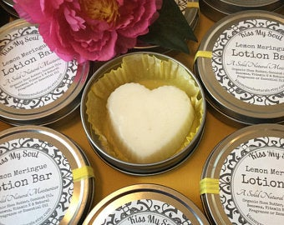

Retail: $12 per.

10 or more of the same scent: $11 per (made to order)

Scents: matching names and oils to the candles

**Pure **Essential Oil** Rollerball blends or Shea Butter bars can be requested at higher price point—request a quote

**Additional Customization:**

Custom labels with your logo: request quote, 6 week lead time required

Custom Scent Requests (ie: Cranberry for holiday etc.): 6 week lead time required

**Payment:** Cash, Check or Credit Card for payment in full must be made prior to or upon Delivery

**Delivery:**

Pickup in Lansdowne PA or Free Delivery within 8 mile radius of Lansdowne for orders over $140

Meeting up at a Networking event for transfer can be arranged but not guaranteed

Or delivery charge to your office of $20-$30 depending on distance.

***Sara Burns*****Kiss My Soul Naturals LLC** [**Saburns712@yahoo.com**](mailto:Saburns712@yahoo.com) **610.715.8281**