All-in-One - multipurpose ultrasonic system
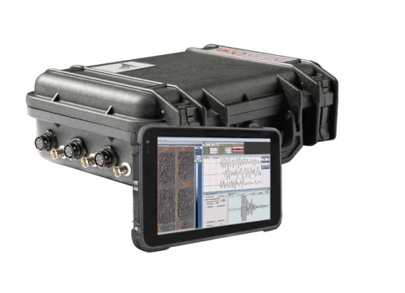
All-in-One is an easy-to-use non-destructive testing instrument with a multipurpose acquisition unit and specialized piezoelectric sensors that allows to perform sonic and ultrasonic tests for the characterization in situ and in the laboratory of materials such as concrete, masonry and stone materials, PIT and cross hole in piles and diaphragm foundations.
All-in-One is used to solve a wide range of tasks:
- Pile Integrity Testing (PIT)
- Ultrasonic tomography testing of building structures, architectural monuments, and trees
- Cross-hole logging of concrete foundations, piles, retaining walls, diaphragm foundations, dams, etc.
- Soil stabilization control
- Ultrasonic laboratory studies of rock samples
It is well known that the speed of sound depends on the elastic properties of the medium. Measurements of the travel time of ultrasonic pulses in the studied object allow to do non-destructive testing of the material, i.e., to define its strength, homogeneity, presence of cracks or cavities in it.
The All-in-One system is able to measure the propagation time of pressure (P) waves with high accuracy, and for quality control the actual waveform of a signal is displayed on the screen of a tablet connected via Wi-Fi.
There are 3 basic kits of All-in-One:
1) MCHA is designed for ultrasonic cross-hole testing (logging) and tomography of the bored piles, drilled shafts, concrete piles, augercast piles, retaining walls, diaphragm foundations, concrete dams, barrettes, and other similar structures in accordance to ASTM D6760-16. The kit includes a set of specialized borehole piezoelectric modules: receiver, transmitter, and, optionally, combined receiver-transmitter unit. In the maximum configuration, the system allows to perform simultaneous measurements with three “source-receiver” pairs thus significantly reducing the acquisition time and cost. 50 or 80 kHz modules are available. High-power transmitters and high-sensitive active-type piezoelectric receivers allow measurements in wells set more than 3 meters apart.
Delivery set:
- Acquisition unit All-in-One with charger and set of cables
- Transmitter probe
- Receiver probe
- Bifid probe (option)
- 2 or 3 pulleys
- 2 or 3 cable reels (60m or 100 m)
- Cable driver
- Tripod
- Transport case

2) Kit P.I.T is designed for low strain impact integrity of piles testing using echo-methods. In literature, this method is known as Pile Integrity Testing and is described in ASTM D5882-16.

Delivery set:
- Acquisition unit All-in-One with charger and set of cables
- Hammer with accelerometer
- Accelerometer
- Transport case
- Software PIT
- Option: tablet computer

