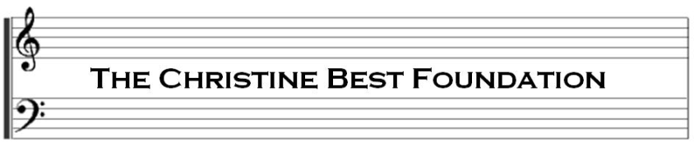

Grant Application Form – Grants for Community Organisations and Projects

1. **DETAILS OF PERSON MAKING APPLICATION**

Full names ............................................................................................

Age Range 0-10 | 11-18 | 19-25 | 25 +

Address ............................................................................................................................

Email …………………………………………………………………..

Telephone ……………………………......................

1. **ORGANISATION DETAILS**

If you are applying on behalf of an existing organisation, please fill in the questions below. If you are applying for a start-up grant, please proceed to section 3.

If you are applying on behalf of a number of organisations wishing to pursue a collaborative community project, please include details in this section relating to the Lead Organisation and include details of Partner Organisations in section 3.

1. Name of organisation

……………………………………………………………………………………………………………………………………………………………

1. Position of applicant in relation to organisation

………………………………………………………………………………………………………………………………………………………………….

1. For how long has the organisation been in existence? …………………………………………………..
2. Details of organisation’s principal officers

Full names ............................................................................................

Age Range: 0-10 | 11-18 | 19-25 | 25 +

Address ............................................................................................................................

Full names ............................................................................................

Age Range: 0-10 | 11-18 | 19-25 | 25 +

Address ............................................................................................................................

Full names ............................................................................................

Age Range: 0-10 | 11-18 | 19-25 | 25 +

Address ............................................................................................................................

1. Please provide details of who currently benefits from your organisation, including participants and estimated audiences? Please include approximate numbers over past 12 months.
2. **PURPOSE OF FUNDING REQUEST**
3. What is the purpose of your application? Please set out details below, including, as applicable to your application, the nature of any project you are planning or your organisation’s particular need for funds, any relevant dates, locations, how your plans will be carried out, by whom and for whose benefit.

If you are applying for a start-up grant for a new organisation, please include details here of key individuals who will have positions of responsibility within the organisation.

1. If your project or organisation involves working with children or vulnerable adults, do the relevant people within your organisation have up to date CRB checks?

YES/NO (please circle)

1. Please explain why the grant is necessary for the success of your project or organisation.
2. Will there be any Partner Organisations involved? YES/NO (please circle)

If you have circled yes above, please provide details below.

1. How do you (and Partner Organisations where applicable) intend to monitor the appropriate use of any funding received from The CBF? What financial safeguards are / will be put in place?
2. Please explain how you think your project or the work of your organisation would satisfy the objectives of The Christine Best Foundation.
3. **FUNDING INFORMATION**
4. Amount requested: £ ………………………………………
5. Total projected cost of project/activity: £……………………………………..
6. Have you received any funds from other sources?

YES / NO (please circle)

1. Do you intend to apply to other sources for funding? YES / NO (please circle)

If you have circled yes on either of the above questions, please provide further information below.

1. Please provide a budget breakdown to show how any funds received from The CBF would be allocated. This section will require more detail if you are proposing a community project, particularly in collaboration with Partner Organisations.
2. **FINANCIAL INFORMATION**
3. If you are an existing organisation, we request that you enclose copies of the organisation’s most recent accounts with your application. If you are unable to do so, please explain why.
4. If you are an existing organisation, does your organisation charge a membership fee?

YES/NO (please circle)

1. If you are applying for a start-up grant, will your organisation charge a membership fee?

YES/NO (please circle)

1. Income of your organisation (if applicable):

2016 £ ……………………………………. 2015 £ ………………………………… 2014 £ ……………………………………

1. Expenditure (if applicable):

2016 £ ……………………………………. 2015 £ ………………………………… 2014 £ ……………………………………

1. **DECLARATION**

I confirm that the above information is correct to the best of my knowledge.

I understand that the Grant Application Committee may contact me for further information to assist the Board of Trustees in making a decision.

I understand that, if this application is successful, any grant provided by The Christine Best Foundation is made on the condition that it is used for the reasons cited in section 3 above; and I undertake to provide evidence that, should my application for a grant be successful, the grant has been used for the purpose for which it was intended.

I undertake to inform The Christine Best Foundation of any change in material circumstances relating to this application.

**Signature of applicant ……………………………………………………………..**

**Date……………………………**

**All information received will be treated with the strictest confidence and will not be shared with any third parties.**