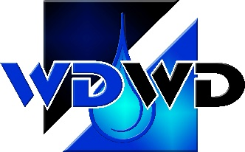

Winston-Dillard Water District

121 NW Douglas Blvd., Winston, OR 97496

Office 541-679-8467 ~ Fax 541-679-4875 ~ www.wdwd.us

**REGULAR MEETING**

**Proposed Agenda**

**May 21, 2025 to follow Budget Committee Meeting @ 4:30 PM**

**Call to Order**

**Visitors**

**Public Comment**

* Members of the public wishing to discuss items not covered by this agenda are welcome to address the Board as a whole. Individuals are asked to state their name and address for the record. Individuals will be limited to 3 minutes maximum time to speak on any topic not on the agenda, unless additional time is granted by the Board. Individuals providing public comment shall not use profanity or try to intimidate the Board. The Board reserves the right to delay action on items discussed until all information can be gathered on the topic.

**Presentation and Reports**

* **Approve Meeting Minutes**

Regular Meeting Minutes April 23, 2025

* **Bills to be paid**
* **Monthly Operations Report**

Plant / Distribution

* **Monthly Financial Reports**

Financials

* **Staff Reports**

Water Master Plan Update

Winston Reservoir Project Update

**Old Business**

* None

**New Business**

* Intergrator of Record Contract
* Pump Station PLC Replacement
* Meter Purchase
* Annual COLA

Winston-Dillard Water District

Regular Meeting Proposed Agenda – May 21, 2025

Page 2 of 2

**Good of the Order**

* SDAO Grant
* Johnson Street Mainline Project

**Adjourn Meeting**

**Public Budget Hearing - Wednesday, June 18, 2025 at 4:30 PM**

**Regular Meeting to follow**