**NOTE: DECISIONS/ACTIONS WILL BE HIGHLIGHTED IN GRAY**

**MONTH:** March 23, 2023

* **Announcement:** Michelle Batten will be facilitating today’s meeting for Raini Bowles.
* **Welcome & Introductions - Roll Call – In attendance:**

|  |  |  |  |  |  |  |
| --- | --- | --- | --- | --- | --- | --- |
| Raini Bowles |  | Candace Falsetti | x | Michelle Batten | Tricia Ellinger | x |
| Ashley Porter | x | Nicole Gaylin | x | Parker Luce | Holly Walund (guest) | x |
| Dori Boyle | x | Jill Mathews | x | Penny Fisk | Wendy Margolis | x |
| Brittany Shipley | x | Jose Martinez | x | Tracie B. |  |  |

* **Approval of last meeting notes** (Informal)
* Postponed to next month’s meeting
* **Youth Voice**
* Postponed to next month’s meeting
* **WBU survey results**
* We didn’t have as many responses as we’d like. If you can, please get the word out to visit [www.APlaceToShine.Org](http://www.APlaceToShine.Org) to take the survey. Thank you!
* **Introducing monthly YES partner:** Holly Waglund, Idaho Department of Juvenile Corrections, Project Manager, Youth Crisis Centers and Youth Assessment Centers
* **Holly Waglund presentation:** Holly is a PM for Idaho’s new and upcoming Youth Assessment Centers and Youth Crisis Centers. Both projects are currently in the implementation stage.
* Holly presented information on the assessment centers’ guiding principles and more. There are currently eight centers in Idaho. As of today, they are set to open on July 1 of this year.
* The Youth Behavioral Health Crisis Centers have FOUR PRIMARY FUNCTIONS:

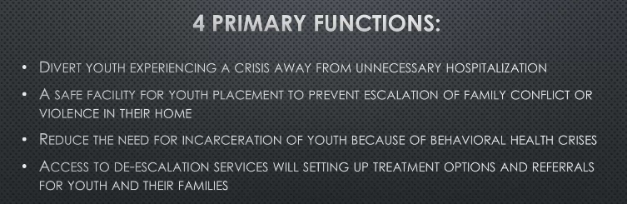

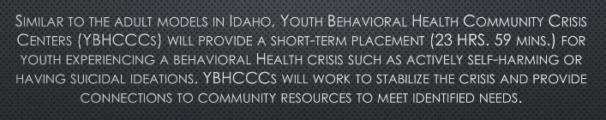

* Questions or comments:
* **Michelle:** Will the crisis centers be operating by July 1 as well? **Holly:** Hopefully, but they are a little bit more of a moving target than the assessment centers.
* **Brittany**: A barrier for current assessment centers is that they only do assessments for kiddos living in one county. **Holly:** Yes, that is a limitation; we just had limited funding. Also, when we were developing the centers, the centers were directed to look at their regional or city data and develop a target population and a target area. However, we are looking at this as we move forward... We’re looking at other state models such as Las Vegas. **Michelle:** So, these aren’t really regional centers then, correct? **Holly:** Correct. Each center defined what their target areas were.
* **Brittany re crisis centers:** We are currently discussing and wondering what it will look like when a youth has a high need and needs transportation... Do they go to a hospital/facility? Has this been decided? **Holly:** Not a concrete answer for this right now. Realistic processes and policies are being developed by IDHW, and they are working with the centers. Also getting feedback from People USA. IDHW’s Treena Clark is looking at this as well. **Michelle:** I’d like to invite you back Holly, to give us an update. **Holly:** Agreed.
* **Reminder of review resources for FAM -** Invitational flyer, QRs, weblinks ([www.aplacetoshine.org](http://www.aplacetoshine.org)), spreading the word
* **Next month’s partner announcement:** Candace Falsetti from IDHW.
* **Family Questions/Comments ?:** N.A.
* **Upcoming meeting ideas and collaboration** (families have any special questions or concerns to be addressed by upcoming partner?): N.A.
* **Next meeting: April 27, 2023 (4th Thursday of each month)**
* **Adjourn**