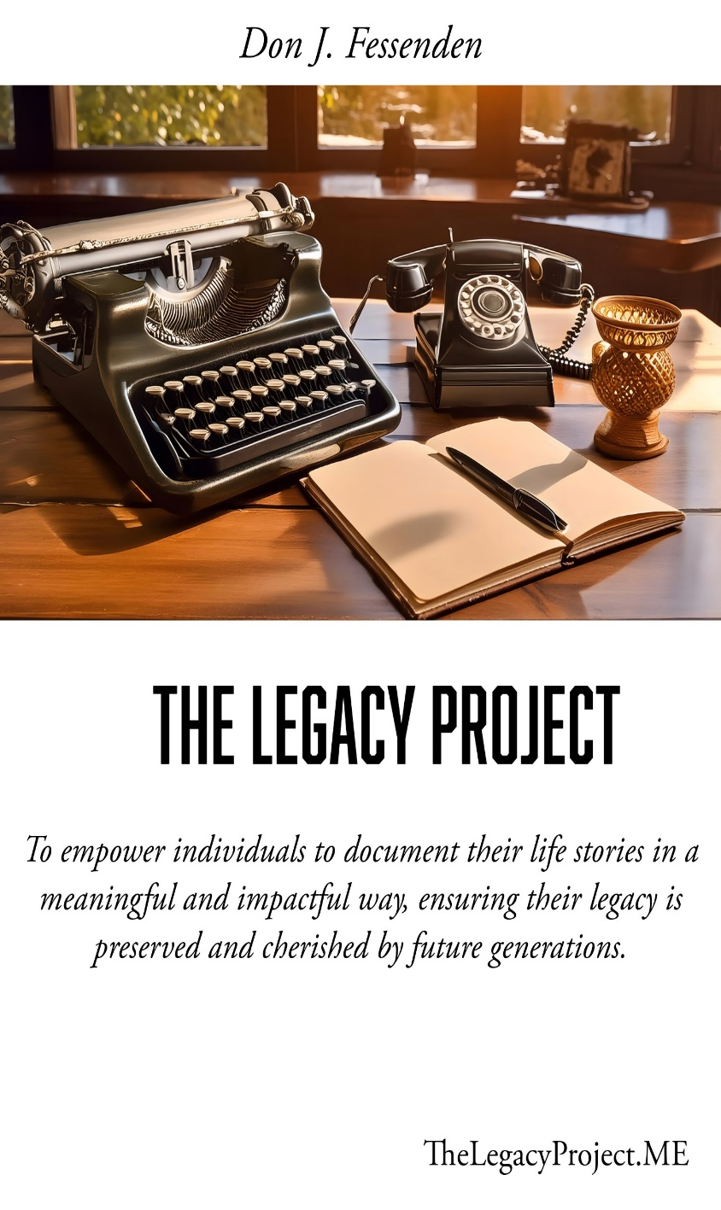

© 2024 The Legacy Project. All rights reserved.

No part of this pamphlet may be reproduced, distributed, or transmitted in any form or by any means, including photocopying, recording, or other electronic or mechanical methods, without the prior written permission of The Legacy Project, except in the case of brief quotations embodied in critical reviews and certain other non-commercial uses permitted by copyright law. For permission requests, write to The Legacy Project at the address below.

**Contact Information:** The Legacy Project  
420 Poindexter Ct, Lexington, SC, 29072  
Email: info@thelegacyproject.me  
Phone: (609) 220-7007

This pamphlet is intended to provide an overview of The Legacy Project's services and offerings. While every effort has been made to ensure the accuracy of the information contained herein, The Legacy Project reserves the right to make changes without notice.

**The Legacy Project: Your Story, Your Legacy**

**Unlock the Power of Your Life’s Story**

Welcome to The Legacy Project, where we help you capture your life’s journey in a beautifully written autobiography. Whether you’re writing for your family, future generations, or yourself, our comprehensive coaching and ghostwriting services make it easy and enjoyable to tell your story.

**Why Choose “The Legacy Project”?**

* **Personalized Guidance:** Work one-on-one with Don J. Fessenden, a seasoned educator and author, to ensure your story is told with authenticity and heart.
* **Comprehensive Support:** From initial planning to final publication, we offer a range of services tailored to meet your needs.
* **Preserve Your Legacy:** Create a treasured heirloom that will inspire and connect your loved ones for years to come.

**Our Services**

**1. Coaching Plan**

* Personal consultation with Don J. Fessenden
* Custom foundational plan for your autobiography
* Monthly check-ins as needed
* Detailed feedback and editing suggestions
* Access to writing resources and templates

**2. Basic Ghost-Writing Plan**

* All features of the Coaching Plan
* Professional ghostwriting (up to 10,000 words)
* Bi-weekly progress check-ins
* Initial round of editing for clarity and coherence

**3. Ghost Writing with Finished Manuscript Plan**

* All features of the Basic Ghost-Writing Plan
* Expanded word count (up to 25,000 words)
* Comprehensive editing and proofreading
* Professional formatting
* Delivery of a fully finished manuscript

**4. Ghost Writing with Finished Manuscript and Amazon Publishing Plan**

* All features of the Ghost Writing with Finished Manuscript Plan
* Full-service Amazon publishing support
* Cover design, metadata optimization, and interior formatting
* Marketing advice and Amazon Author Page setup
* Distribution recommendations

**Start Your Journey Today**

*“Father Time Waits for No One” unknown*

**Contact Us:** When you’re ready to preserve your legacy?

Get in touch to schedule your initial consultation and learn more about how we can help you tell your story.

**Email:** [info@thelegacyproject.me](mailto:info@thelegacyproject.me)

**Website:** [www.thelegacyproject.me](http://www.thelegacyproject.me)

**Preserve Your Legacy**

Everyone has a story worth telling. Let The Legacy Project help you tell yours. Join us on this transformative journey and create a legacy that will inspire and connect your loved ones for generations to come.

**The Legacy Project:**

Your Story, Your Legacy!