BODY FLOW By Mel Wilkerson and others
I want to thank all the contributions from great teachers like Ken Ritucci, Tony Oxendine, Rich Reel, Tim Marriner, Barry Wonson, the GSI and Callerlab documents and others from whom at one time or another from whom I have happily plagiarised stolen and otherwise bastardised sections of their infinite wisdom, added some of my own thoughts and set this down.
Smooth Dancing & Body Flow is defined as action which allows the dancers to move comfortably, without abrupt changes of direction or excessive stops, with steps that match the beat of the music.

Two key Conditions exist
- The movement must be physically comfortable allowing the dancers to move naturally.
- The other condition, since this is dancing, is that the action should allow the dancers to match their steps to the beat of the music.
If something affects or interferes with either of those two conditions, then you will have a disconnect in body flow that will affect the overall enjoyment of the dance.
Consider it this way. Dancing that has poor body flow and is not smooth means dancers tire easier. Tired dancers do not enjoy the dance and dance poorly. A poor dancing experience leads them to go home early. Dancers that have had a bad dancing experience and left early are unlikely to really want to come back.
To ensure we keep those two principles intact; it is important to understand what are the factors that affect them. First let’s start with smoothness and timing.
Principle Factors Affecting Smooth body flow and Timing
The goal of timing is to allow the dancer to start moving with the first beat of a musical phrase, and then to move smoothly and without interruption until the dancing action has been completed.
- Tempo - The dancers' sensation of speed is affected both by the timing and the tempo 124-128 is a good tempo but it should not be below 122 nor above 130

- Body Position - The caller must choose material so that the dancers are positioned at the completion of one call so that the transition to the next can be accomplished without abrupt changes in direction.

- Hand Availability - The hand that is to be used next must be available at the completion of the preceding action in order for the action to feel smooth.

- Anticipation There are three types of anticipation that the caller must be aware of.
- Encouraged or prompted anticipation is rhyming word patterns that sometimes encourage dancers to anticipate a particular call. Examples:
"Forward up and back you reel, Pass Thru now Wheel and Deal."
Up to the middle and back you float (what comes next)
Dixie style to an ocean wave, take a peek (what comes next)
- Conditioned anticipation is continued use of the same phrasing and calls which develop a conditioned reflex-like dancer response that you may not want. Your dancers often start or perform the second call without you even saying it. Example:
“Ladies Lead - Flutterwheel.”
“Pass the Ocean, Ladies Trade”
“Double pass thru, Track two”
- Instinctive anticipation occurs when existing momentum of the dancers create an instinctive tendency (anticipation) to continue a given body action in the same direction Example:
From Lines - “ touch ¼, all 8 circulate – (Anticipated forward action is instinctive)

- Execution These are the factors that allow the dancers to hear the call, react to it and execute it properly. There are many but the primary three are:
- Familiarity of material being used will affect the smoothness and rate of execution. Precision of movement creates the sensation of smoothness from one person to the next even in the same square.
  - Adequacy of training on how the dancers are taught. Or even if the calls are taught differently geographically.
  - Space available. If dancers are "squeezed“ they cannot dance smoothly. Example: From a starting Double Pass Thru or 8-Chain Thru, the calls Flutterwheel or Ladies Chain will cause "squeezing”. If you have a crowded floor, it is generally not a good idea to use Tidal Waves or Tidal Two-Faced Lines

- Kinesiology – refers to the study of body movement and includes consideration of the anatomy of people and how their physical characteristics affect the way they move. Body movement needs to be comfortable, so dancers remain balanced and are able to manage their momentum. Avoid “Overflow”.
Body relationships play into "counter-dancing" which the need for dancers turning around each other to counter-balance each other. Call design refers to the body movement difficulties that are built into some square dance calls. Perhaps the most obvious example of the problem is the call Square Thru where the dancers are required to counterbalance each other and counter dance using each other as a reference to the movement.

LET’S LOOK A LITTLE DEEPER
We already know that Smooth Dancing is all about body flow. This is when the timing matches the choreography and the movement of the body flow seamlessly, or in some cases are deliberately stopped for effect, leading into a new pattern, If you achieve this, you have bodies in motion that flow and move with the music comfortably, and effectively and enjoyably. That is what body flow is all about.
- Body flow does not mean you cannot have a sudden change of direction, nor does it mean that you cannot use the same hand twice. It does however mean that when those things happen, they happen for a reason that enhances the flow and the experience bringing harmony and happiness to the dance. Body flow does not mean that the direction of travel is smoothly flowing in the same direction because changes of direction are part of what dancing is all about. Body flow does not mean you cannot have periods of stop and go or pauses or check steps because those are inherently part of any dance.
- Body flow does means that all of these things will exist in a smooth flowing square dance, but when they happen, they are intended and judiciously used to enhance and increase the experience as a welcome expectation and not as a jarring digression from what you as a caller are trying to achieve. – Happy dancers that want to dance to you.

BODY FLOW
Callers create a myriad of choreographic sequences for dancers to dance to. That is part of our job. If the caller does not pay attention to BODY FLOW and HAND USE when moving from one position to the next, the result is a “technically proper use of defined movements in a choreographic sequence” but no matter how “proper” it is a sequence that is both awkward and uncomfortable to dance.
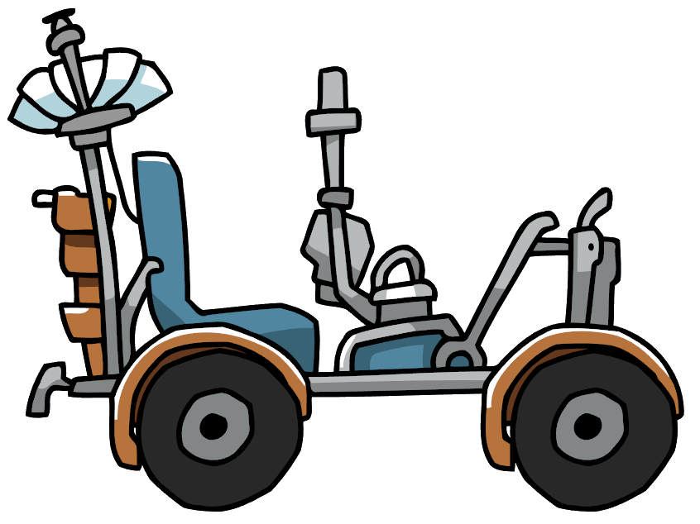
Think of it like a car with moving parts. If the mechanic just slapped those parts into the right place, taped the windshield on the car, welded the frame and body on the car and put an old kitchen chair on the floor for a seat, but took no time to appreciate the aesthetics, he would create a vehicle that could both move and get you from point A to B but one that you would not likely want to drive on a regular basis.
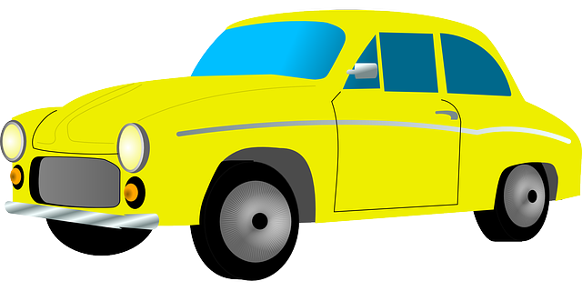
Now consider a car that the people that built it, took the time to design the car, not only for functionality and efficiency of use, but also for comfort and style and the overall aesthetic look. Chances are you would prefer that one to drive and it is also likely people would want to ride with you.
Just like the only way to really test a car is to drive it, and the only way to really understand body flow and the effect it will have on the dancers, from a caller’s point of view, is to get out and dance it. I do not say this lightly.
It is possible to analyse movements with computer programs, kinaesthetic logic, and definitions and determine that “technically” it should flow”. However, the reality is, once you add the factor of real people dancing, you have other variables such as expectation, room for the action to take place, preceding and subsequent movements, and so many more things you must go back and check it again. That can only be experienced by dancing it,
Note: Always check your prepared choreography for body flow, and hand use. Dance them yourself from BOTH left and right-hand dancer positions and for both Heads and Sides
For those of you that are fully extemporaneous (sight) callers, you should have already checked your modules and flow sequences. Now what you must be aware of is the movement mechanics of each movement you “sight call” and what comes before and what comes after each movement. This takes practice.
It is important that if we are going to understand body flow, we must look at in conjunction with choreographic sequences – not individual movements.

The following is examples of GOOD body flow and hand use:
- From a Line — Right and Left Thru, Flutter Wheel,
Reverse Fluttewheel…(Flows nice)

The following is an example of MEDIOCRE Body flow
- From parallel Boxes. – Right and left thru – Flutterwheel,
Reverse Flutterwheel (crowded space)

The following are examples of REALLY BAD body flow and hand use.
- From a Line — Right and Left Thru, Reverse Flutter Wheel, Flutterhweel (awkward direction reversal)
Body flow is only one aspect of smooth dancing, but I would say that it is one of those aspects that without it, other important things such as variety just do not work.
While variety is a very important thing to calling and dancing, NEVER use choreography that is not flowing, just for the sake of variety. This is something that happens all too commonly, and the main reasons are:
- Callers are filling in their tick list of what they must call and are focused on calling as many calls as they can or their list, rather than on the dancers
- The caller is bored and drops a module or equivalent in for variety but doesn’t pay attention to the “before and after” effects
- Gaining the dancers attention such as trying to fix a problem or break a dancing habit with a “gotcha”
Adding variety making it more interesting or correcting a dancing error can be achieved in so many other ways without making it uncomfortable for the dancers.
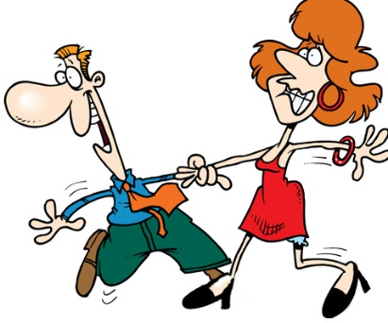
Boys and Girls – It was said before, but it is worth re-iterating, Callers should think of more than one dancer when considering a combination sequence. Think of all the dancers involved, and especially think of the ladies.
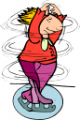
No offense ladies, but the truth is that most callers are men, and most lady callers have been taught by men. This is slowly changing but, it is a proven scientific fact that most men are generally lazy. (Whether or not that is changing is still open for debate) With that in mind, callers tend to find excellent flowing choreography for themselves or how they were taught, which is usually from a man’s perspective. It is not uncommon to overlook the fact that usually two, but sometimes all four, of the ladies in the square have turned into human corkscrews or as they say in Germany, Figure skaters

SEVEN OBVIOUS ASPECTS OF BODY FLOW
Body flow has at least the following SEVEN aspects. There are likely more, but these are the most common. It is important to be aware that there are, or may be, exceptions to all these, which are part of the dance. These could be such things as using a right hand twice when defined, or a deliberate direction change that is part of a movement. These are however not common but remain the source of many arguments and I am sure that at the end of this presentation, some of those arguments will come up again.

Aspect 1 – Forced (not natural changes of direction)
The dancers should not be forced to sharply change their direction of motion.
An obvious example:
- From Right Hand Waves: Ends Run; Bend the Line; Reverse the Flutter
Other bad flow examples which often occur with new callers managing formations or resolving the square:
- From Lines facing out: Wheel & Deal; Zoom
- From facing Couples: Star Thru; Veer Left
- From Right Hand Box Circulate: Out facers Run; Veer Left

Aspect 2 – Repetitive hand use
The dancers should not be forced to use the same hand twice in a row.
An obvious example:
- From Double Pass Thru: Centres Square Thru 3; Touch 1/4
Other examples:
- From Static Square: Heads Square Thru 4; Star Thru
- From Standard Lines: Star Thru; Right & Left Thru
- From Standard Lines: Star Thru; Allemande Left

Aspect 3 – Overflow.
Avoid overflow. From time to time the turning direction should be changed.
Example:
- From Static Square: Heads Touch 1/4, Head Boys Run, Star Thru, Slide Thru, Touch a Quarter, Boys Run, Partner Trade, Touch a Quarter, Girls Run, Star Thru, California Twirl, Slide Thru, Allemande Left
Other examples include the often seen “two particular moves called back-to-back”. While technically do-able they simply do not work and should never be called:
- From Right Hand Waves:
  - Spin the Top; Fan the Top
  - Swing Thru; Fan the Top
  - Cast Off ¾; Swing Thru
  - Cast Off ¾; Centers Run

Aspect 4 – Room To Move
The dancers should be given room to move to perform the movements. Square breathing (expanding and collapsing the dance area) should be natural and not forced due to the choreography.
- From Parallel Boxes
  - Right and left thru, Flutterwheel, reverse Flutterwheel
- From a Static Square
  - Heads Star thru, Zoom,

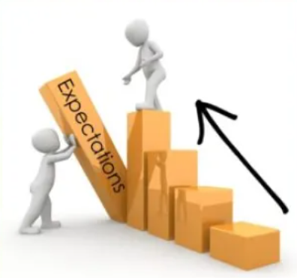
Aspect 5 – Dancer anticipation and expectation
The come movements while logically should work, do not work due to the nature of the movement, the short time it takes to complete or other reasons, create a dancer expectation for a forward flowing action or a different hand use. With regard to hand use, this is almost the same as using the same hand twice but with contact already established. Examples include
- From Lines – Touch 1/4, Zoom
- From Facing Couples – Dixie Style To A Wave, Left Swing Thru
- From Facing Couples – Slide Thru, Partner Trade
- From parallel wave – Walk and Dodge, Wheel Around (compare it to walk and dodge, cast off ¾ where the outsides are pivots or A Walk And Dodge Reverse Wheel Around where the walker keeps moving forward and the dancer adjust to make it a pivot instead of a backing up motion.)

Aspect 6 – The Wayward Hand
This is an ongoing argument about where the hands should be at the end of the movement as opposed to does the hand use during the movement make the next movement awkward. Examples:
- Right And Left Thru, Swing Thru
- Right And Left Thru, Star Thru
- Chain down the line, Square Thru
Note: most of these deal with hand positioning on a courtesy turn

Aspect 7 – Dealing With Offsets
Some calls end a little bit offset, so that the dancers might not be in exactly the right position for the next call. Dancer anticipation must be considered and is acceptable for some things but should not be relied on for everything. This is especially true when you have challenge dancers and callers at a BASIC, SSD or Mainstream dance. Make your choreography smooth flowing in a way that dancers do not explode and/or spread out from the desired formation and have to constantly adjust to do the next call.
Examples:
- from Standard Lines: Left Square Thru 2; Trade By
- from Standard Lines: Square Thru 2; Trade By
- From Standard Lines: Everybody do the girl’s part of Slide Thru; Everybody Trade
- From Lines: Tag the Line, Face Left; Centers Trade
On the other hand, the next combination is OK, because the dancers are expecting the next call and therefore adjust themselves to do it smoothly. This is another interesting aspect of Body Flow.
- From Double Pass Thru: Centers Square Thru 3; Allemande Left
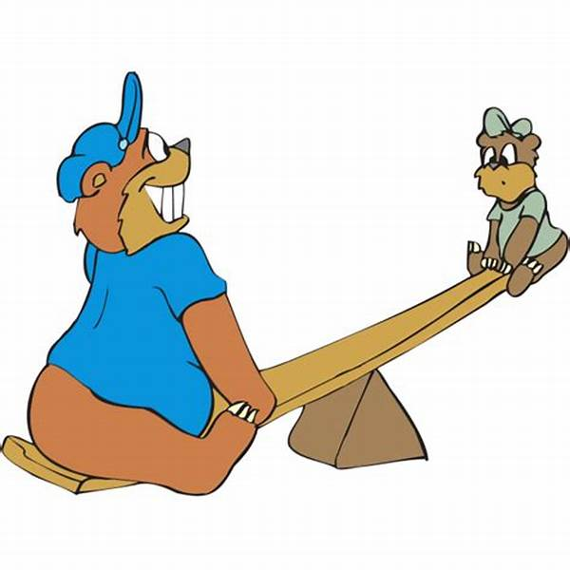
LOOKING AT IT HOLISTICALLY
It is important to see the whole picture to achieve comfortable balance. If you only look at one aspect of body flow, like only looking at one dancer, that aspect may be fine but the whole thing is out of balance.
With all that in mind, consider the following singing call figure that was pulled off a recording session at a caller’s school. It looks fine at a glance but take a closer look. What is wrong with it?
(H) Promenade 1/2, Right & Left Thru, Square Thru 2, Right &Left Thru,
8-Chain 2, Star Thru, Right & Left Thru, Star thru, Swing Corner and Promenade
- Break up heads head heads with heads head sides
- Right and left thru, square thru – wayward hand
- Square Thru 2, Right And Left Thru, no problem
- Right and Left Thru, 8 Chain 2 – wayward hand – lady adjustment to position offset
- 8 Chain 2, Star Thru, - girls left hand twice
- Star Thru, Right And Left Thru, - boys right hand twice
- Star thru and swing both the mans and ladies’ hands are occupied and require an adjustment of hands and of position
Summary. As a final note, always consider body flow when you strive for smooth dancing. You may have absolutely perfect lead timing, command timing and execution timing, but if you do not consider the human body and the way it moves comfortably, even the best music, and the best timing will make for a very uncomfortable dancing experience.
Callers must strive to understand that smooth dancing requires so much more than just not using the same hand twice in a row or changing directions every second movement. These are important, but not always necessary, nor are they required. A good balance of flow, direction changes and hand activity that meets anticipation, expectation and comfort is a whole picture thing. Remember that smooth body flow, as like other aspects of square dancing, has exceptions to all the rules. The dance is a total experience that involves the dance patterns, good timing, the sensation of smoothness and flow, the intellectual excitement, and many other factors.
The competent caller knows when the rules are broken, when the definitions break the general rules, and when to deliberately break the rules to enhance the enjoyment of the dance experience. He/she will do this only when the total program goals require it. Certainly, most of a square dance evening should be smooth flowing, comfortable dance patterns that move without hesitations or scrambling and do not require abrupt direction changes.

WHAT ABOUT WALK AND DODGE, PARTNER TRADE?
You will note that Walk and Dodge, followed by Partner Trade has not been discussed.
You will also note that if you take the time to research many documents, the Callerlab Knowledge base, and many caller school curricula, Walk and Dodge, Partner Trade is not on most of the “do not call” lists, and yet it remains a common focal point of the body flow argument.
I stated earlier that there are exceptions. Most of the following is not my own thoughts, but based on many Callerlab documents, caller discussions, and notes such as Tim Marriner’s choreographic notes. Those that knew Tim Marriner, know he was the incarnate of smooth dancing. I think he summed it up best.
Walk and Dodge, Partner Trade is only uncomfortable when the dodger (usually the lady) goes right and then makes make a pivot turn as the right-hand dancer for the partner trade because the left-hand dancer gives no room.
This is easily avoided by waiting until hand contact is made and touching hands prior to the trade portion of the movement. One of the reasons for the touching of hands is that without it, whenever there is a forward action by either one or both dancers, there can be a tendency for dancer adjustment and crowding. All partner trades are uncomfortable when this happens.
When walk and dodge has the right-hand dancer dodging left, the movement is comfortable because the right shoulder pass of the trade is achieved in a forward action which automatically gives room. Hands should still touch before trading. Unfortunately, very few callers today use that much variety in their calling. The action of sidestep forward for the trade (by the dodger) is actually not uncomfortable at all and is very commonly used in square dancing in combinations like. (Boys Run, Partner Trade or Girls Run, Pass Thru).
Round dance comparison danger: Many callers note Round Dancers do it seamlessly and if you ask any round dancer that square dances, it is one of the most basic and most common flowing step patterns in any dance. DO NOT EVER COMPARE ROUND DANCE OR BALLROOM DANCE BODY FLOW TO SQUARE DANCE BODY FLOW. The rhythm, hand and body position, footwork and many other things are completely different. The dance is specifically designed to accommodate those differences.
The argument, depending on the caller, is that the dodger often tries to turn inward sharply creating a hard direction change rather than a forward stepping action. A hand touch stops this.
There are too many combinations and sequences to list that lend to flow issues like overflow, such as large “same directional movements” through an entire sequence. These often do not become evident until you dance them. Hopefully however, this is enough to get you thinking about body flow, its importance, and more importantly, what not to do.
Also see Tim Marriner Caller Education in the Callerlab Knowledge Base on Body flow worksheet, The Do Not Call List and Smooth Dancing.

BODY FLOW NOTES AND SEEING THE PATTERNS – LOOKING AT IT AND SEEING THE FLOW PATTERNS
Tim Marriner 2004
EXERCISE ON TRACKING BODY FLOW. Callers should do this exercise to look at and discuss body flow and tracks prior to discussing what makes good flow and what makes bad flow.
Use a pencil to trace the pattern of the #1 man in the square in the following sequences.
- Heads Touch ¼, Centers Walk and Dodge, Swing Thru, Boys Trade, Boys Run, Bend the Line, Right and Left Thru, Flutter Wheel, Slide Thru, Pass Thru, Allemande Left, Right and Left Grand, Promenade Home.
- Sides Left Square Thru, Left Touch ¼, Walk and Dodge, Wheel Around, Dixie Style to an Ocean Wave, Allemande Left, Right and Left Grand, Promenade Home.
- Heads Pass the Ocean, Extend, Swing Thru, Boys Run, Ferris Wheel, Zoom, Double Pass Thru, Leaders Trade, Swing Thru, Boys Run, Tag the Line, Face Out, Wheel and Deal, Zoom, Right and Left Grand, Promenade Home.
- Sides Face Grand Square, Heads Pass Thru, Separate, Around One, Come into the Middle, Square Thru 3, Allemande Left, Swing at home.
- Sides Lead Right, Right and Left Thru, Veer Left, Couples Circulate, Chain Down The Line, Dixie Style to a Wave, Boys Cross Run, Recycle, Eight Chain 5, Allemande Left, Promenade Home.
- Heads Square Thru, Right and Left Thru, Pass Thru, Trade By, Right and Left Thru, Pass Thru, Trade By, Allemande Left, Right and Left Grand, Promenade Home.
- Sides Reverse Flutter Wheel, Sweep ¼, Pass Thru, Swing Thru, Boys Trade, Boys Run, Bend the Line, Box the Gnat, Square Thru 2, Right and Left Grand, Promenade Home.
- Heads Square Thru, All Square Thru, Partner Trade, Pass Thru, Wheel and Deal, Double Pass Thru, First go Left Next go Right, Forward and Back, Right and Left Thru, Slide Thru, Allemande Left, Swing at Home.
- Sides Lead Right, Circle to a Line, Pass Thru, Tag the Line, Face In, Left Square Thru but on the fourth hand Right and Left Grand, Promenade Home.
- Four Ladies Chain, Roll Away, Circle Left, Roll Away, Circle Left, Walk Around the Corner, Do Paso, Turn Partner Left Men Swing in to a Thar Star, Slip the Clutch, Allemande Left, Promenade Home.
Now try the same thing following Girl #1 and compare the results. Which doodles look the most interesting and why?
This is the beginning of understanding body flow. You want to have the body flow move seamlessly from one move to the next. Directions changes are essential as is the use of hands. It doesn’t matter if there is a short sharp change of direction as long as the flow is there to support it. (LEFT TOUCH ¼, WALK AND DODGE, PARTNER TRADE for example.) Similarly, it is not always wrong to use right hand to right hand movements as long as the definition and the body flow supports that action. (Touch 1/4 , scoot back, for example.)
Much of calling is good judgement and the only way to learn good judgement is by making mistakes. It is however better to make mistakes while learning to call, rather than while calling. It is for that reason that this list was made. It is important to understand that regardless of the definitions, there are a number of sequences however that do not flow. These are usually called “Bad Flow Combinations”, or as have been referred to, as the “DO NOT CALL THESE COMBINATIONS List.
This is my “Do Not Call List compiled by Tim Marriner”
The following are actual combinations that callers have used over the years and some still do. This is especially prevalent when callers use computer generated choreography which looks at the end position of dancers and adjudicates what can be done from a static fixed position with no body flow considered.
For instance, Heads Square Thru ends in a box or two sets of facing couples. Is it proper to call a Left Square Thru from those facing couples?
- The definitions say you can do it so it is perfectly acceptable to call – Right?
- The computer program that you may use allows this, so it is O.K – Right?
- Your checkers don’t make any objections to this, so it is O.K – Right?
The answer is NO. it is not O.K.
To be smooth, dancers must be able to move from one action to the next without interrupting their motion by changing their pace. This aspect of the sensation of smoothness results not only from properly timing the delivery of the call but also, to feel smooth, the calls must place the body and hands, if used, in a position at the end of one action readily available to start the next action without sharply changing the direction of motion. This aspect of the sensation of smoothness is the result of proper body flow and hand availability.
To a computer this is perfectly acceptable because the computer programs of today do not read body flow or hand freedom (availability from the previous movement). It only sees that there are two couples facing each other and whatever the person that made the program says they can do from facing couples, the program will do.
This is often what is meant by the expression:
“Just because you can call something, doesn’t mean you should”.
The following combinations were developed/compiled by for demonstration purposes only. They are examples of what is technically “legal” as far as definitions go, but not only bad judgement, bad flow and completely stupid to call. It is not however, until you as a caller feel the awkwardness of these flows that you can really appreciate what some callers are forcing dancers to do.
NOTE: This material is not recommended for use at any time as they exhibit bad body flow, inappropriate hand availability, or are deemed improper. Unfortunately, this list is continually growing.
- STAR THRU, VEER LEFT
- TOUCH ¼ (HINGE), SWING THRU / LEFT TOUCH ¼ HINGE), LEFT SWING THRU
- CENTERS IN, BEND THE LINE
- FLUTTER WHEEL, DIXIE STYLE TO A WAVE
- UP TO THE MIDDLE, SQUARE THRU – the up to the middle is an anticipatory fault that makes the dancers think UP TO THE MIDDLE AND BACK – if you want them to go into the middle and square thru, then just call Square Thru.
- ENDS RUN, BEND THE LINE
- RIGHT AND LEFT THRU, REVERSE FLUTTER WHEEL
- SQUARE THRU 3 HANDS, SWING THRU
- SPIN THE TOP, CENTERS TRADE - OVERFLOW
- HINGE A QUARTER – hinge is defined this means you want the dancers to ¼ of a Hinge or essentially 1/16th of the call
- ROLLAWAY WITH A HALF SASHAY – This is a wording issue that is incorrect. It is a rollaway or a half sashay – not both and each one is a different call.
- SPIN THE TOP, TOUCH A ¼ - This ends in a wave so a Touch ¼ is improper but commonly called. if you want them to Hinge then use Hinge.
- SWING THRU, STAR THRU
- RIGHT AND LEFT THRU, VEER RIGHT
- BOX THE GNAT, STAR THRU
- EIGHT CHAIN 4, ALLEMANDE LEFT
- RIGHT HANDED TWO FACED LINE: BEND THE LINE, TWO LADIES CHAIN
- PASS THRU, HALF SASHAY
- DIVE THRU, FLUTTER WHEEL
- RIGHT AND LEFT THRU, PARTNER TRADE
- TOUCH ¼, WALK AND DODGE, WHEEL AROUND
- TOUCH ¼, WALK AND DODGE, WHEEL AND DEAL
- TOUCH ¼, WALK AND DODGE, BEND THE LINE
- SWING THRU, BOYS RUN, TAG THE LINE, GIRLS ZOOM – girls are the leaders everyone will Zoom. by saying Girls Zoom they are the only active dancers and therefore cannot do this call.
- FOUR LADIES CHAIN, HEADS LEAD RIGHT
- RIGHT AND LEFT THRU, PARTNER TRADE
- RIGHT AND LEFT THRU, LEAD RIGHT
- SPIN THE TOP, FAN THE TOP – I would really hate to be in the center for this.
- SQUARE THRU 4, ALLEMANDE LEFT
- LEFT SQUARE THRU 4, RIGHT AND LEFT THRU
- STAR THRU, LEAD LEFT
- STAR THRU, LEAD RIGHT
- LEAD LEFT, VEER LEFT / LEAD RIGHT, VEER RIGHT
- WHEEL AND DEAL & SPREAD, TAG THE LINE
- COUPLES HINGE, WHEEL AND DEAL, TAG THE LINE
- FROM STANDARD COUPLES: GIRLS FLUTTER WHEEL
- FROM STANDARD COUPLES: TOUCH ¼, SCOOT BACK BOYS
- FROM RIGHT HAND TWO-FACED LINE: FERRIS WHEEL, VEER RIGHT
- BOX THE GNAT, HALF SASHAY
- CORNER LINES: RIGHT AND LEFT THRU, BOX THE GNAT, RIGHT AND LEFT GRAND
- FROM PARALLEL WAVES: WALK AND DODGE, CAST OFF ¾
- FROM OUT FACING LINES: CAST OFF ¾, LEAD RIGHT
- FROM SASHAYED FACING COUPLES: SLIDE THRU, CHASE RIGHT
- FROM 8 CHAIN THRU FORMATION SASHAYED: TOUCH ¼, SPLIT CIRCULATE, BOYS RUN, PARTNER TRADE
COMFORT AND DISCOMFORT – USE AND EXPECTATION
From other formations there are movements that should flow but do not. This is mainly because they are not used frequently, or because the dancer flow is not taught, and turns are tightened rather than danced. These are a little more subtle than those above and require more explanation.
- STAR THRU, ZOOM. – while this should flow as it is a forward action, it only works if the star thru has the dancers in a completed double pass thru formation. If they star thru and end in a double pass thru formation, the leaders move forward and away in the centre which creates a tight congestion which is awkward.
- (From facing lines) TOUCH 1/4 , ZOOM. Although this call has directional flow and no interference or issues with space or hand availability, because of dancer expectation, it is considered awkward due to the anticipated response of a different call such as a circulate or a roll. Although common in some places, its use has dwindled and is now mainly seen shifted to European strong floors, DBD or stop and go puzzle dancing at challenge levels. I learned this lesson the hard way when I returned from Europe in the Mid 1980s and tried calling it in Canada. Today, most callers agree that a circulate should be put in place prior to the zoom to remove the anticipation factor and to set a forward moving action prior to the zoom for the lead dancers rather than a forward turning action.
- STAR THRU, SQUARE THRU. This is a commonly used combination, especially at basic and early on when learning to dance. Many callers say it is acceptable because of the hand positioning at the end of the star thru, however in reality it is a right hand to right hand movement that is in fact, quite awkward. It has just been used for so long that it is considered “accepted”.
WHAT IS NOT ON THE LIST
You will note that walk and dodge, followed by Partner trade is not on the list. Walk And Dodge, partner trade is only uncomfortable when the dodger goes right and then has to make a pivot turn as the right-hand dancer for the partner trade because the left-hand dancer gives no room. This is easily avoided by waiting until hand contact is made and touching hands prior to the trade portion of the movement. One of the reasons for the touching of hands is that without it, when there is a forward action by either one or both of the dancers, there can be a tendency for dancer adjustment and crowding. All partner trades are uncomfortable when this happens.
When the walk and dodge has the right hand dancer dodging left, then this movement is comfortable because the right shoulder pass of the trade is achieved in a forward action which automatically gives room. You should still touch hands prior to the trade. Unfortunately, very few callers today use that much variety in their calling. The action of sidestep forward for the trade (by the dodger) is actually not uncomfortable at all and is very commonly used in square dancing in combinations like. (Boys Run, Partner Trade or Girls Run, Pass Thru . Many callers note that round dancers do it seamlessly and if you ask any round dancer that does a waltz or two step, or foxtrot. It is one of the most basic and most common flowing step patterns in any dance. DO NOT EVER COMPARE ROUND DANCE OR BALLROOM DANCE BODY FLOW TO SQUARE DANCE BODY FLOW. The Rhythms, hand and body position, framing, footwork and many other things are completely different, and the dance is specifically designed to accommodate those differences.
What makes this movement on and off the list, depending on the caller, is that the dodger often tries to turn inward sharply creating a stark direction change rather than a forward stepping action to go around the walker.
There are likely many others that have not been listed, with several combinations or even full sequences that lend to flow issues like overflow with large same directional movements through an entire sequence that are not evident until you dance them. These however are a compiled list to get you started thinking about body flow, its importance, and more importantly, what not to do.

